**Azure APIM**

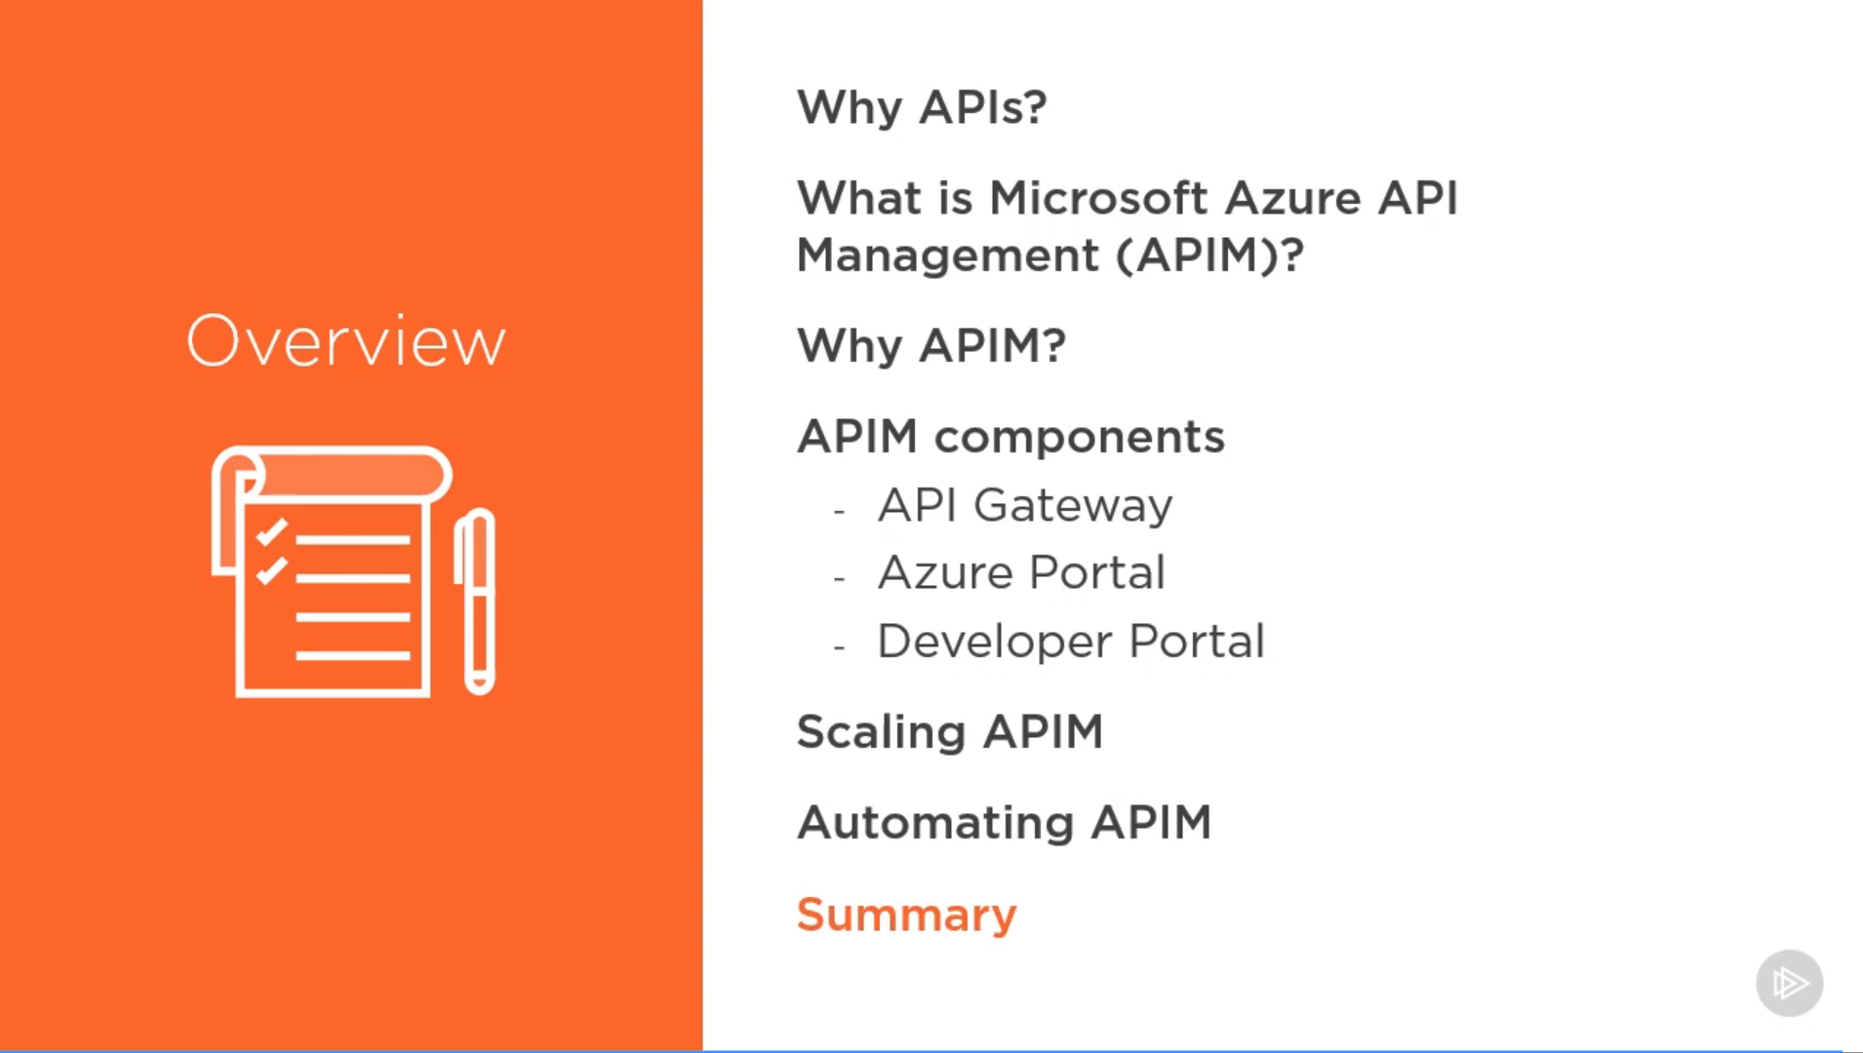

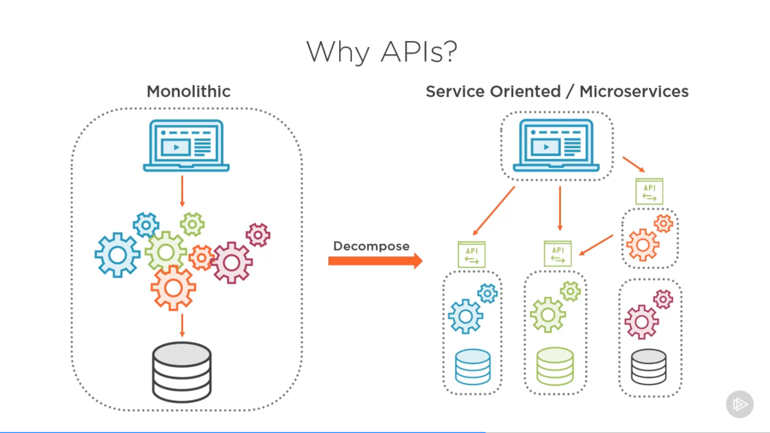

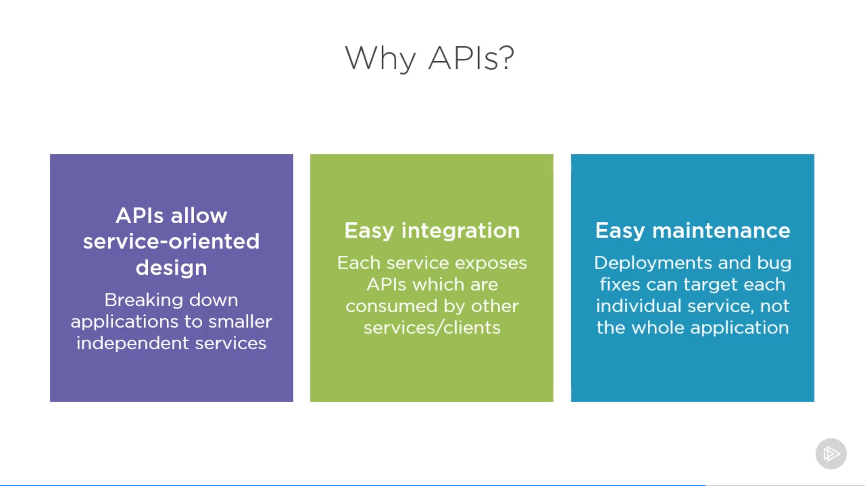

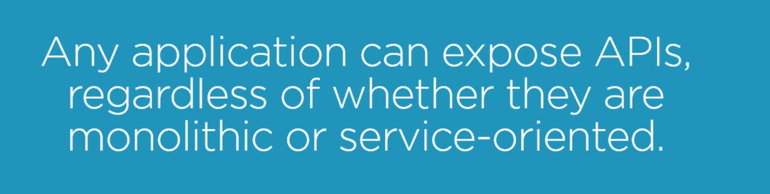

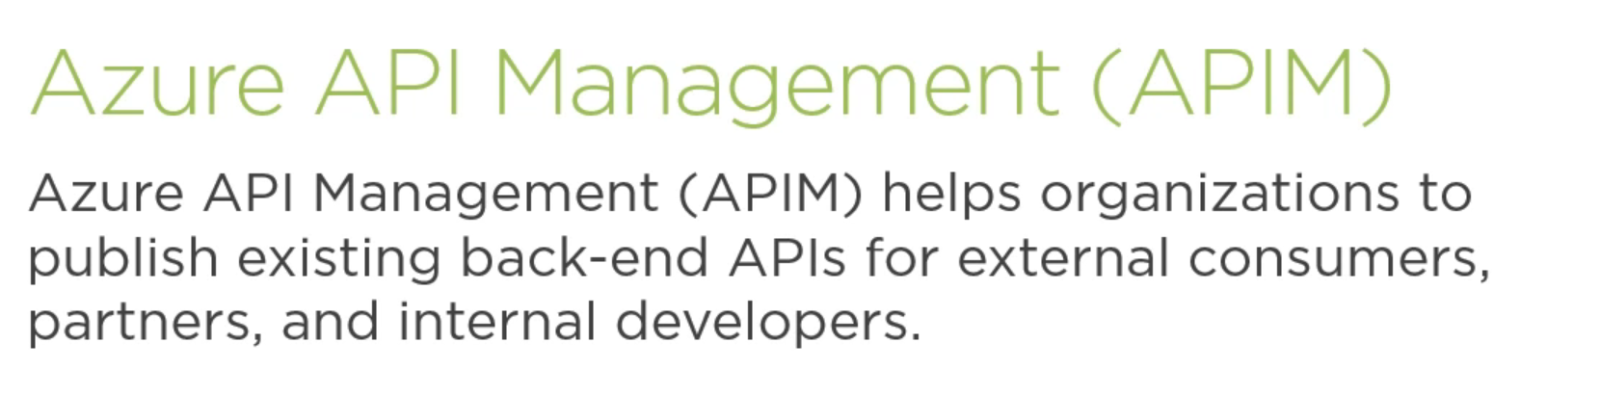

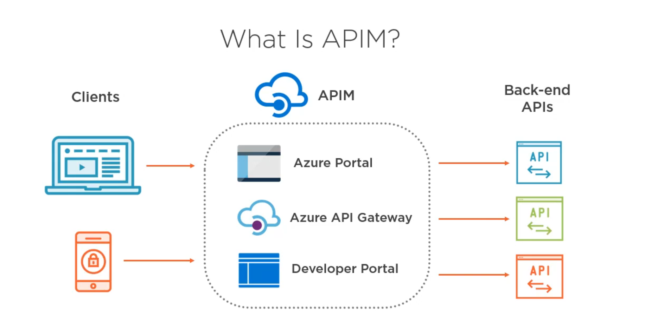

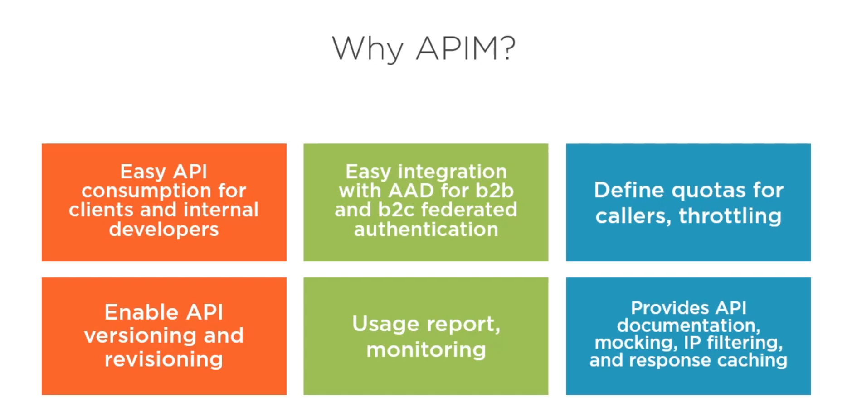

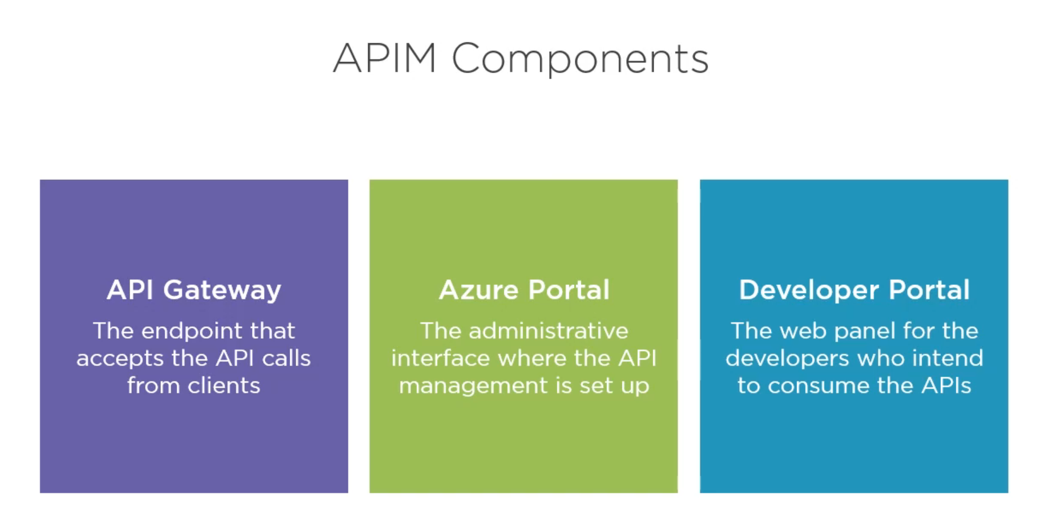

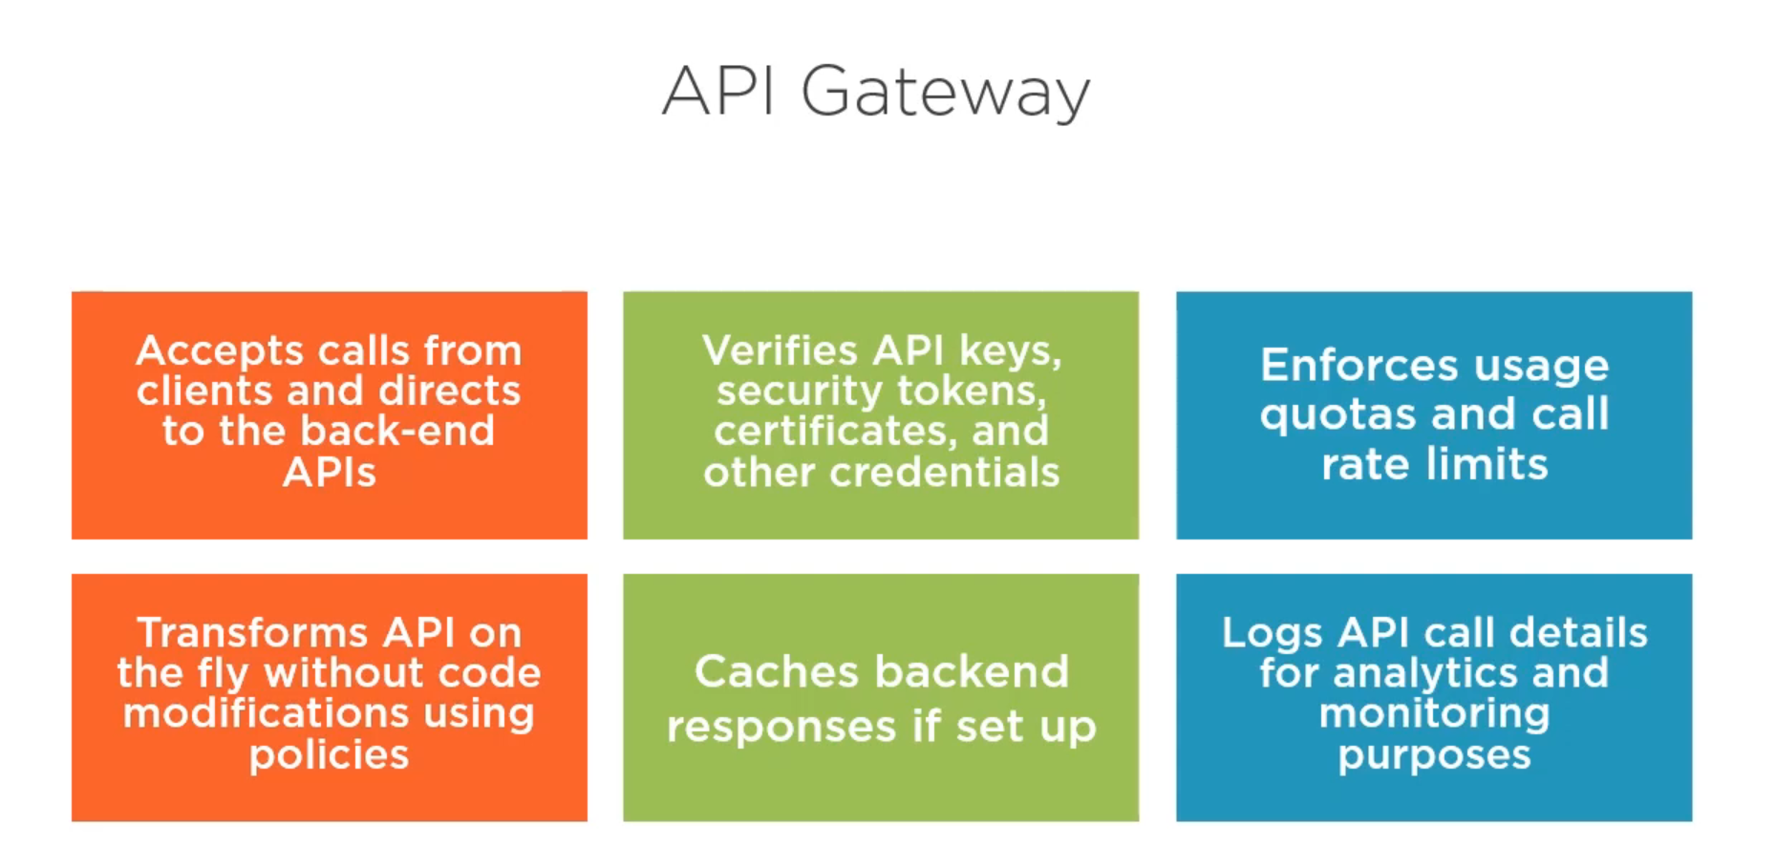

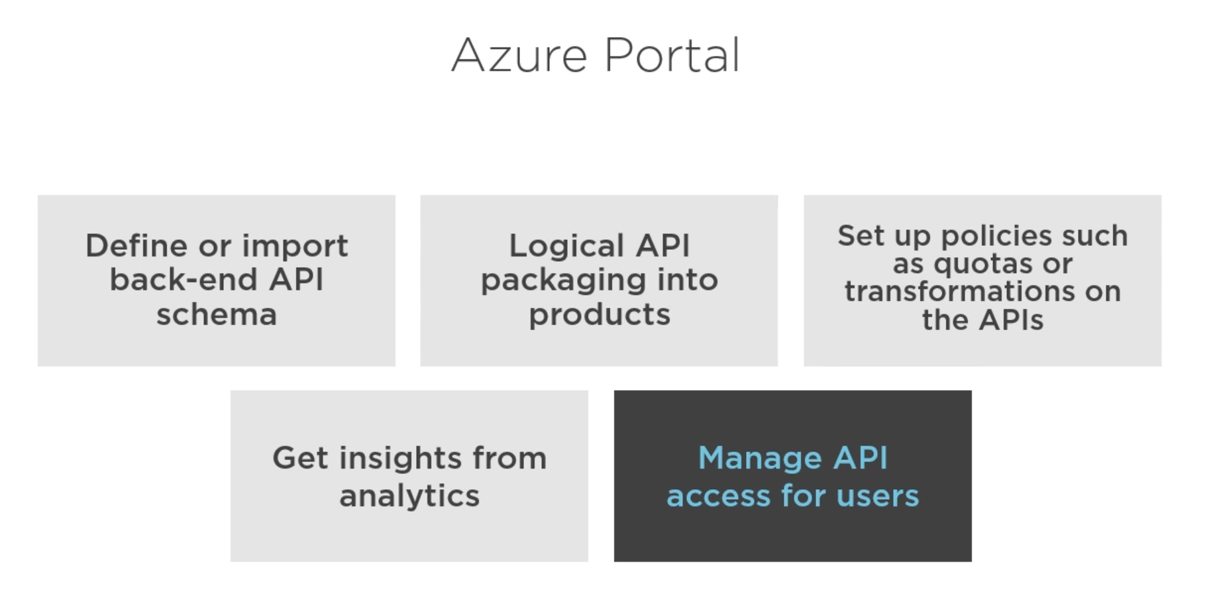

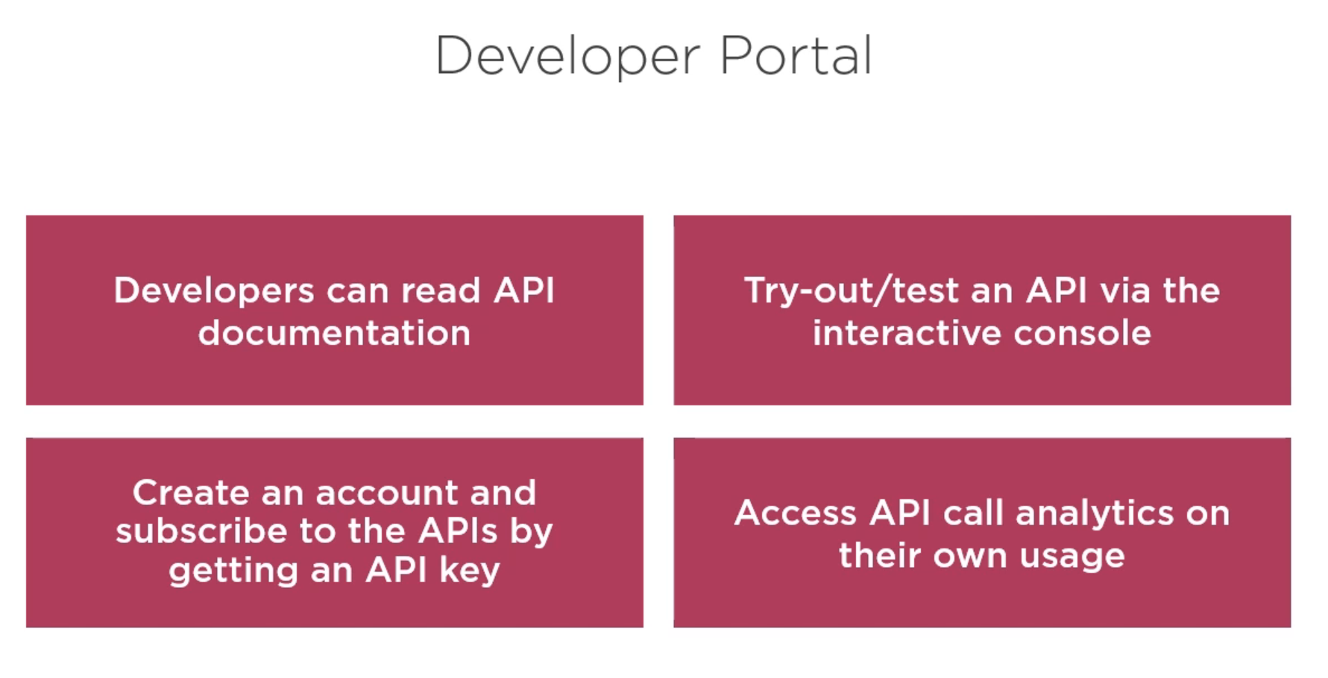

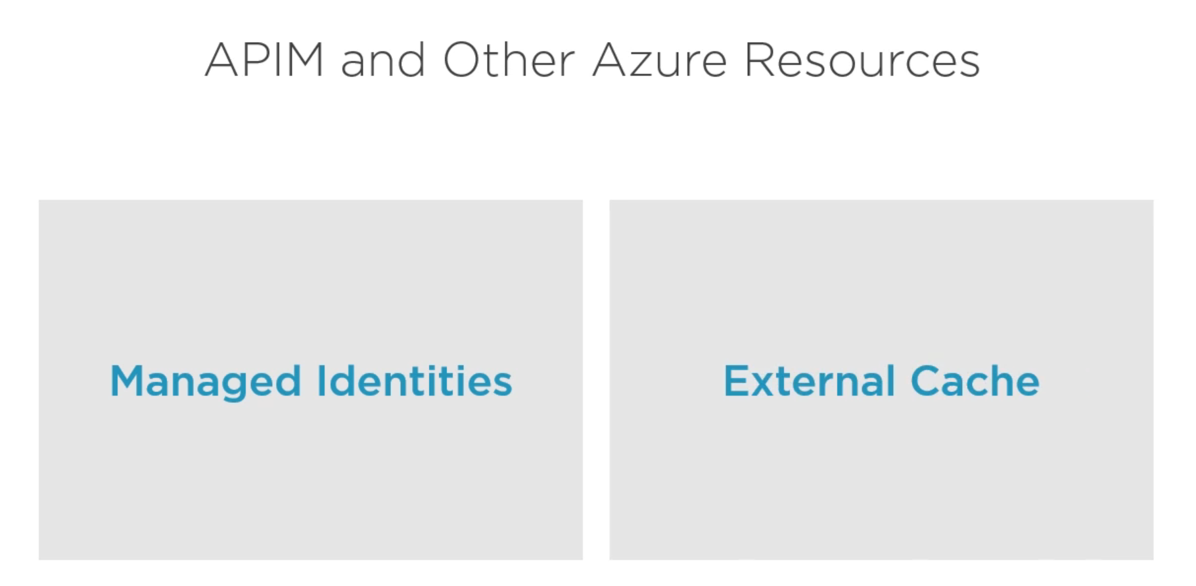

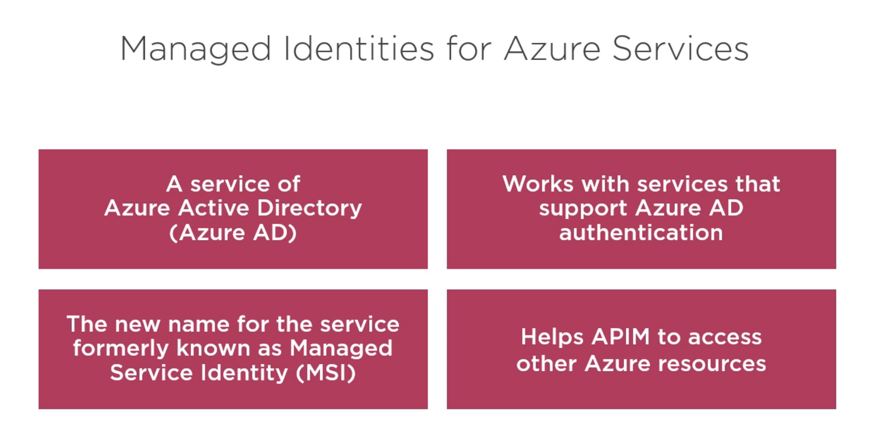

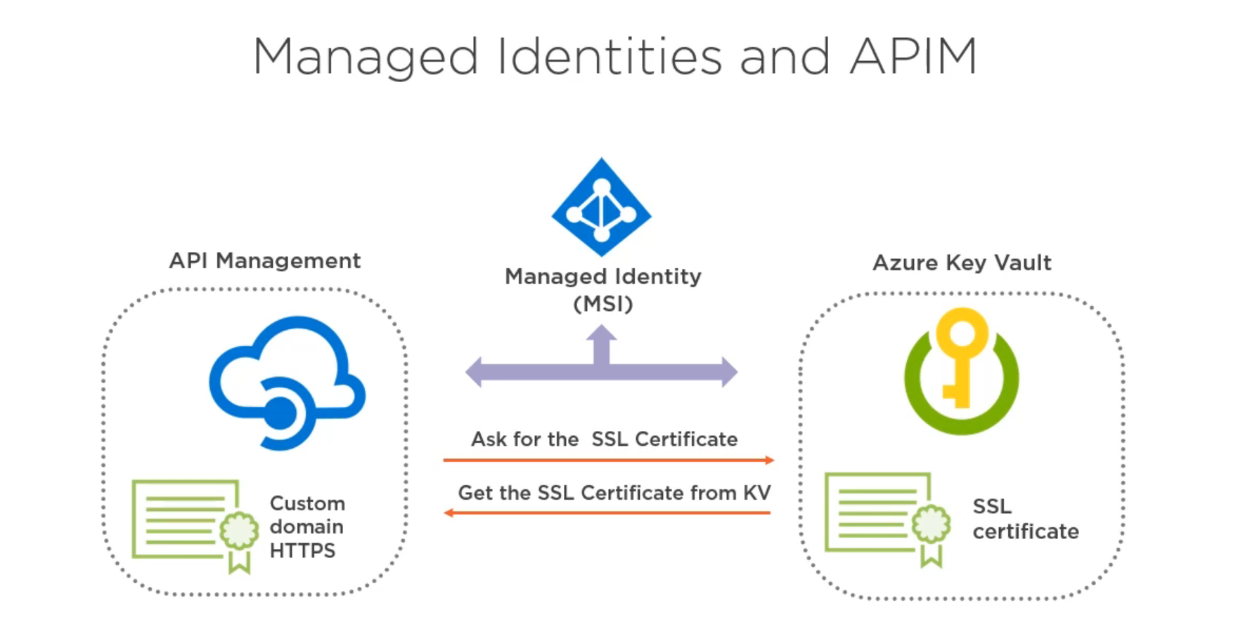

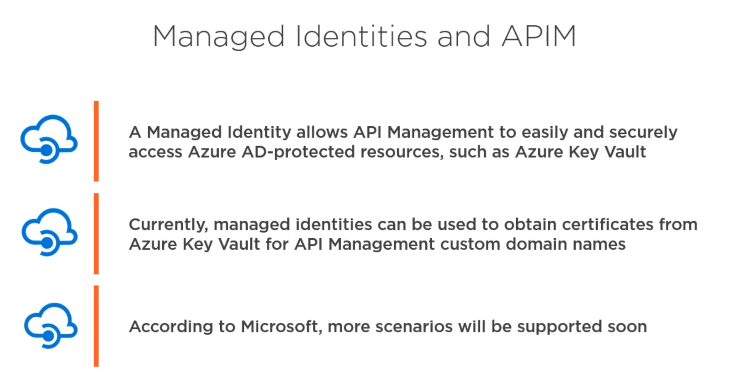

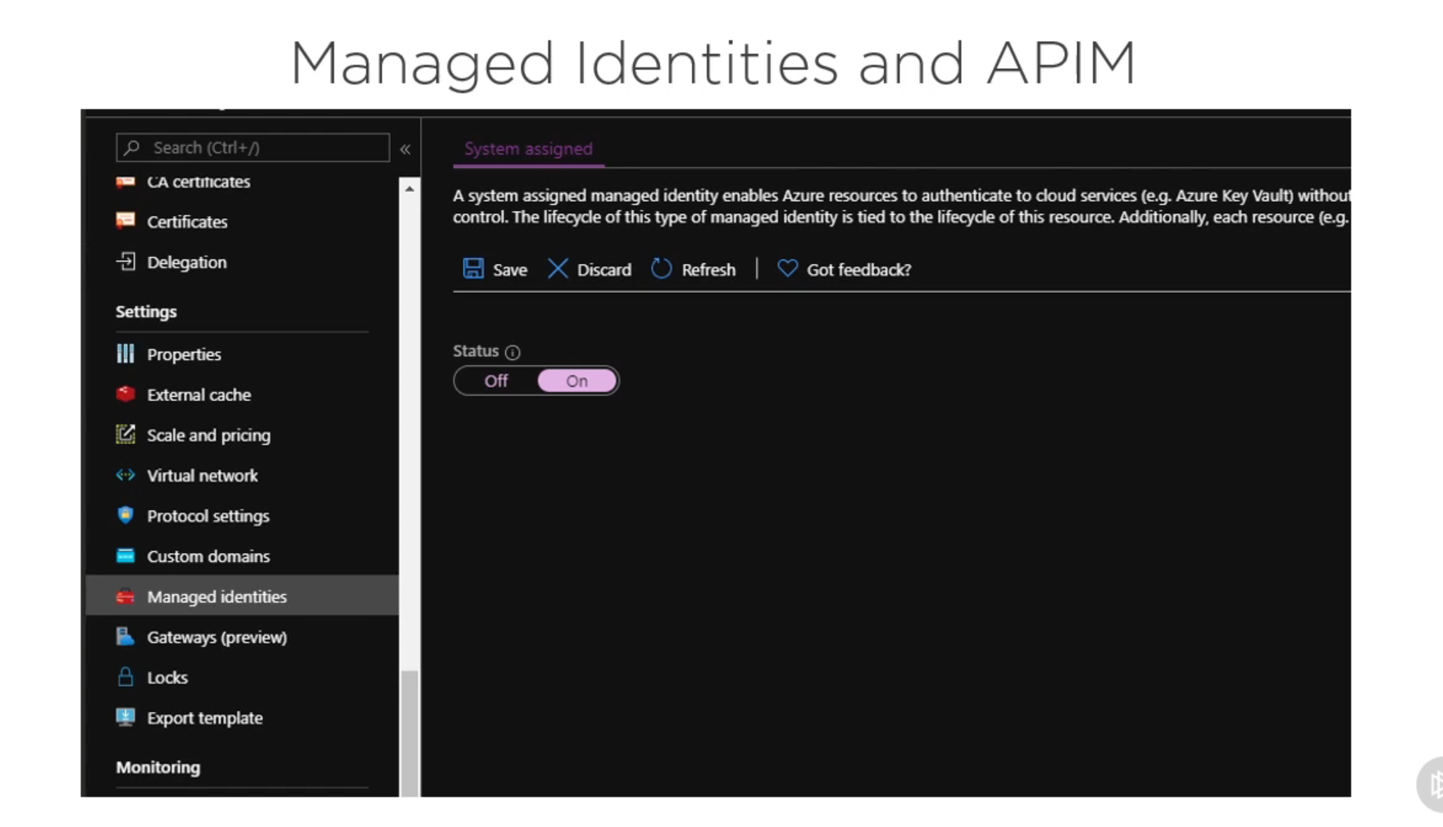

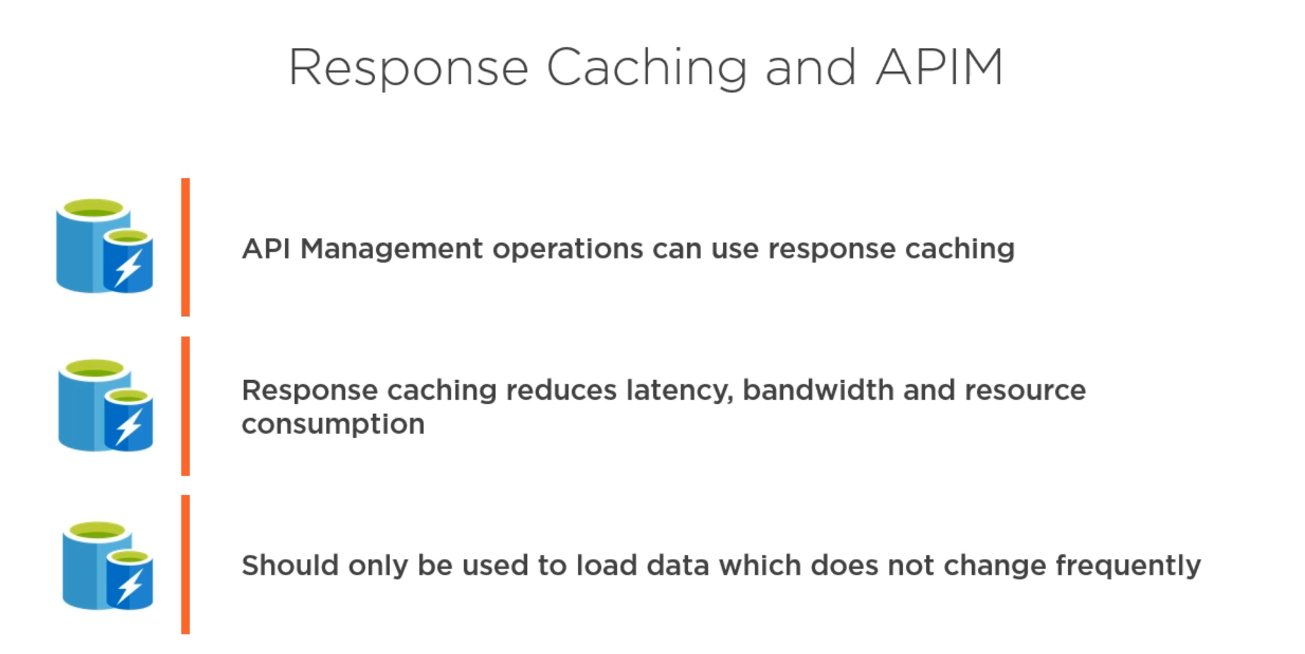

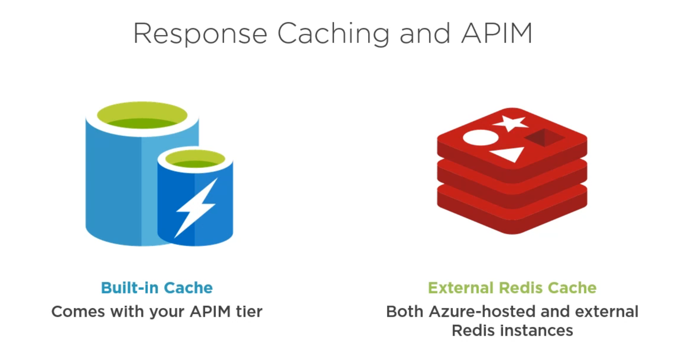

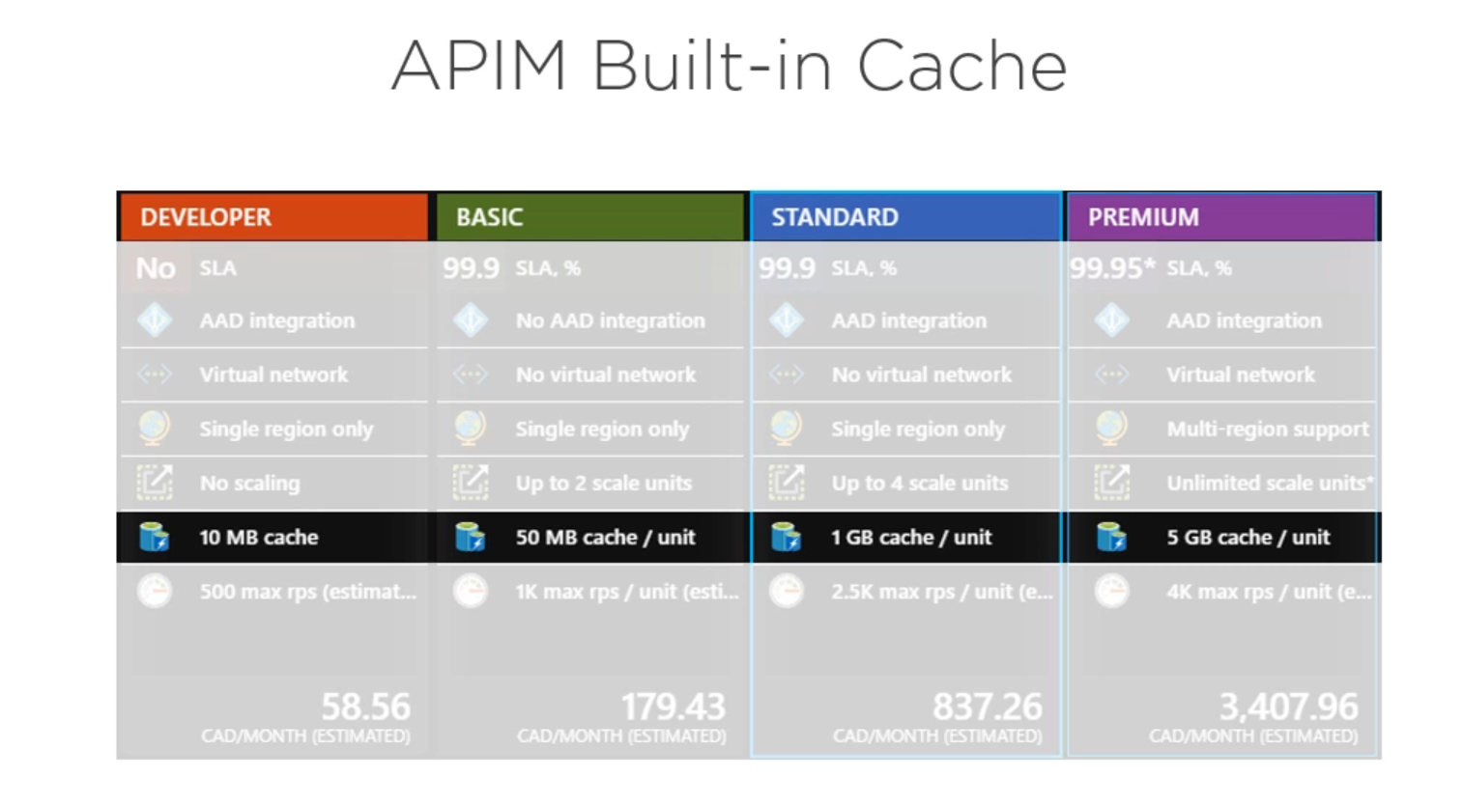



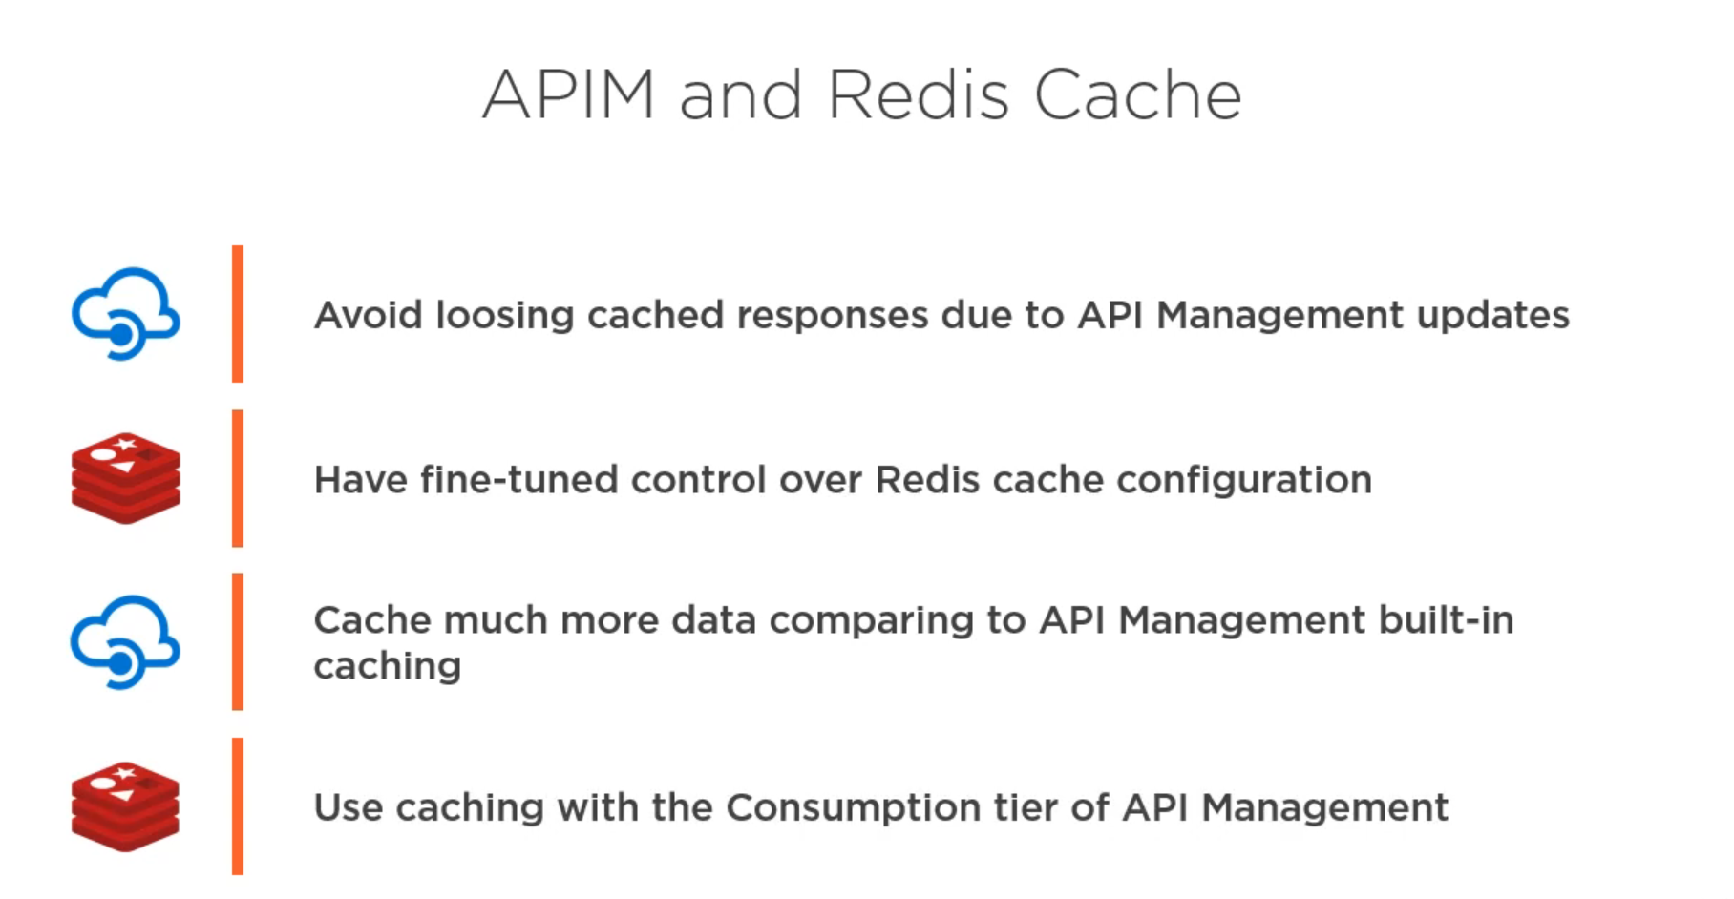

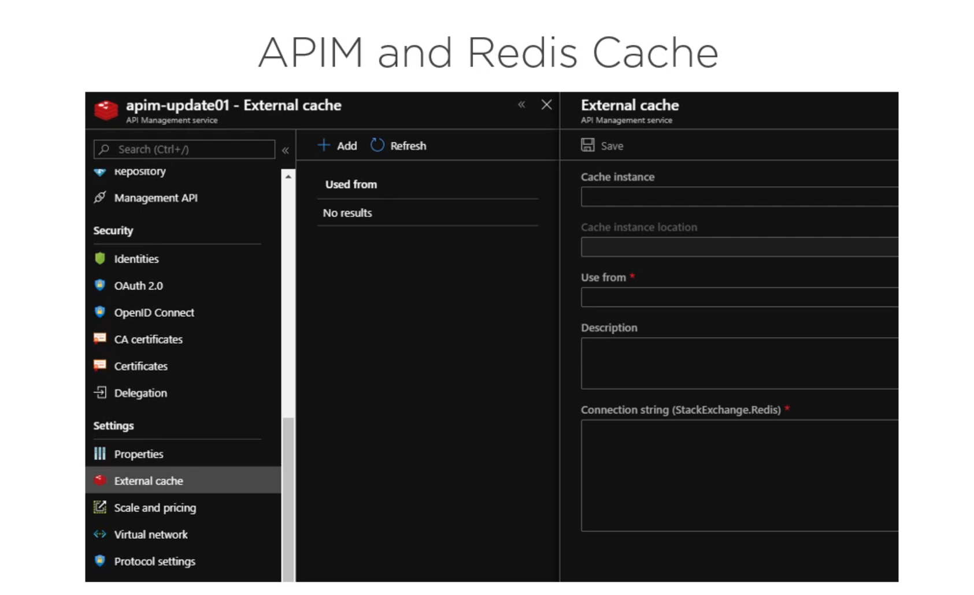

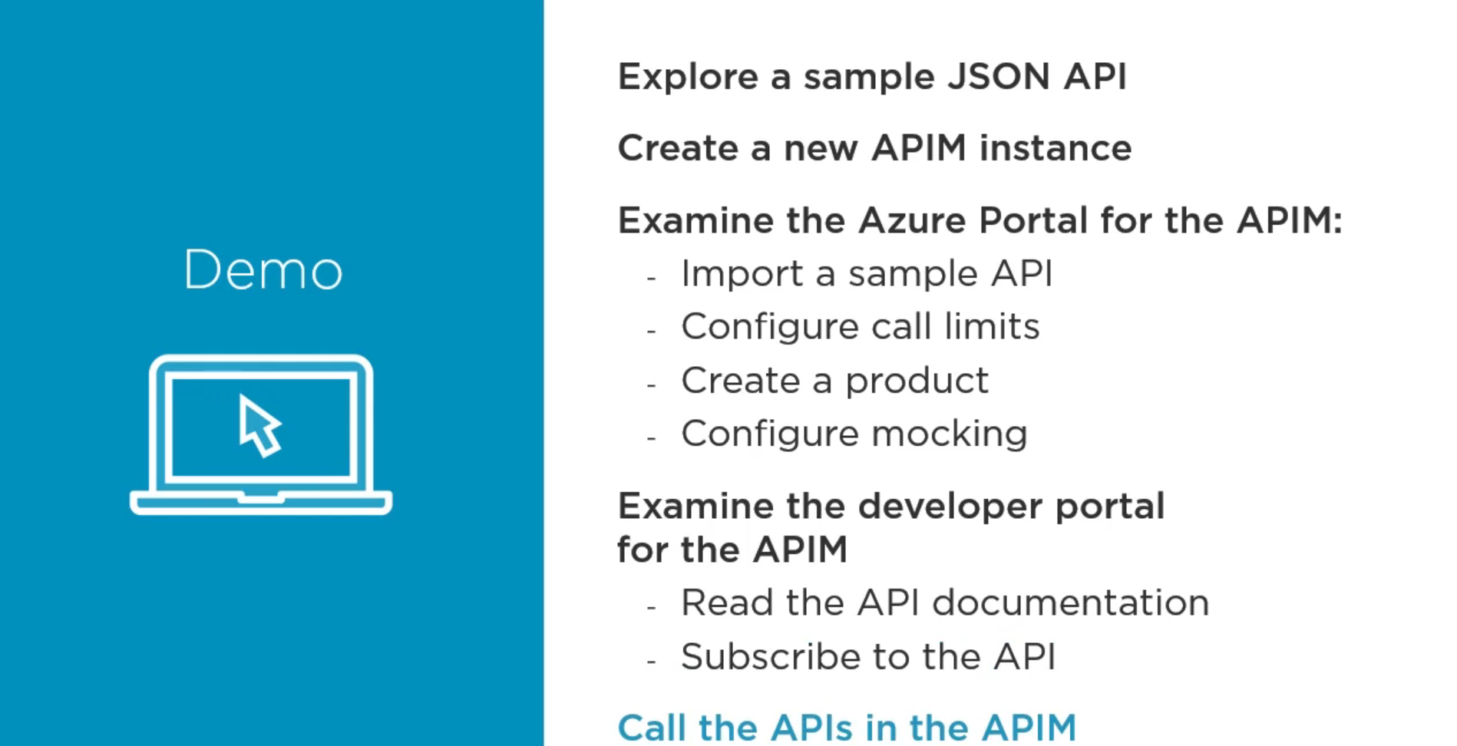

Go to your portal and search for API Management Services.

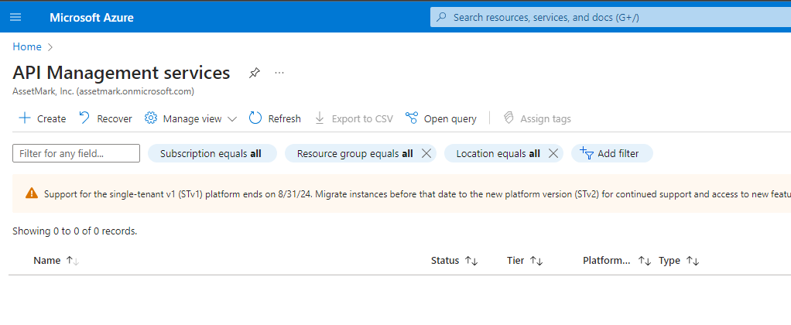

Click on Create

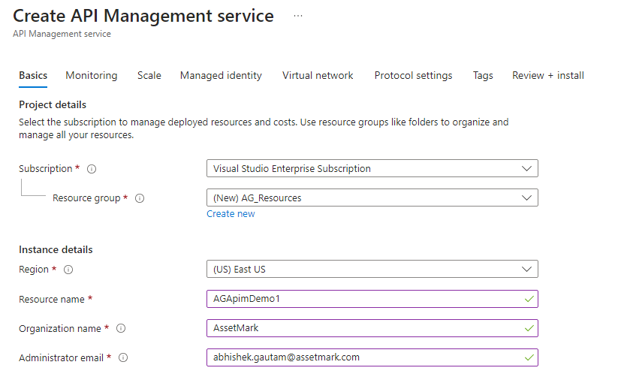

The administrator email will receive all the notifications of the APIM instance.

Click on Create.

It will take around 20 minutes to deploy an APIM.

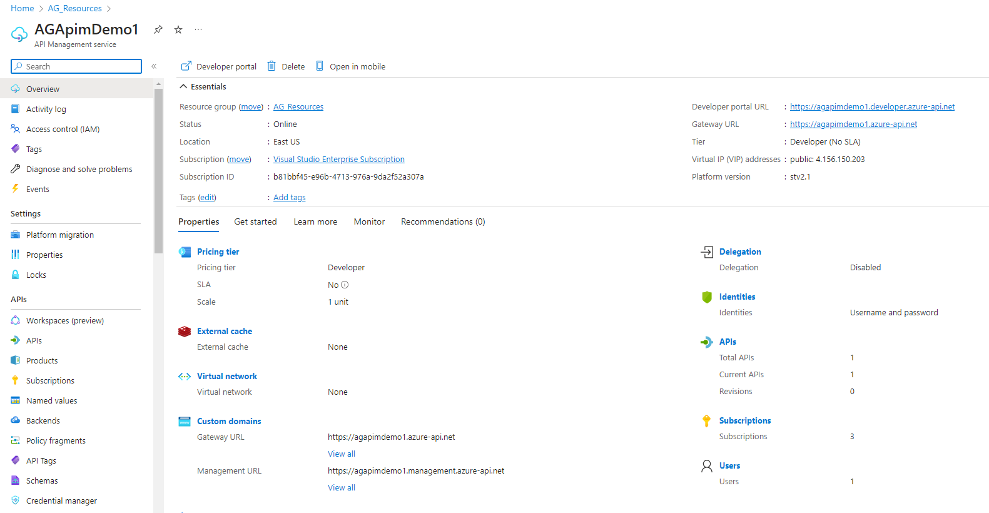

Go to the API tab from the left panel and create a new API form OpenAPI

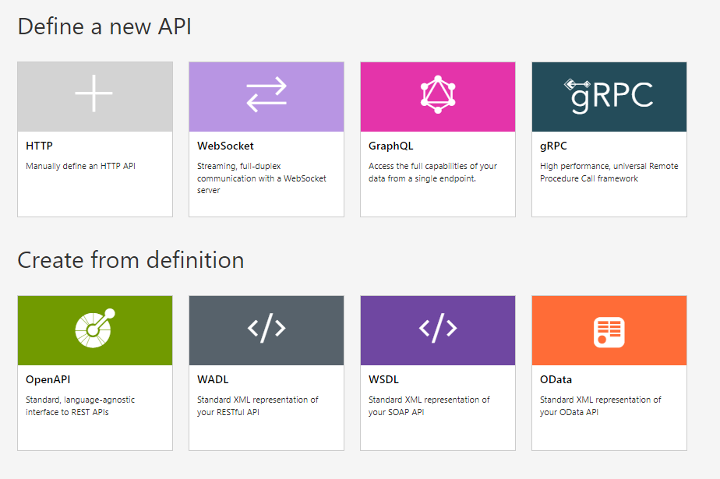

This the window you will face.

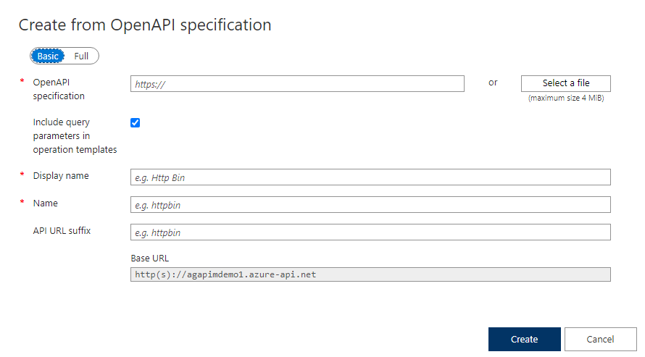

Fill out the URL as :- <https://conferenceapi.azurewebsites.net/?format=json>

This is an API exposed from the azure itself.

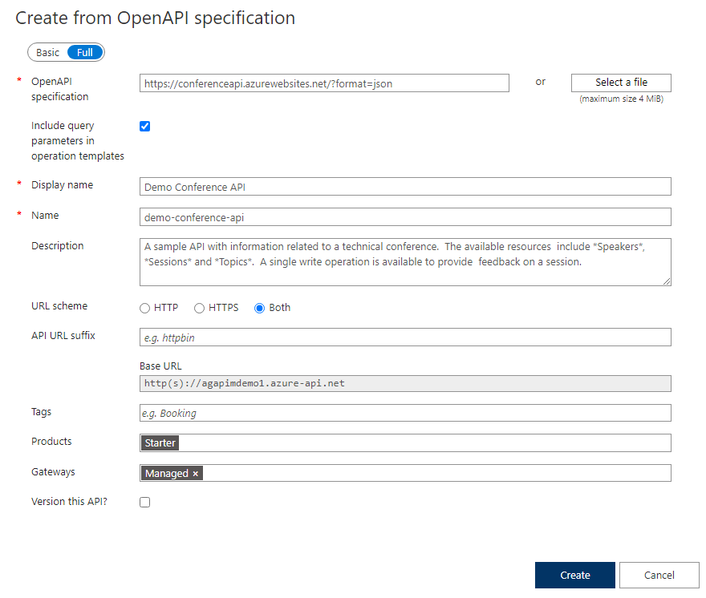

Once you have created the API, your APIM will look something like this

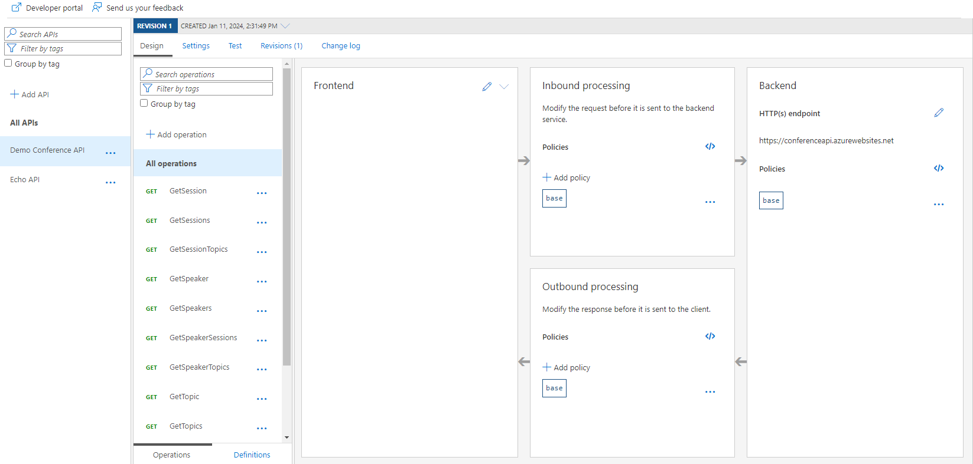

Inside this Demo Conference API you have several operations present.

Now to test any operation inside this API, click on test and then send a request

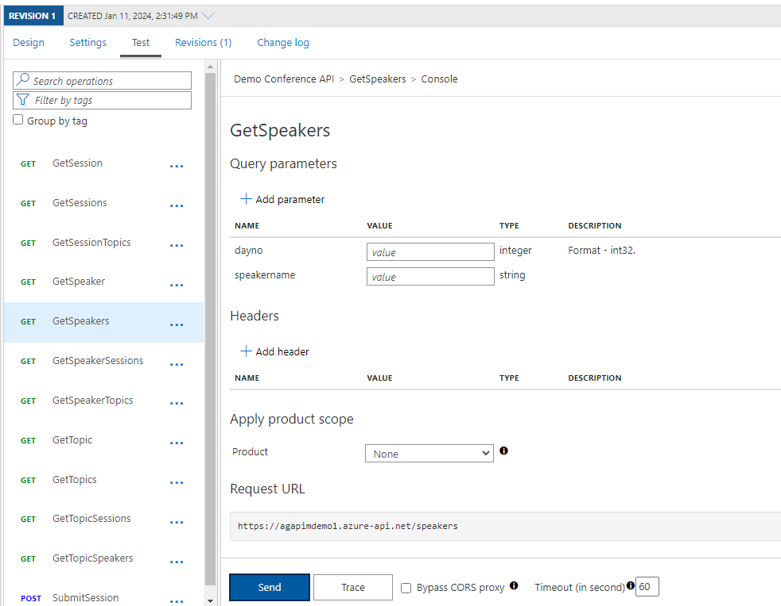

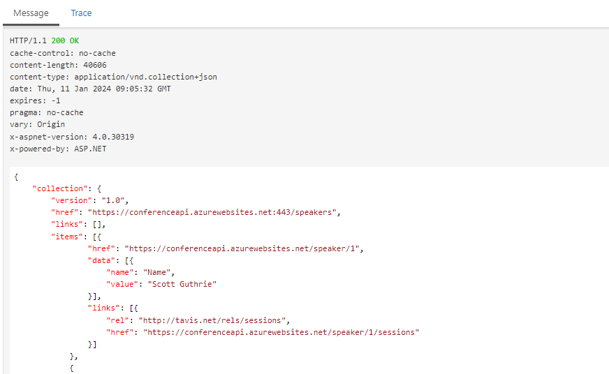

You will get the response

Now let’s create Products (Products are the logical container for the api’s, using products we can divide api’s into logical containers and we can provide authentication or specific policies to these products)

Click on products on the left panel and then add.

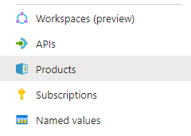

Add our API to this product and hit create.

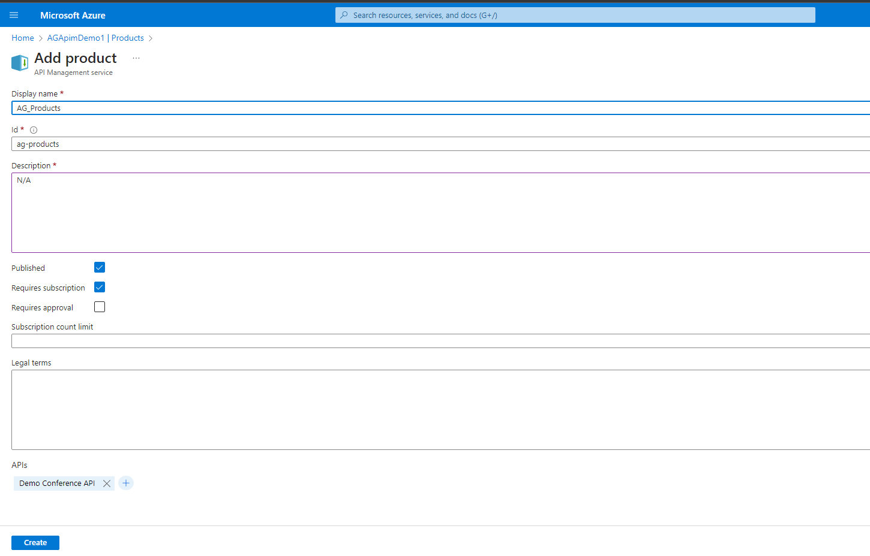

Once the product is added, you can go back to our API and then click on settings, you can see that the new product is visible to the API.

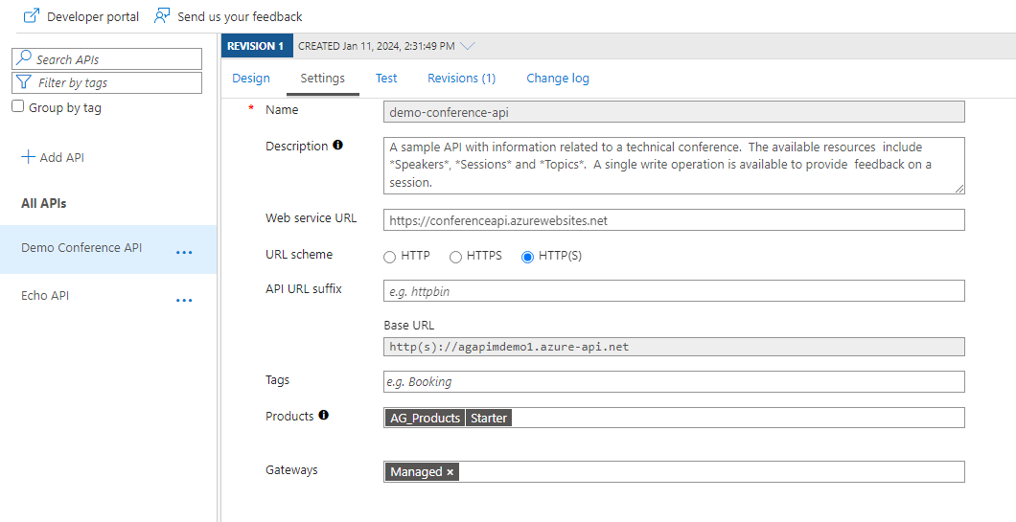

Now let’s add some policies to our API.

Click on the operation and then, you can see three types of policies that we can add in here.

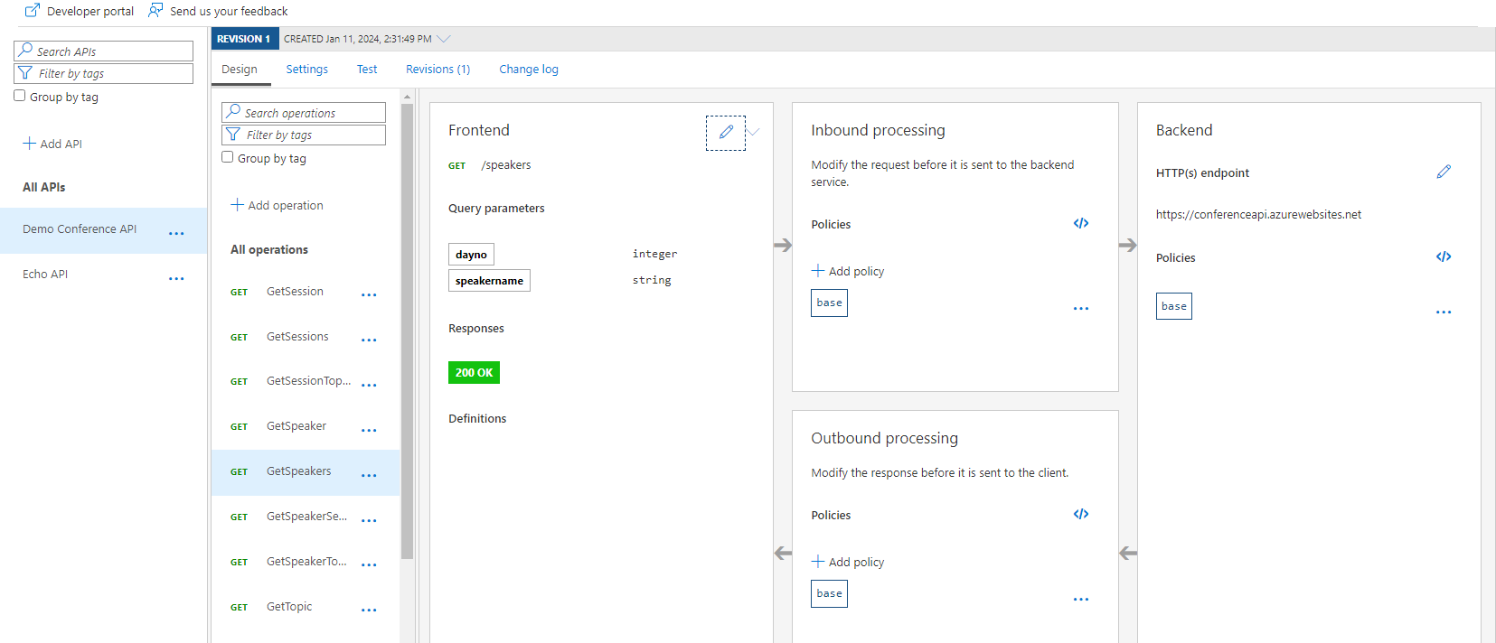

Inbound (Policies before sending the client’s request to the backend, we can do some modifications to the actual request),

Backend (policies applied before sending the request to the backend) and

Outbound (policies to modify the response before sending it to the client).

When you click on add in Inbound policy you’ll get the following options.

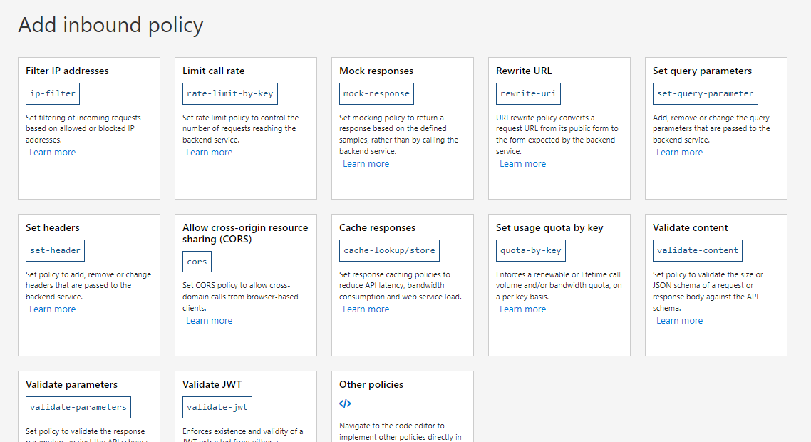

We are adding a limit call rate.

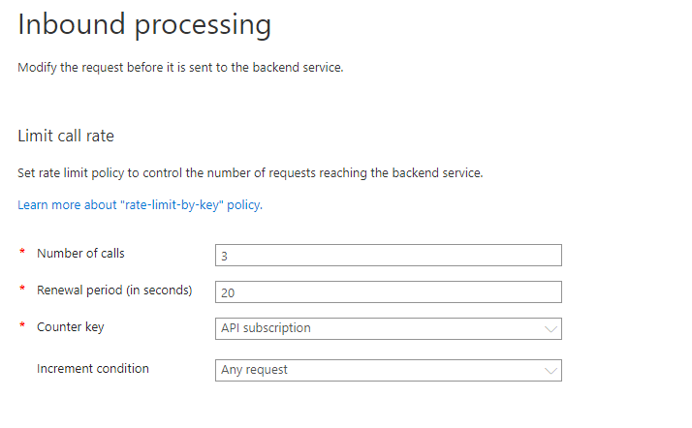

Any subscriber can call this API 3 times within 20 seconds.

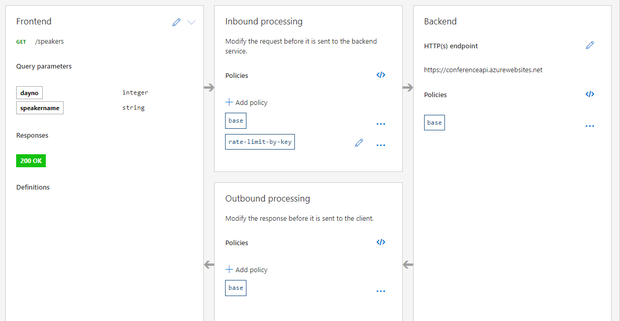

You can see the new Inbound processing policy is added.

To see the backend code you can just click on this.

It’s policy code editor.

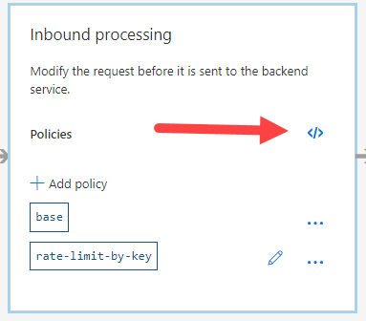

Once you click on it, you’ll get an editor and here you can see that our policy that we just added.

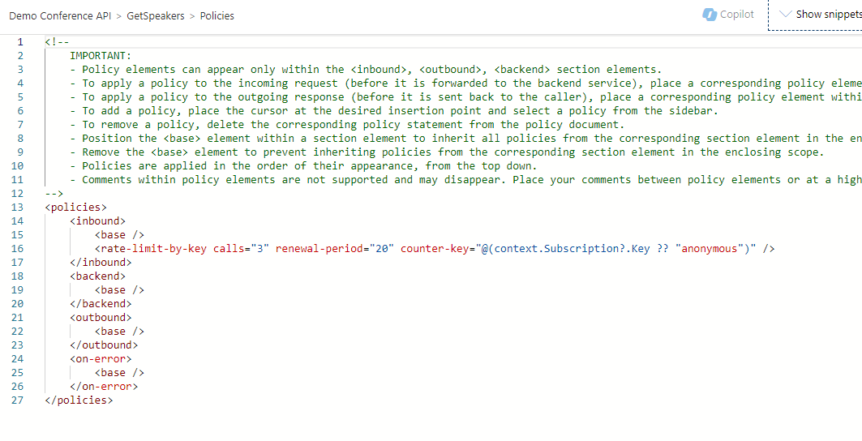

Now let’s try our policy, go to the developer’s portal.

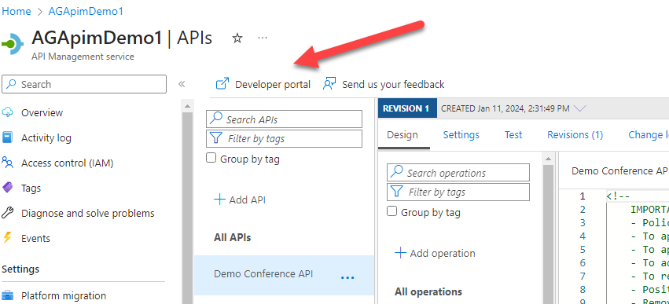

Can’t find the proper link of Developer portal.

Now let’s add another API (blank) on our APIM

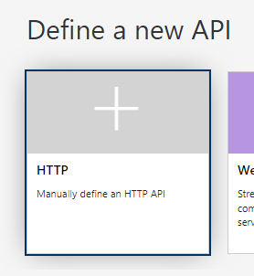

New api is added

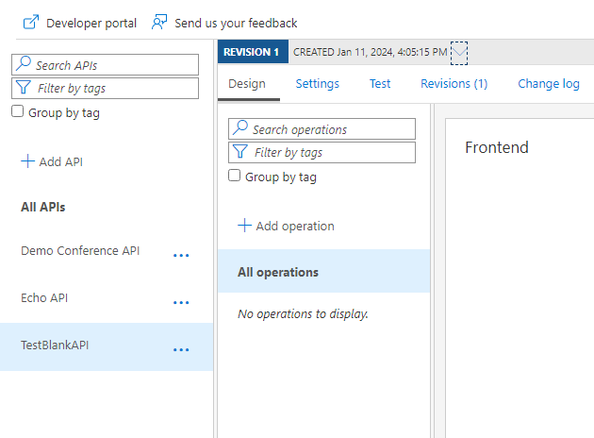

Don’t forget to add the product since without that we will not be able to publish it.

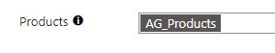

Now let’s add a new operation inside this API.

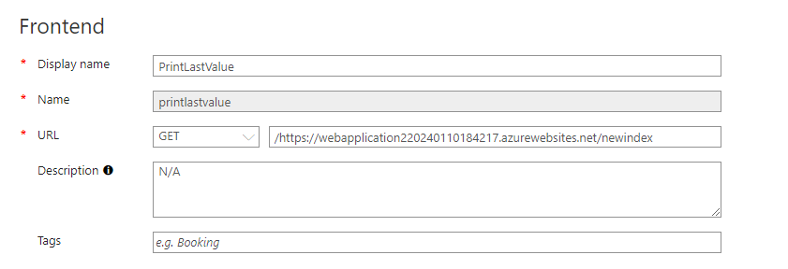

Add any url in there.

Add a response in here

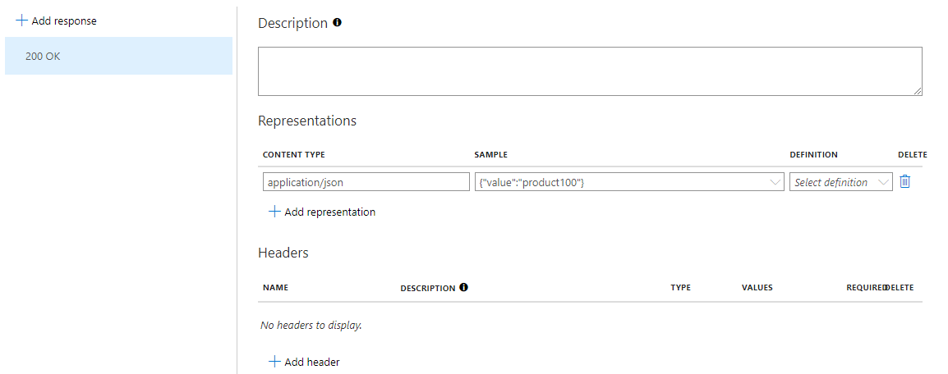

Specify the content type and sample.

Now let’s add policies to this operation. We are now adding a Mock Response Inbound policy to this operation.

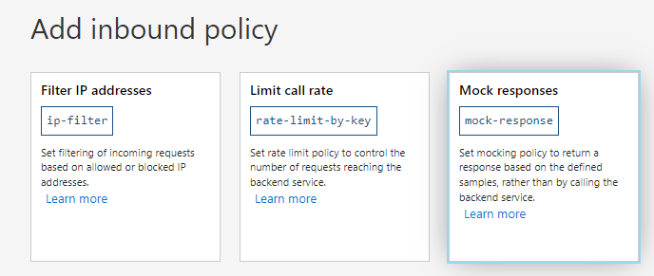

Your response that we have added will show here and just click on save.

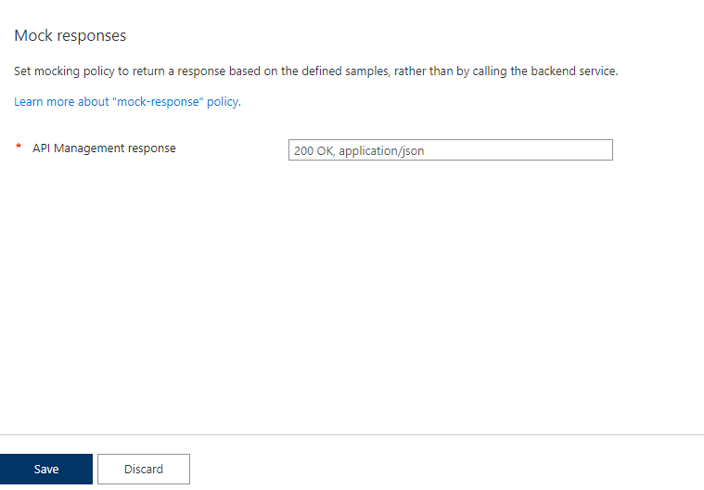

This is used when the backend is not ready but the frontend/client needs something to start, we can mock the response, and the client can move forward with it.

You can again test it on the developer’s portal.



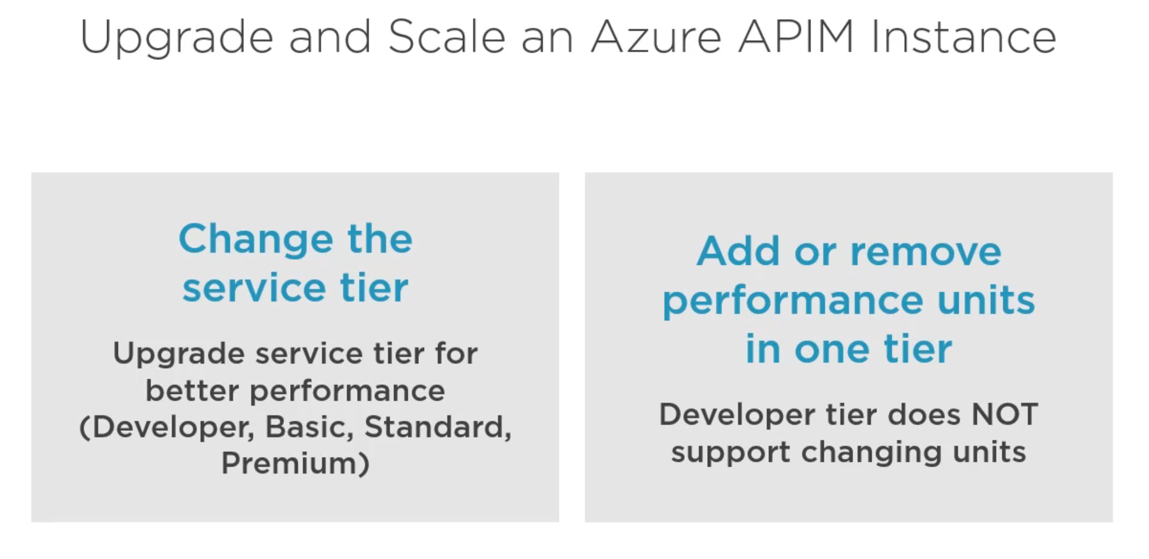

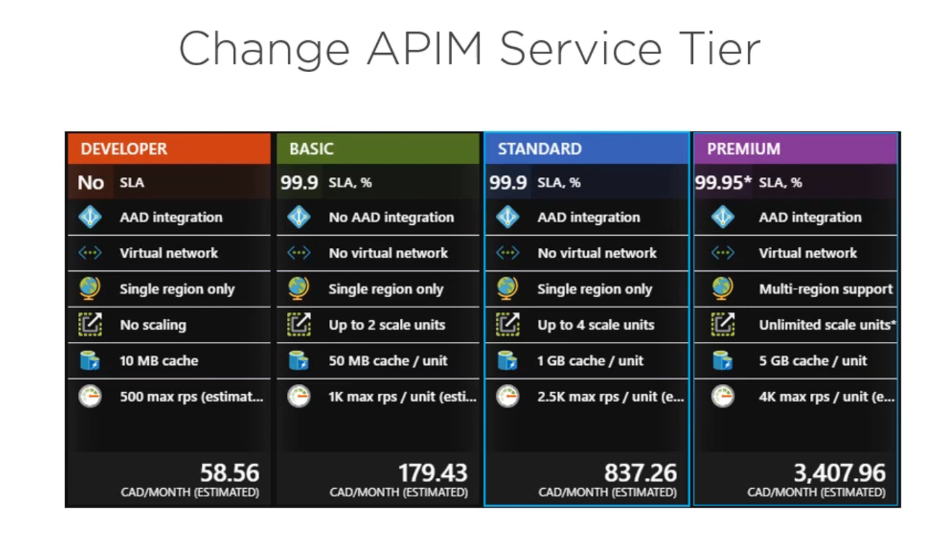





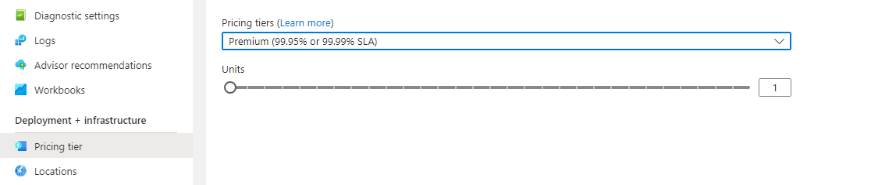

SLA :- Service Legal Agreements.

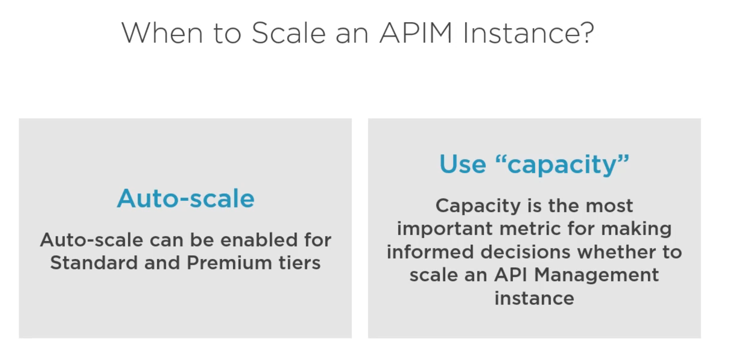

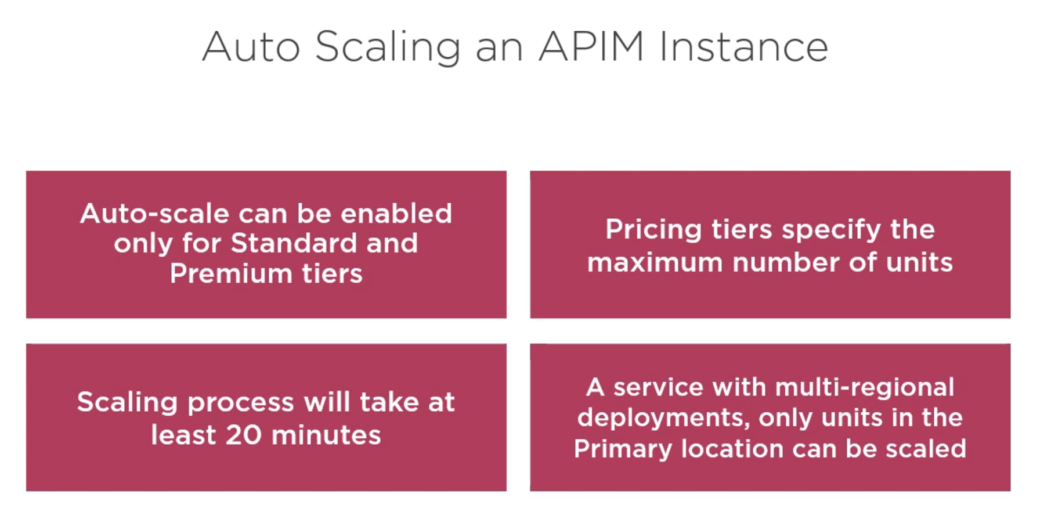

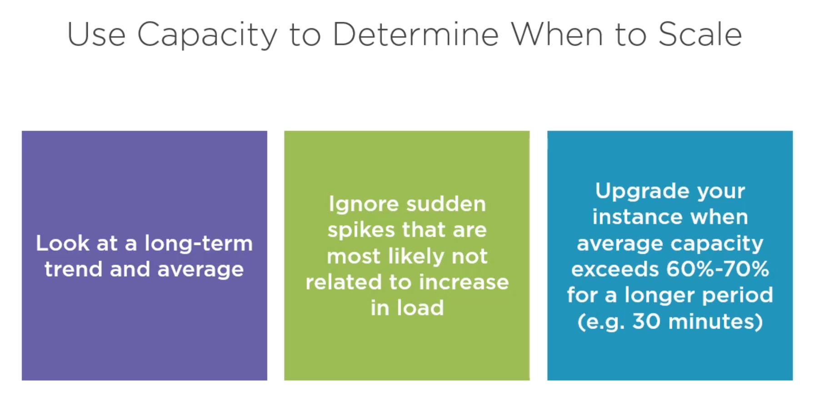

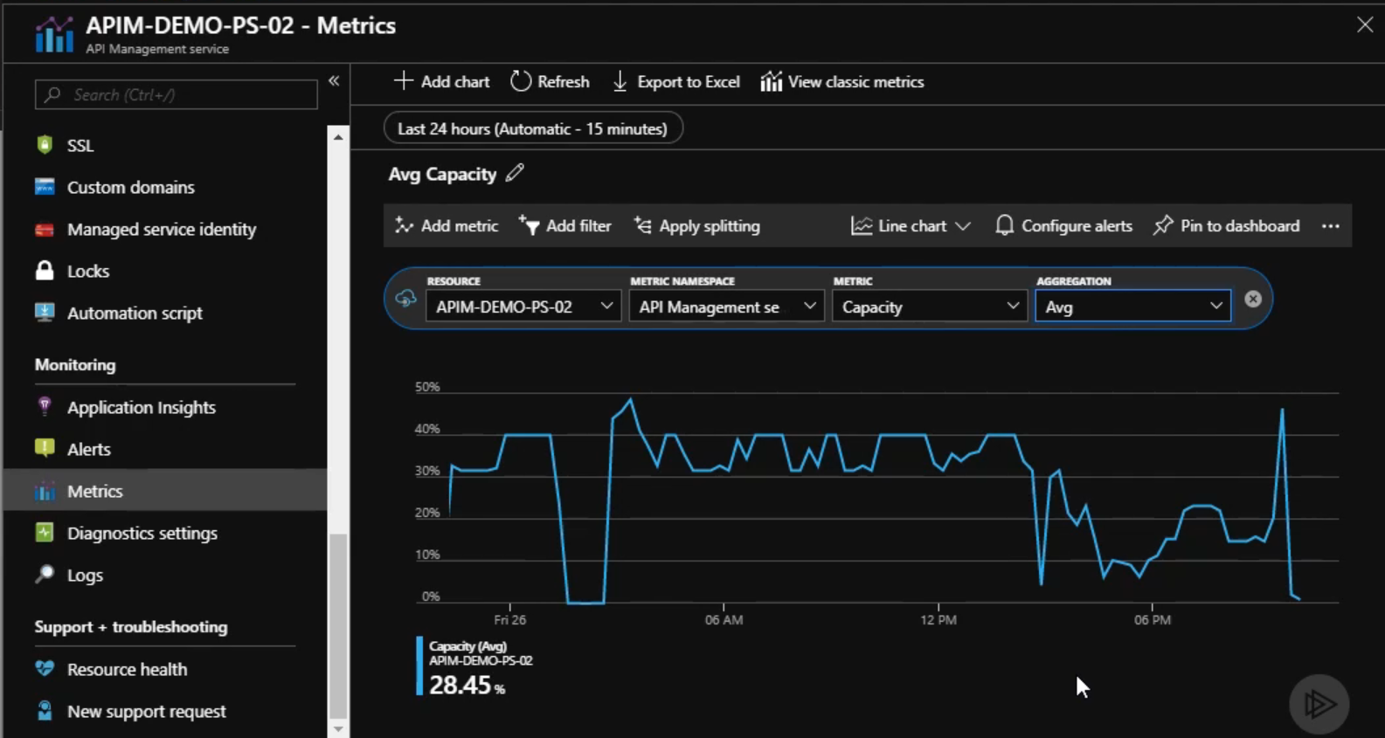

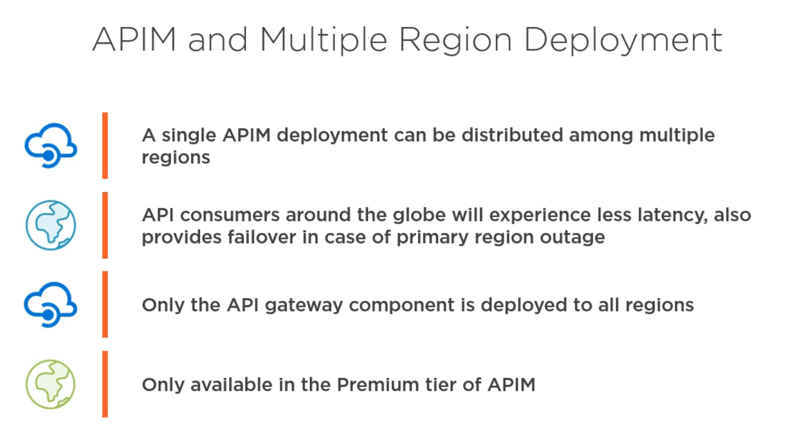

(Can only be configured in Premium tiers)

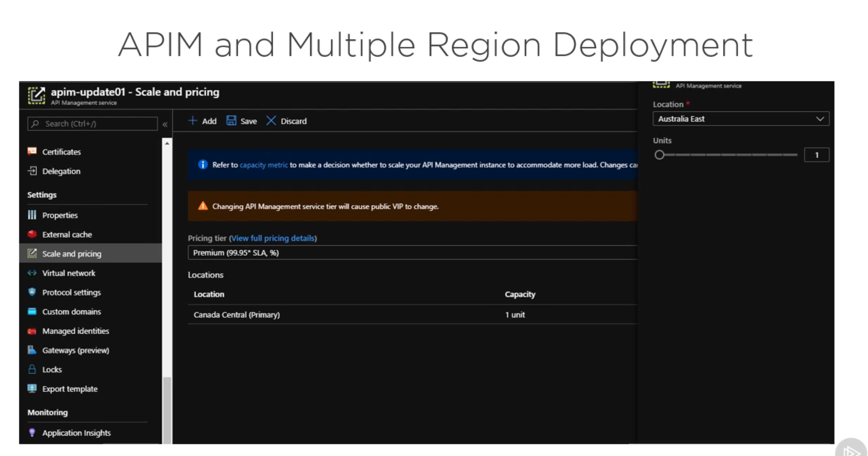

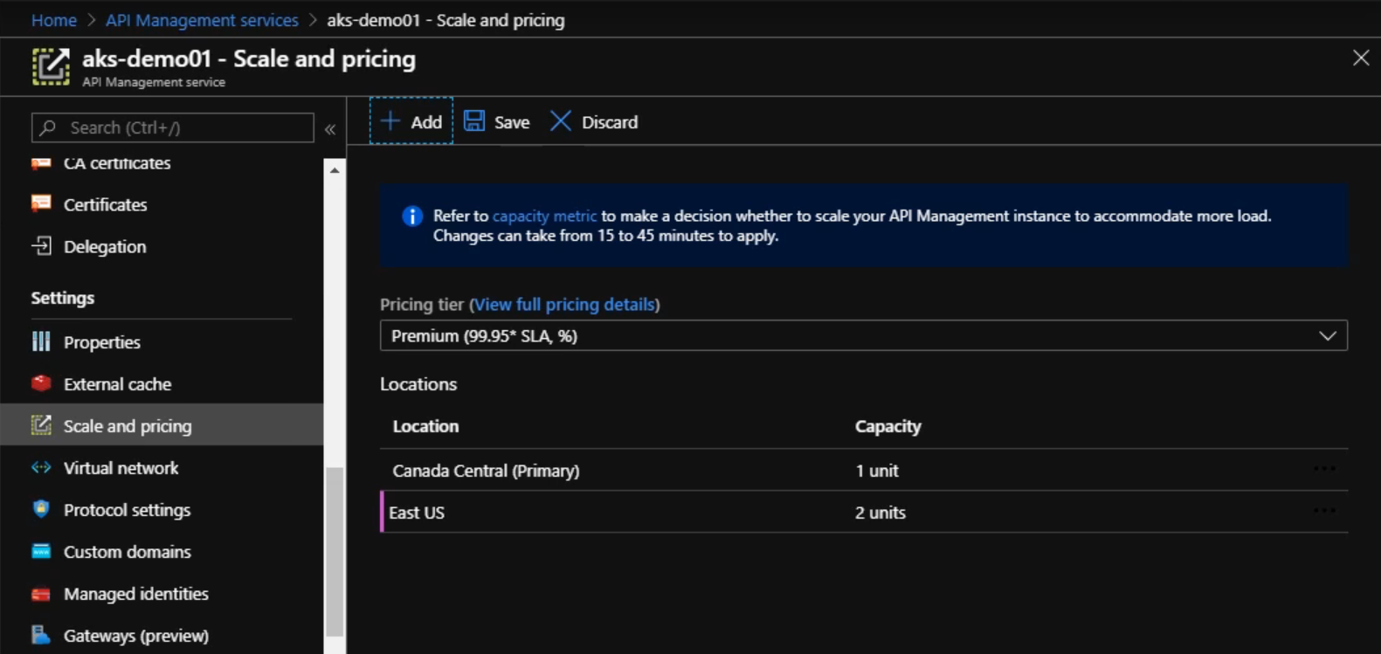

Now if I have my APIM deployed in multiple regions but we don’t have that actual backend API at these locations, then we can’t have the full benefit of it.

We have to configure the echo API for this.

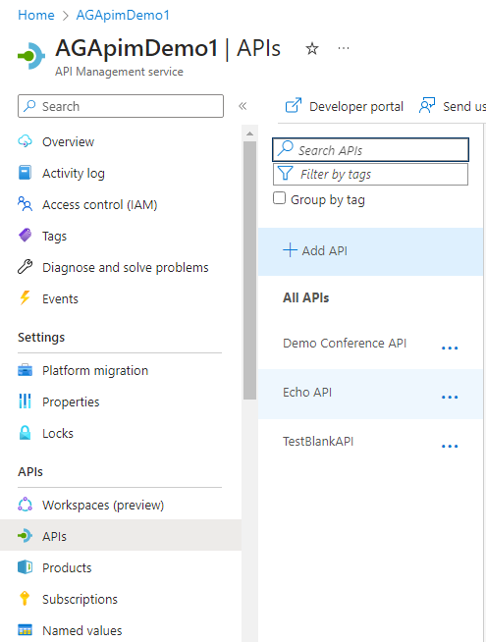

Inside your echo API inbound policy code your policies will be added to use the backend API of the same region where it’s getting the call from the APIM of the same region.

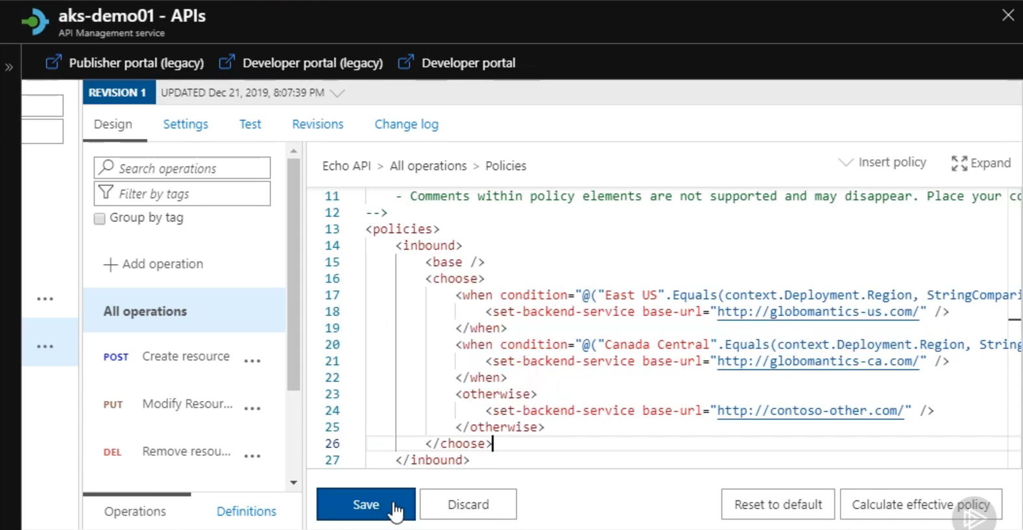

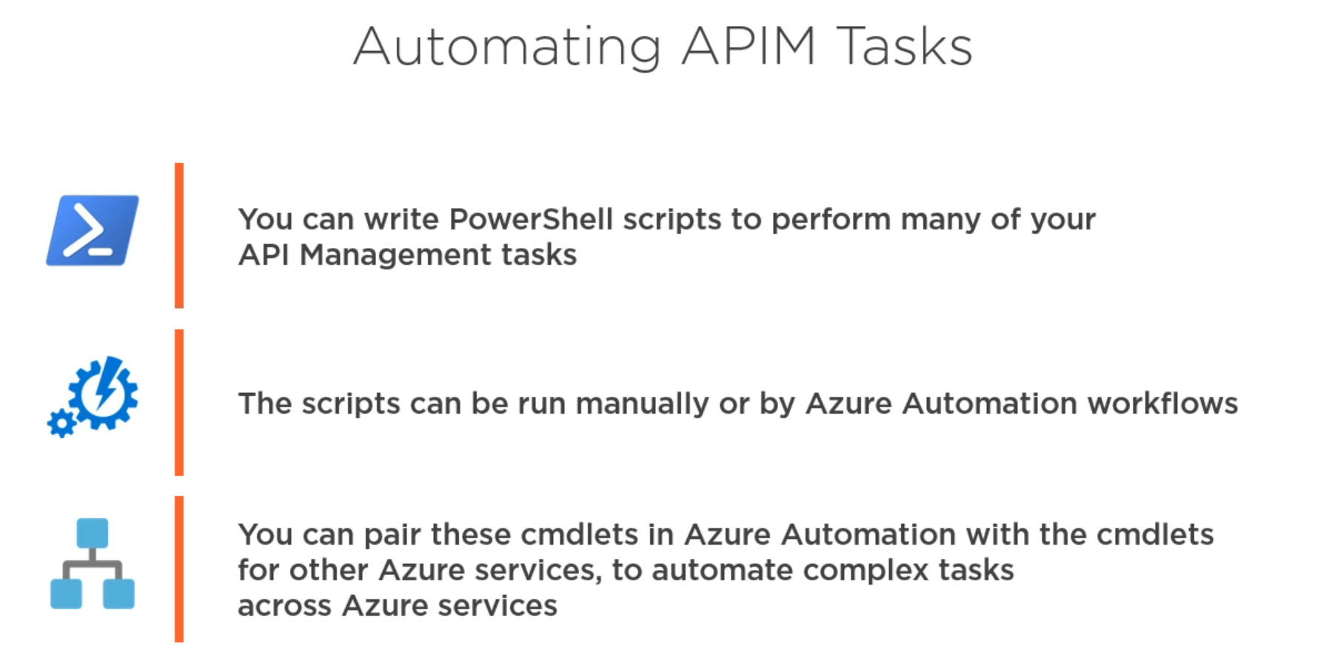

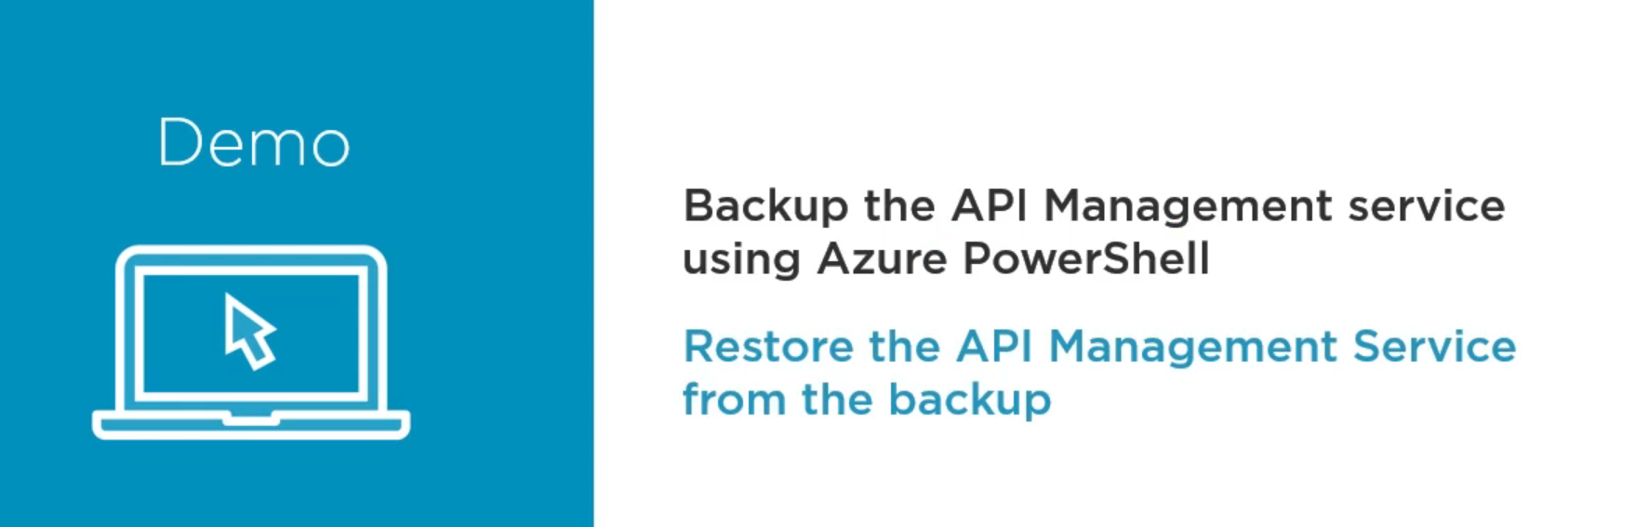

We can have the complete backup of the APIM stored inside the blob storage.

And reapply it when required.

You have to create the storage account and blob storage inside it and then add all these values inside the command and execute it.

First you need to login to azure portal from powershell:_

Connect-AzureRmAccount

(If you are running these commands for the first time then you need to execute :-

Install-Module -Name Az -AllowClobber

Import-Module Az

Connect-AzAccount

)

If you have multiple subscriptions then connect to the active one.

az login

az account list --output table

az account set --subscription <subscription_id>

Powershell command to create the backup:-

$storagekey = (Get-AzureRmStorageAccountKey -ResourceGroupName “” -StorageAccountName “”)[0].Value

$storageContext = New-AzureStorageContext -StorageAccountName “” -StorageAccountKey $storageKey

Backup-AzureRmApiManagement -ResourceGroupName “” -name “” -StorageContext $storageContext -TargetContainer “” -TargetBlobName “”

**How the actual command looks with the values**

$storagekey = (Get-AzureRmStorageAccountKey -ResourceGroupName “AG_Resources” -StorageAccountName “agstorageaccountsample”)[0].Value

$storageContext = New-AzureStorageContext -StorageAccountName “agstorageaccountsample” -StorageAccountKey $storageKey

Backup-AzureRmApiManagement -ResourceGroupName “AG_Resources” -name “AGApimDemo1” -StorageContext $storageContext -TargetContainer “mycontainer” -TargetBlobName “mycontainer.apimdemobackup”

Once you have executed all these commands your respective blob will be created inside your container inside your storage account.

Now to restore your APIM from the backup that you have created, the following are the commands :-

Connect-AzureRmAccount

New-AzureRmApiManagement -ResourceGroupName “” -Name “” -Location “” -Orgnization “” -AdminEmail “”

$storagekey = (Get-AzureRmStorageAccountKey -ResourceGroupName “AG_Resources” -StorageAccountName “agstorageaccountsample”)[0].Value

$storageContext = New-AzureStorageContext -StorageAccountName “agstorageaccountsample” -StorageAccountKey $storageKey

Restore-AzureRmApiManagement -ResourceGroupName “” -Name “” -StorageContext $StorageContext -SourceContainerName “” -SourceBlobName “”

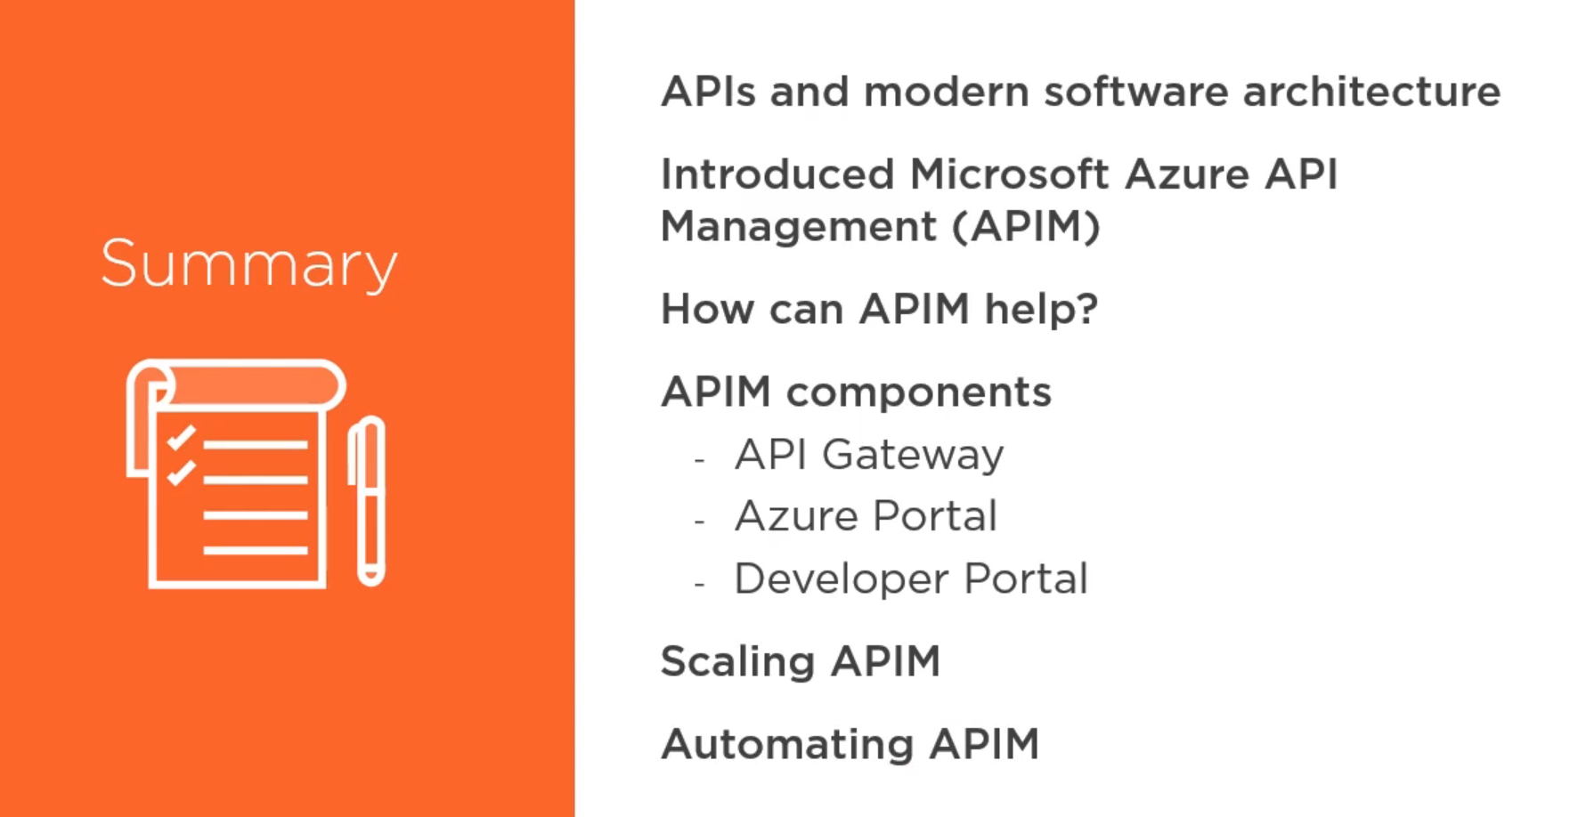

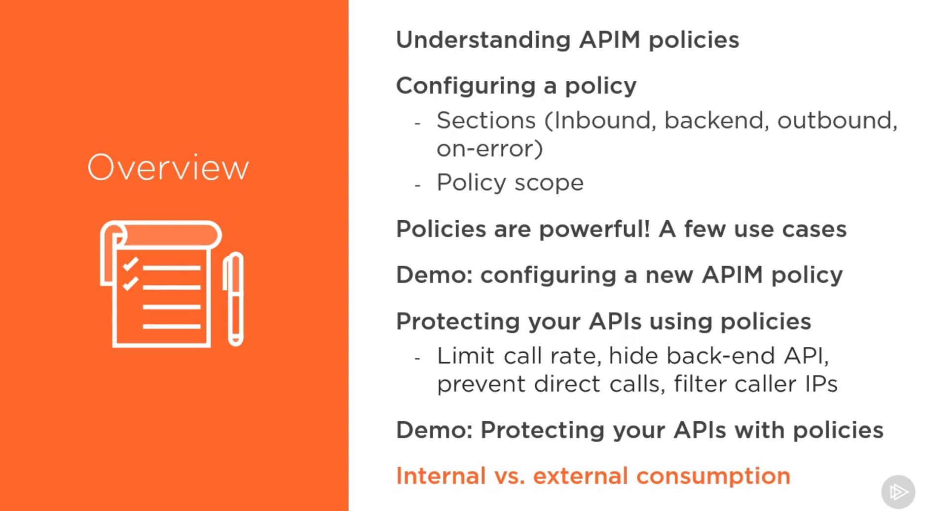

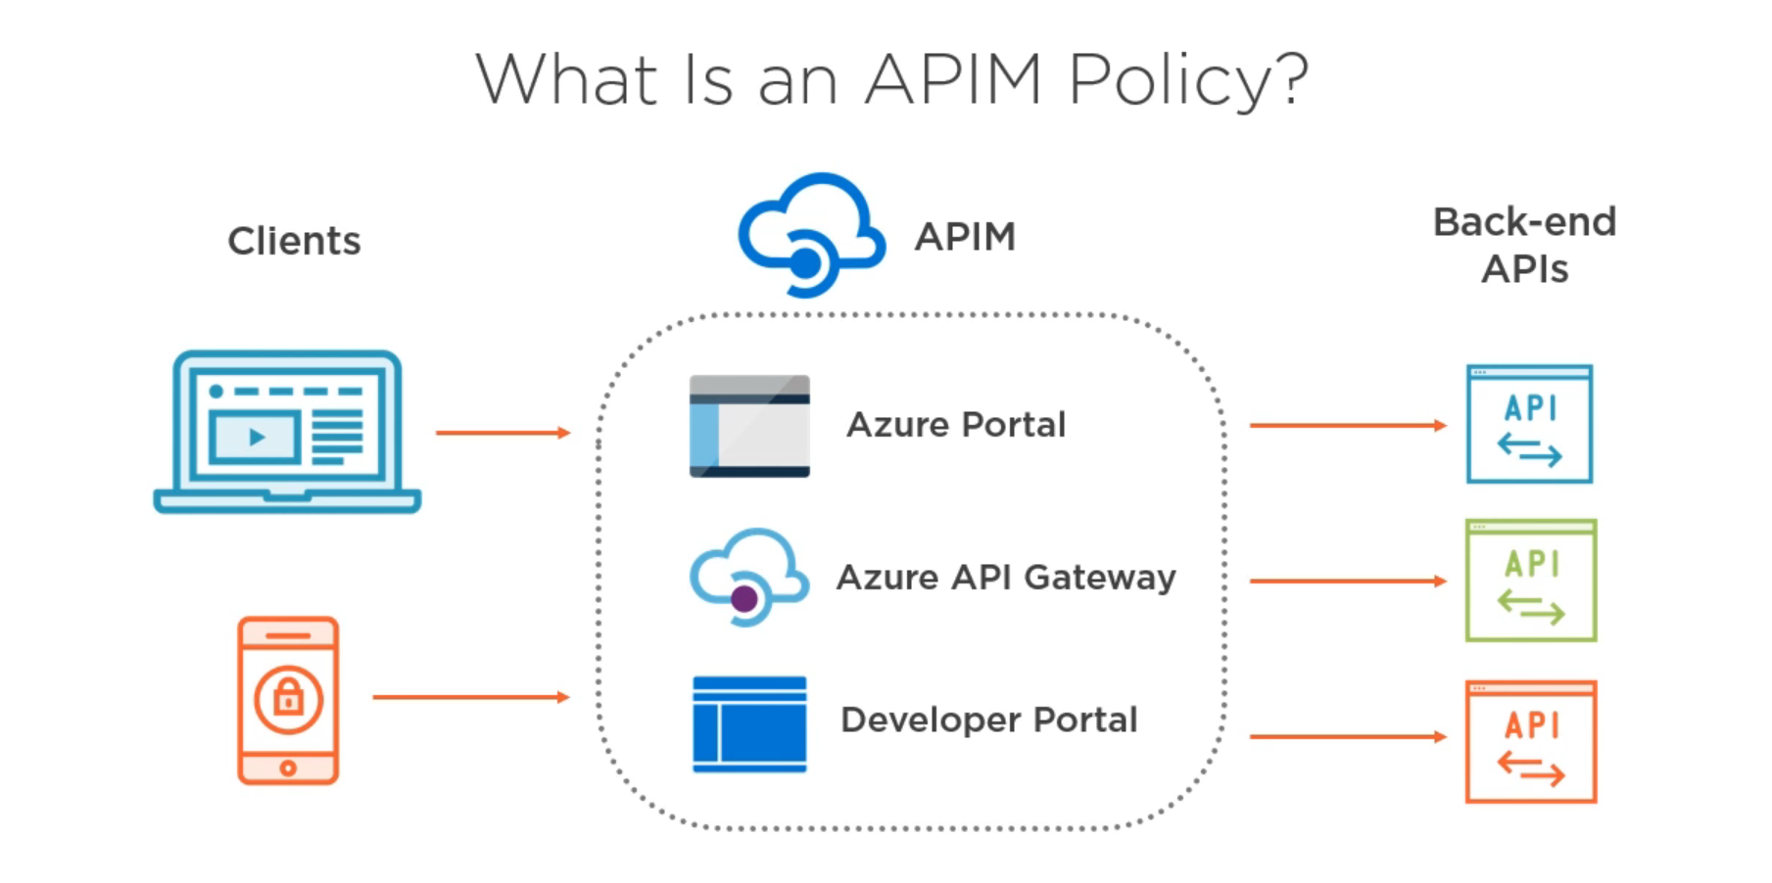

Portal:- Used to add/configure the policies

Gateway:- Actual place where these policies are executed

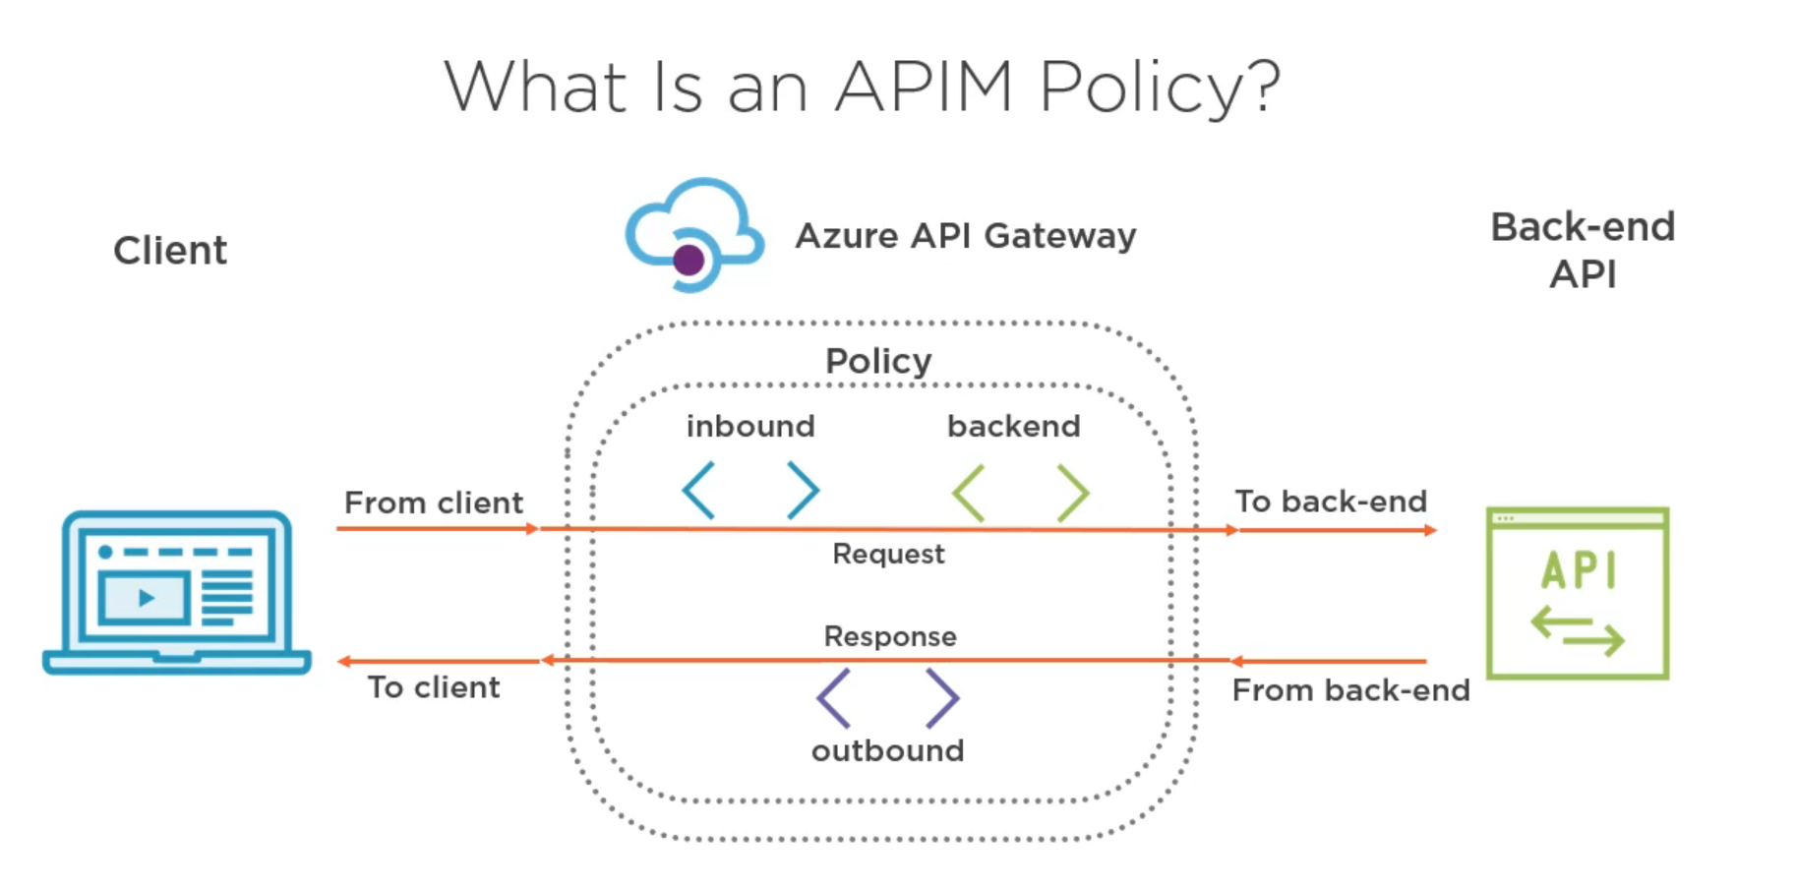

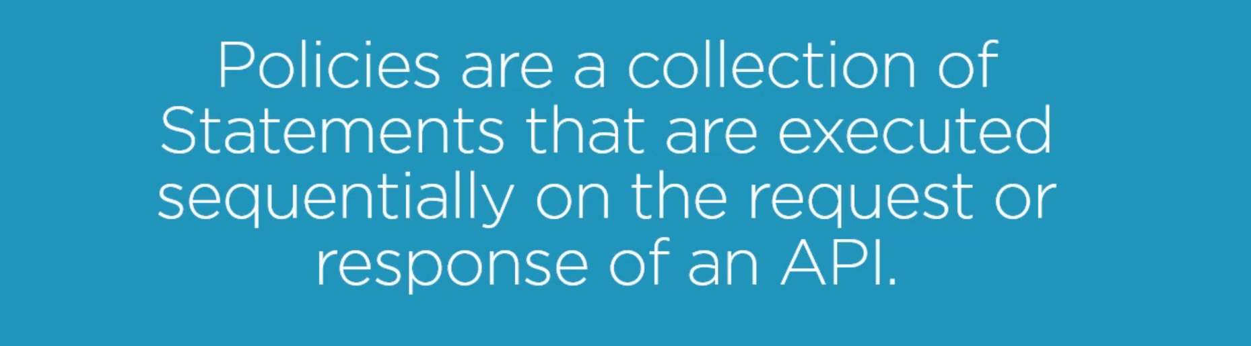

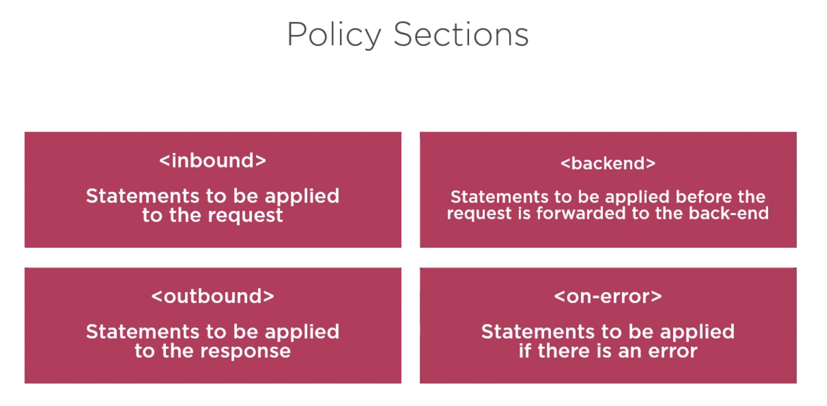

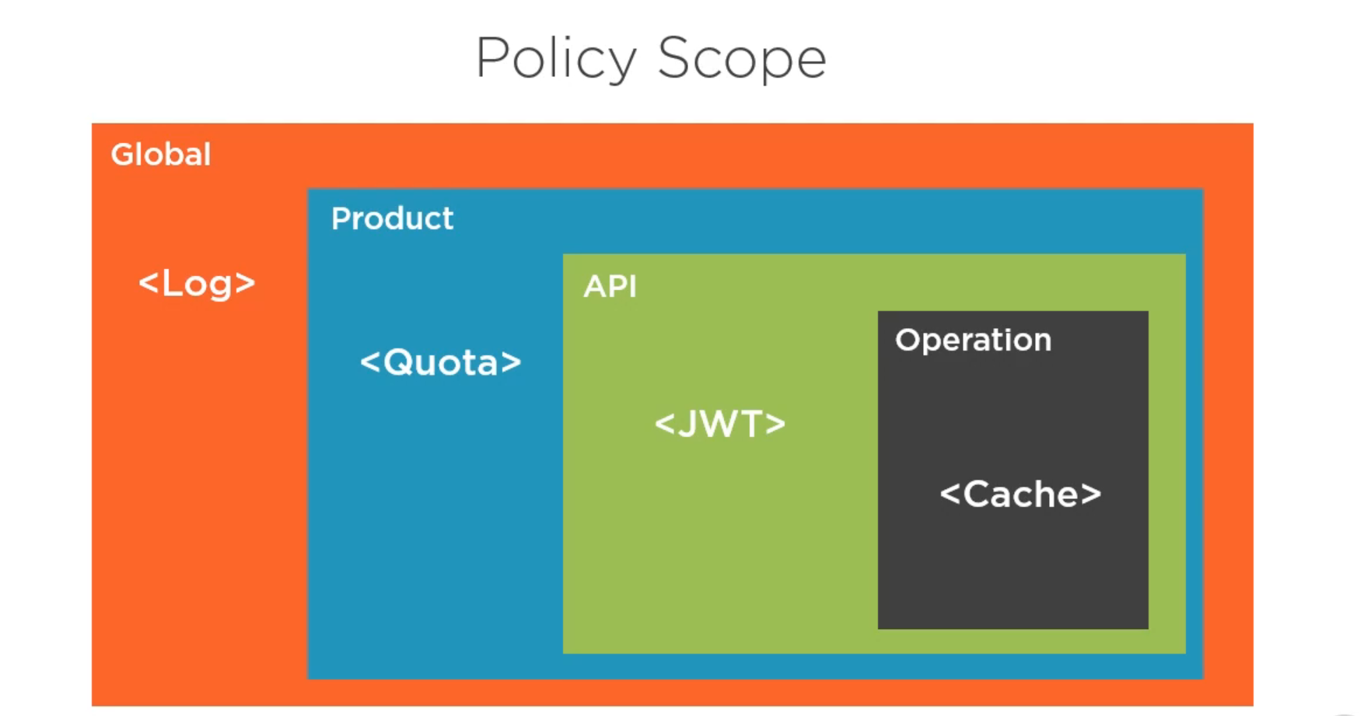

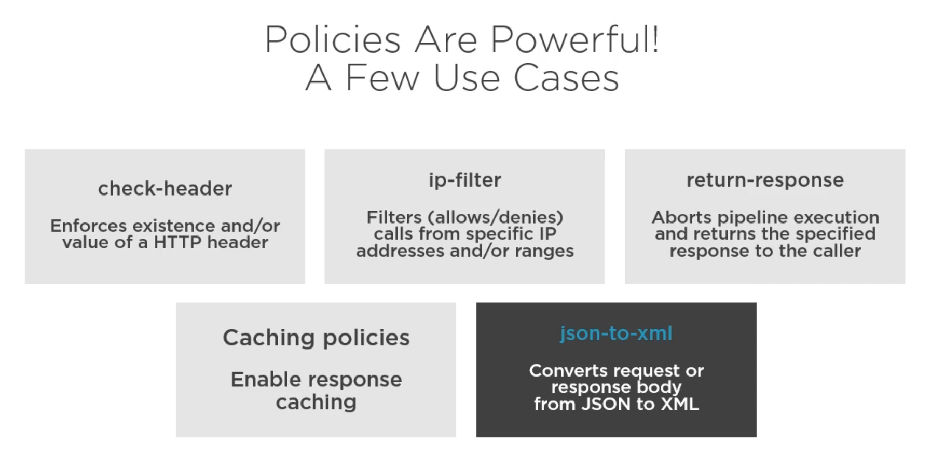

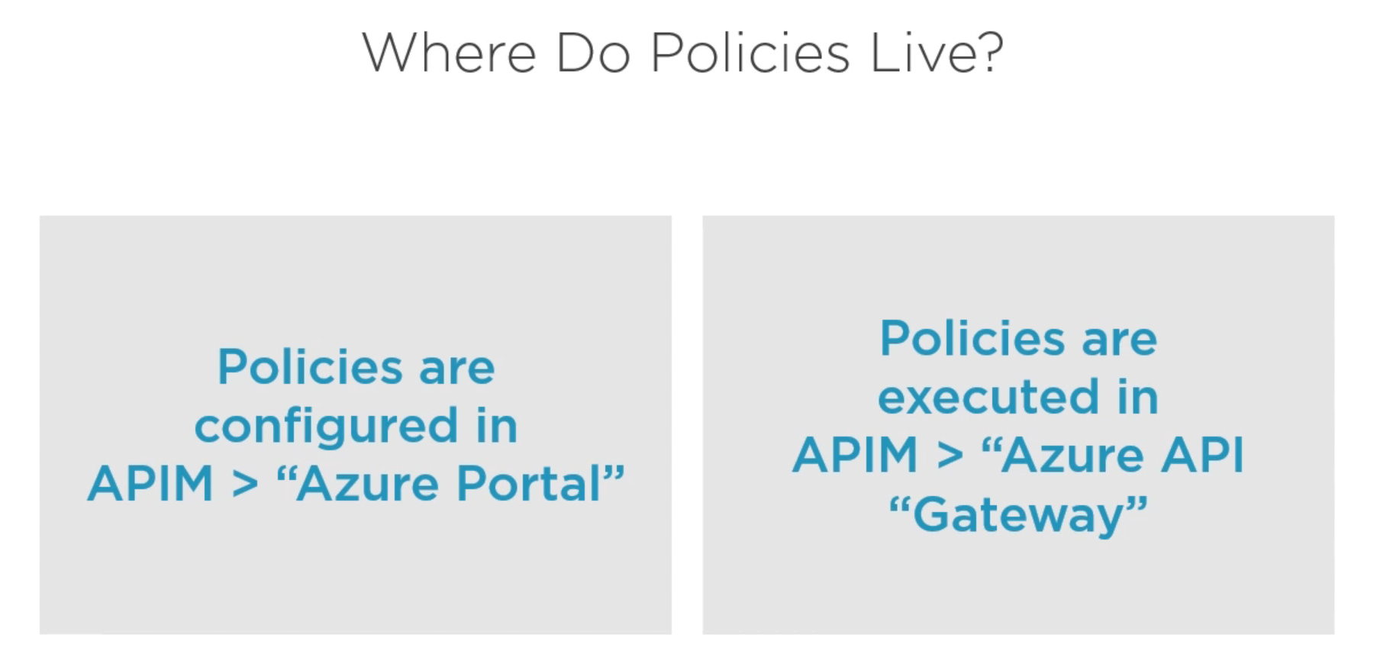

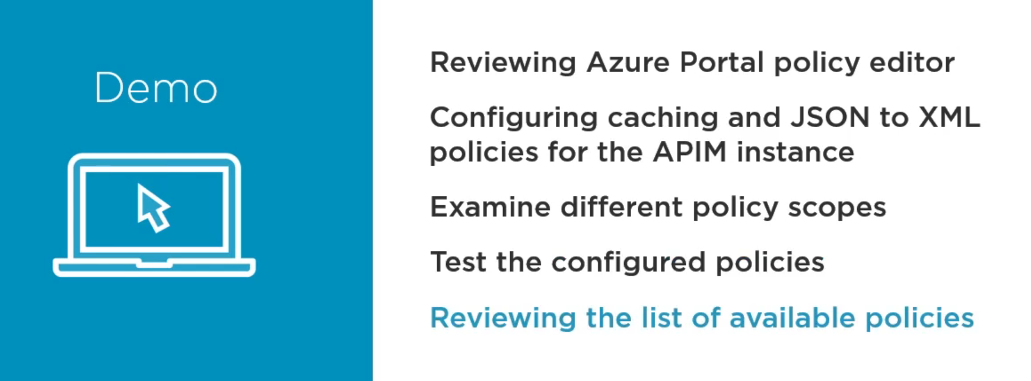

When we click on “All API’s” we can add the policies that will be applied to all the API’s.

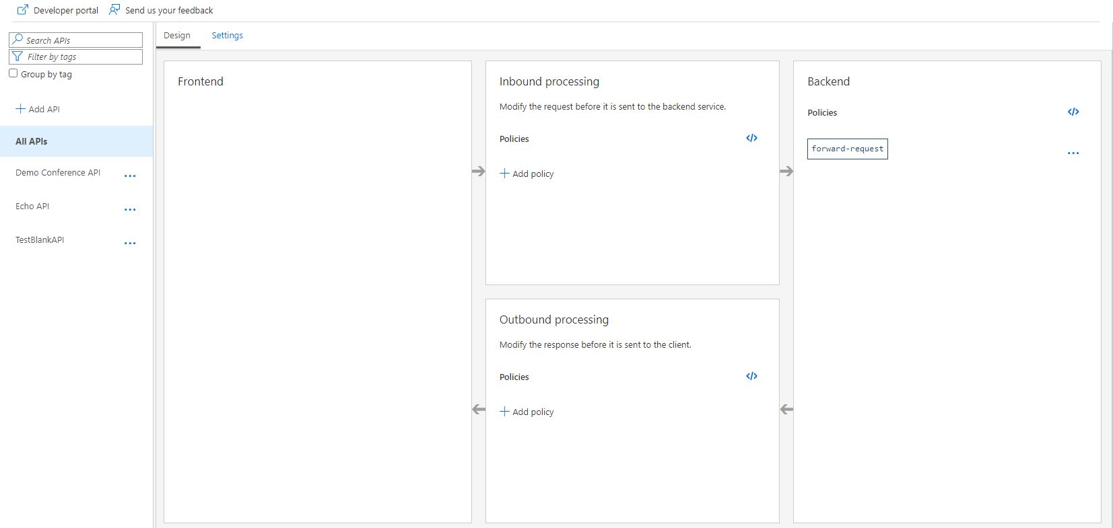

The same goes with “All Operations” we can add the policies that will be applied to all the operations.

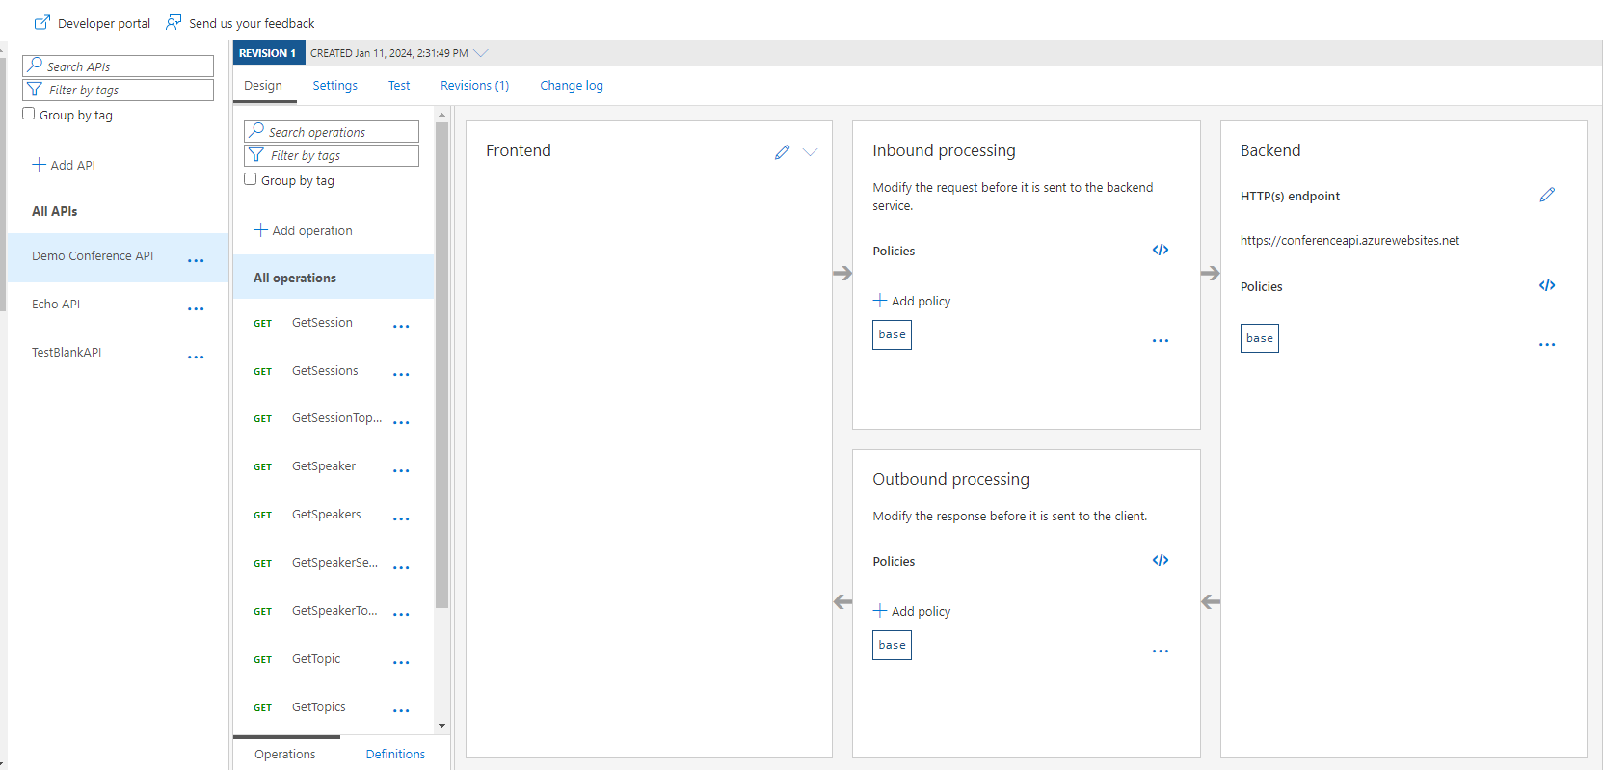

And under each operation, we can add its policies.

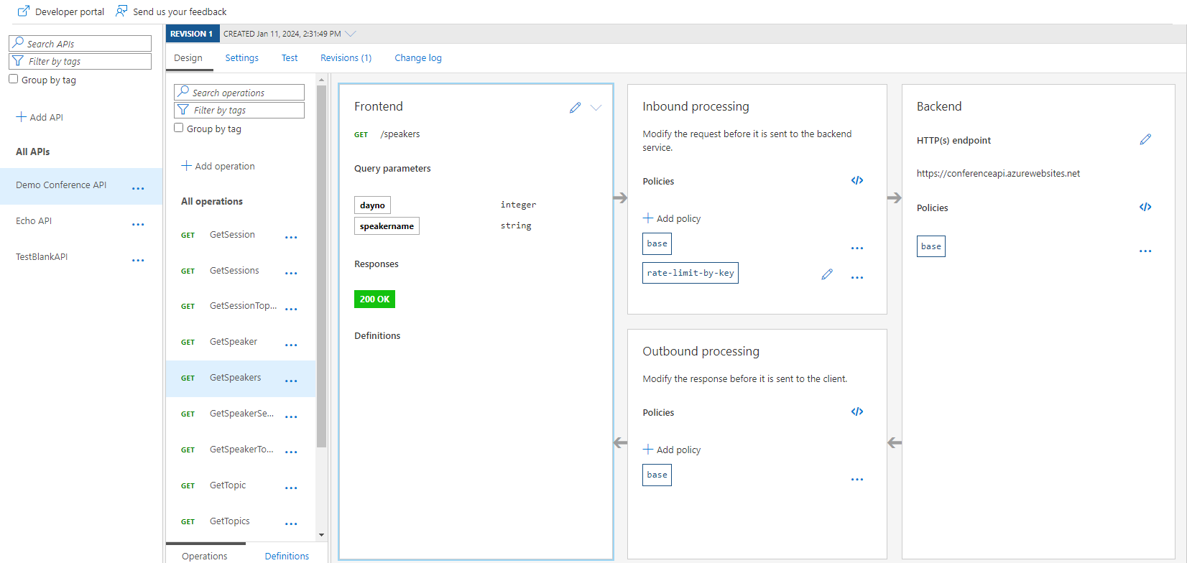

We can also add policies on Products.

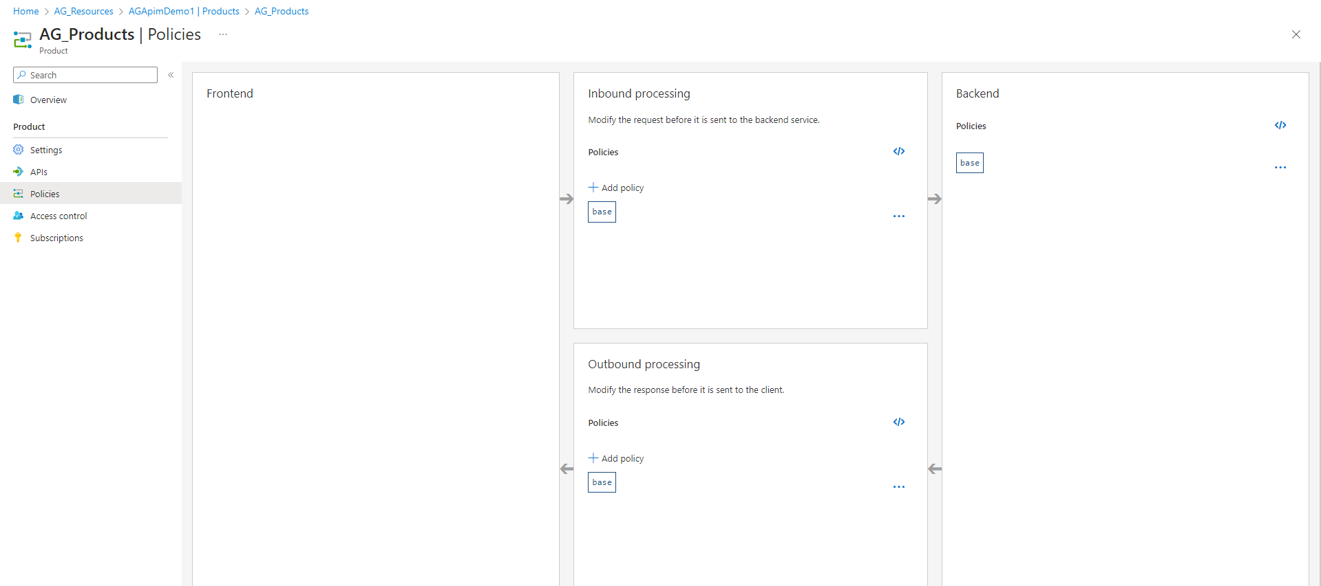

All the operations that are added in this product will contain it’s policies.

Let’s add one Outbound policy in our Operation to convert json to xml.

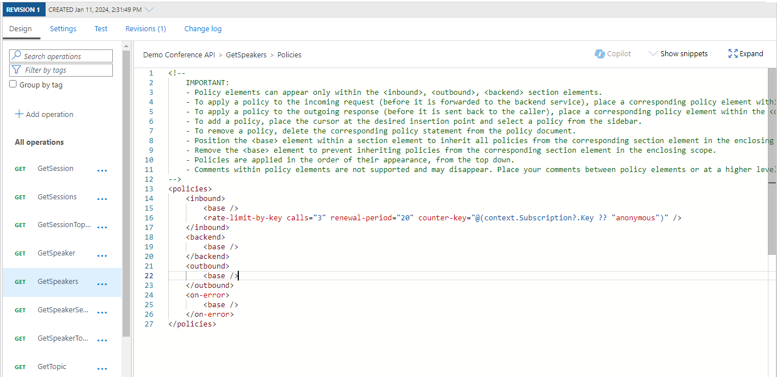

When you click on show snippets you can get a lot of suggestions of the policies.

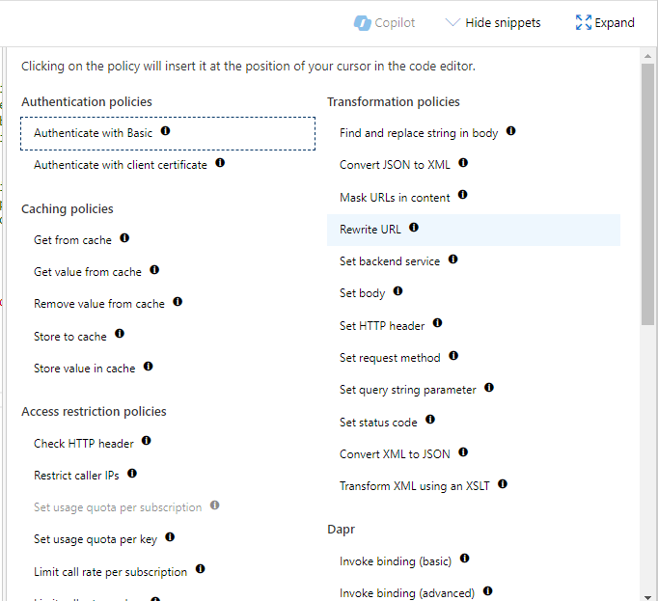

Just click on our option and your policy will be added.

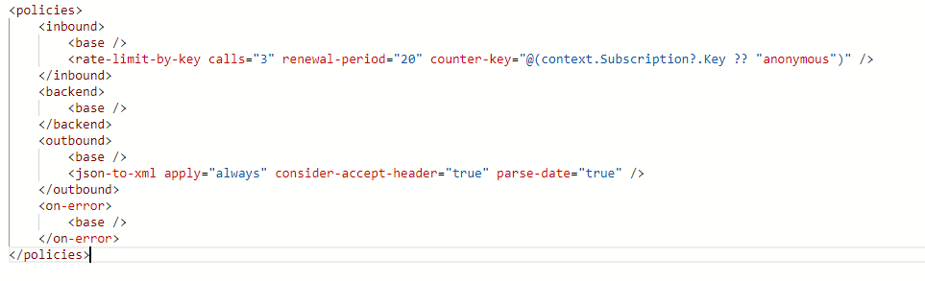And save it.

All the base tags refer to importing the base resource policies (All Api, All Operations).

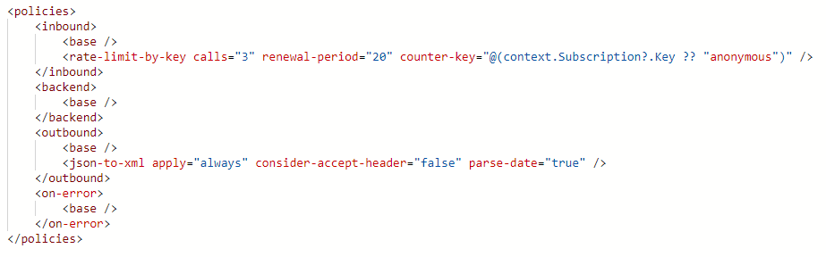

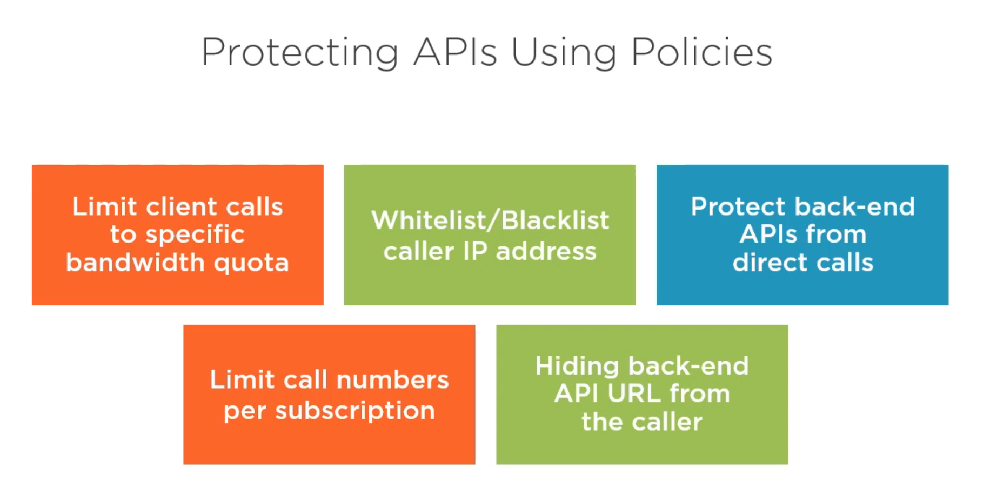

This policy applies on the Product.

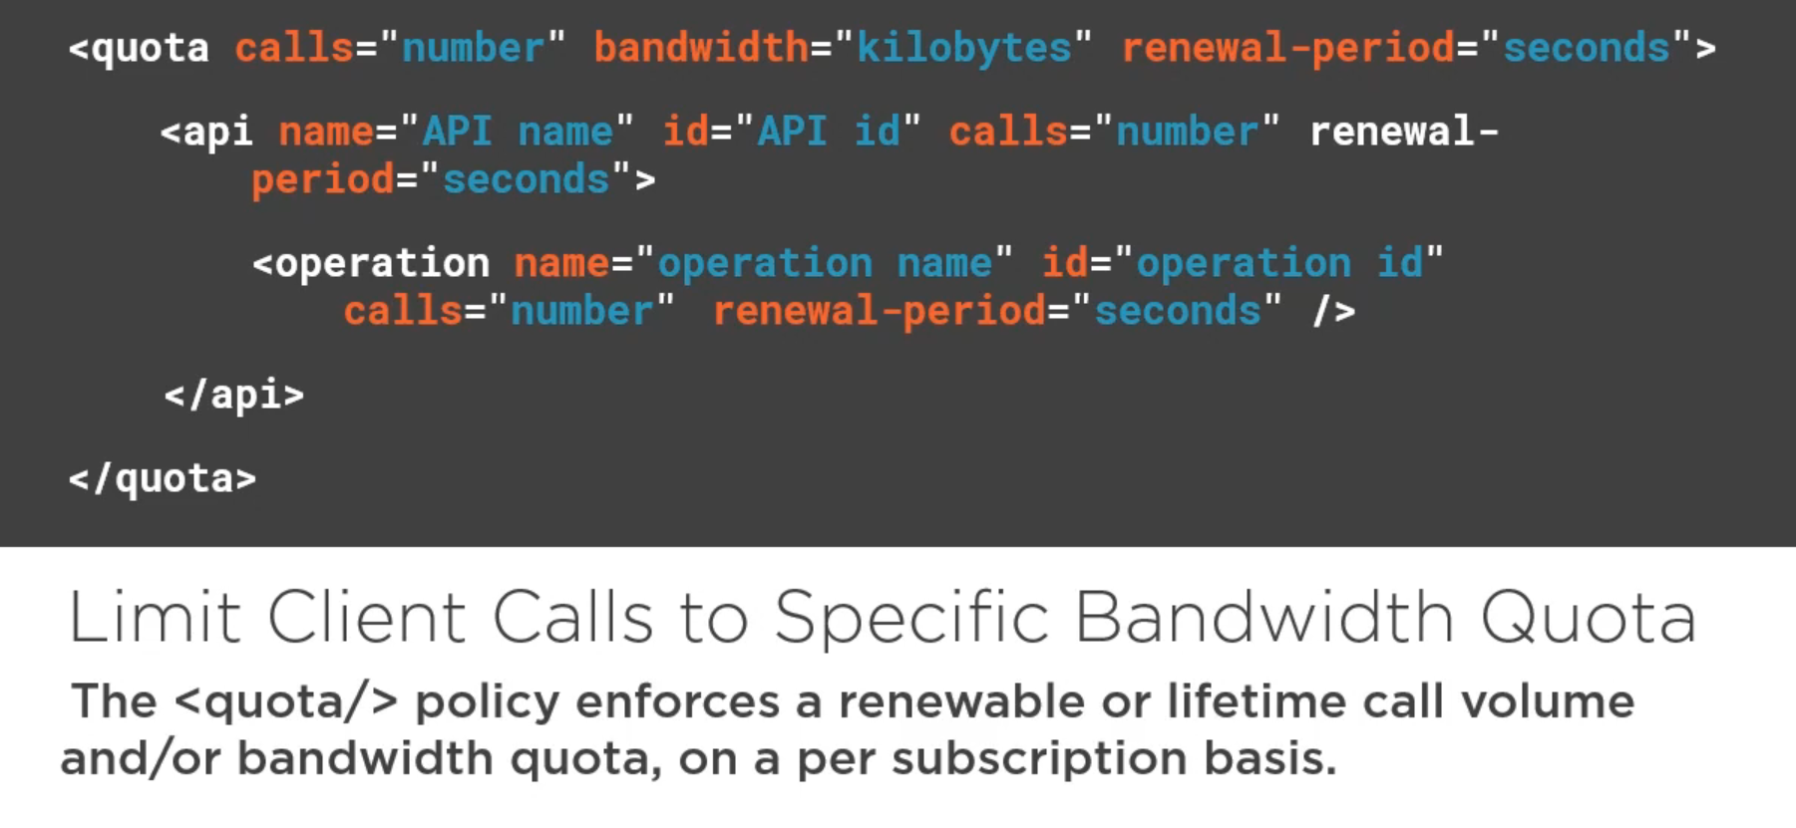

This policy is added on the Operations.

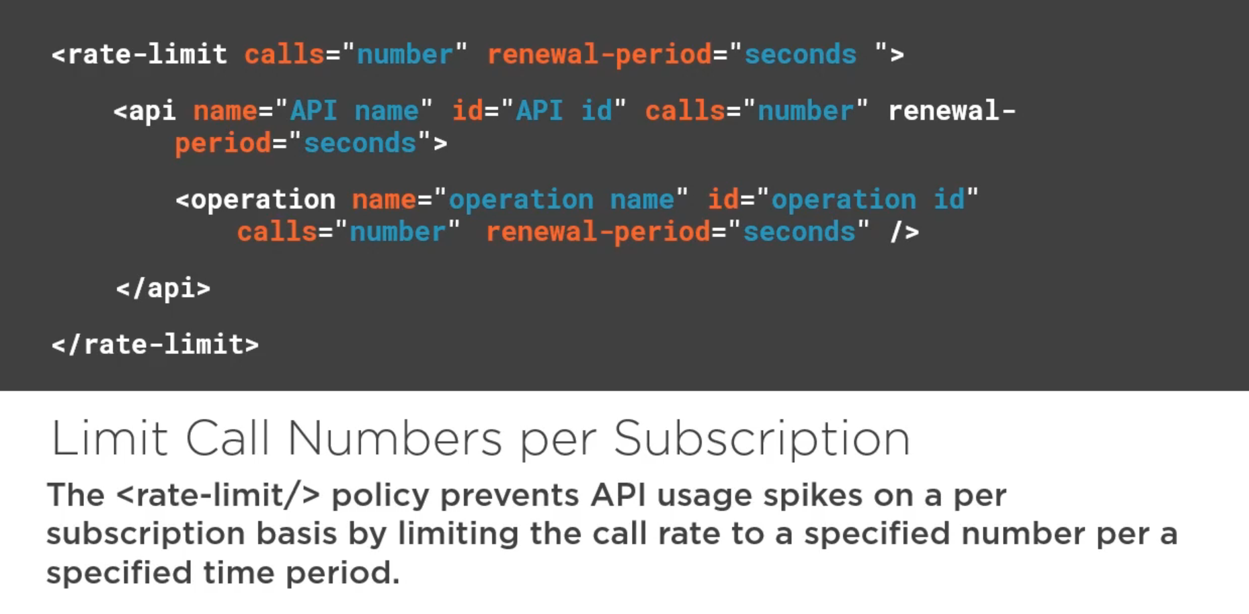

This policy is added on the Operations.

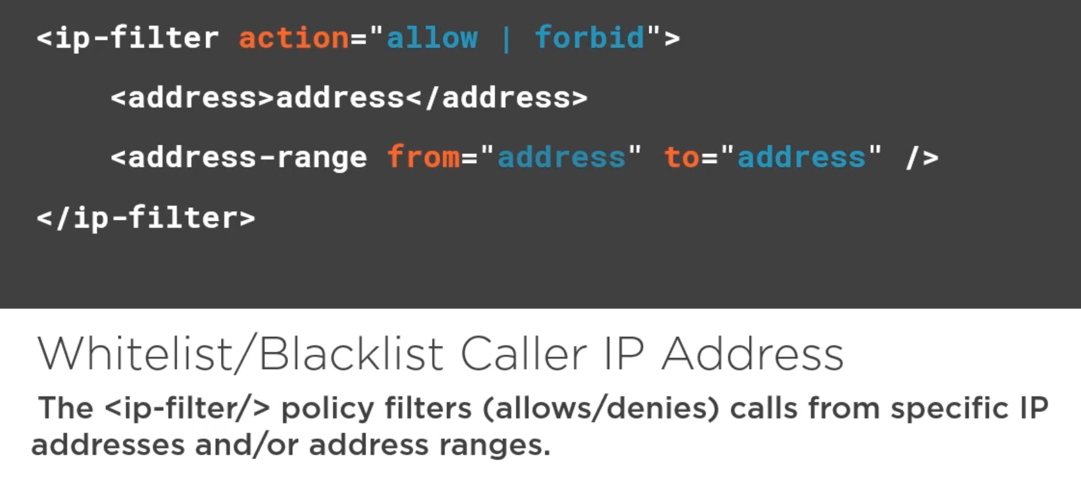

This policy is added to the Operations. And on the outbound section, the rest all are in the Inbound section.

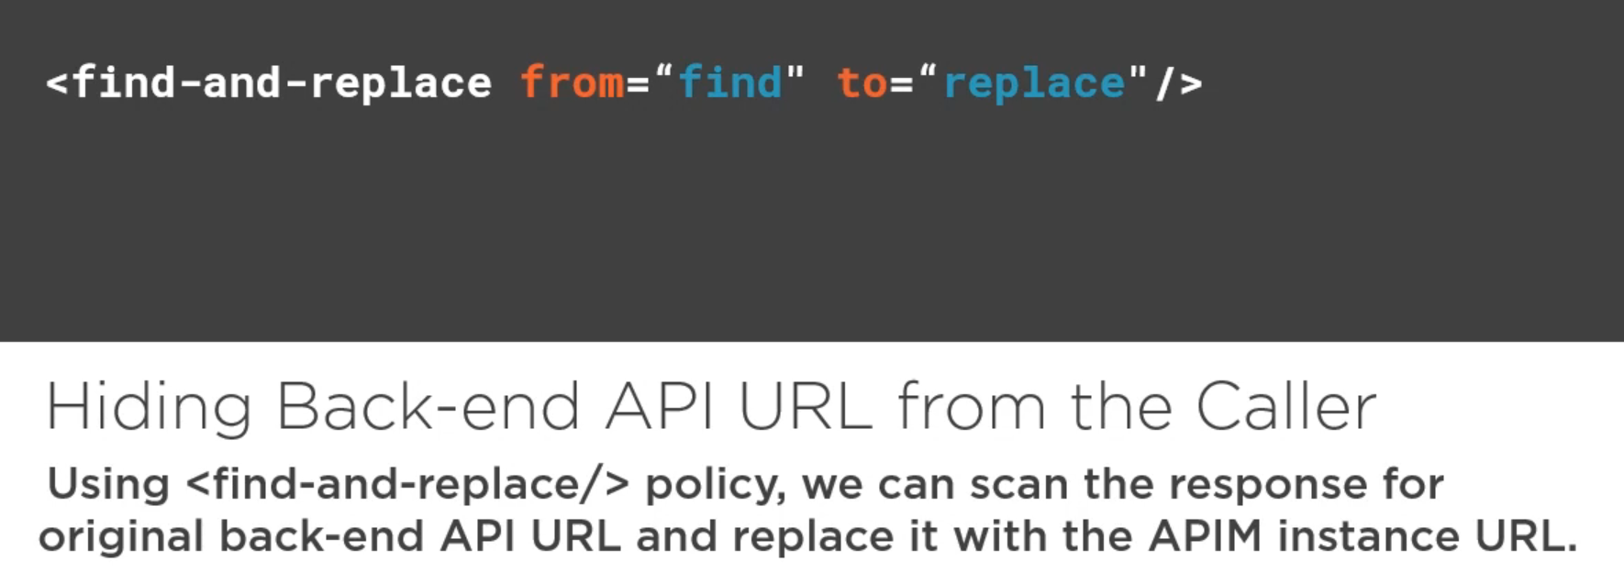

This policy is added on the Operations.

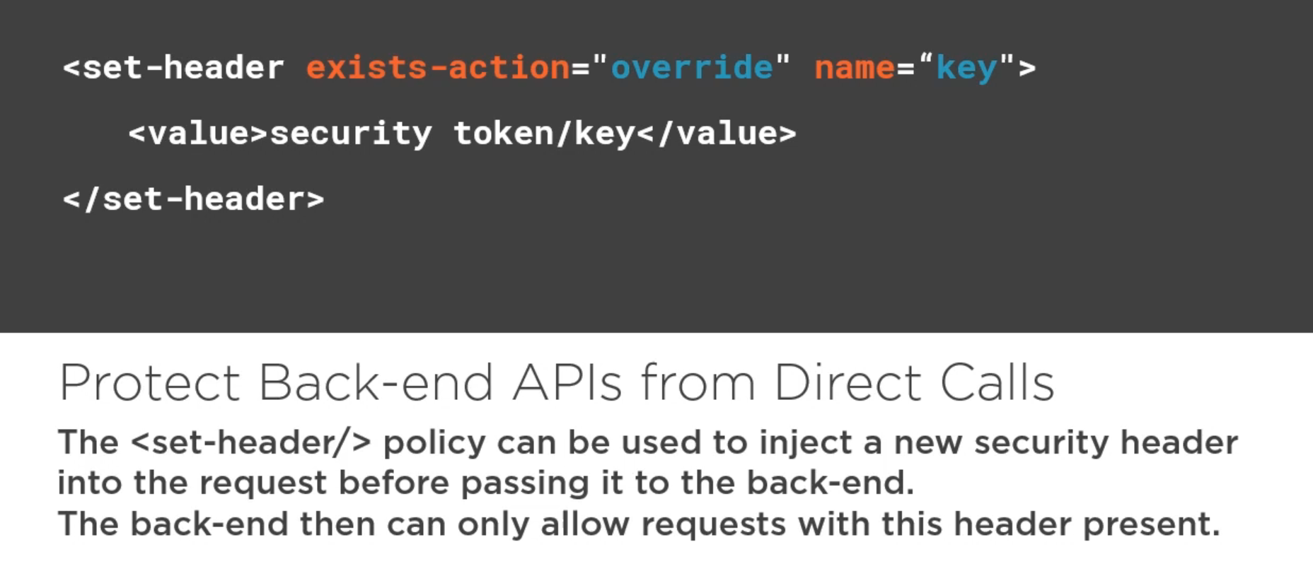

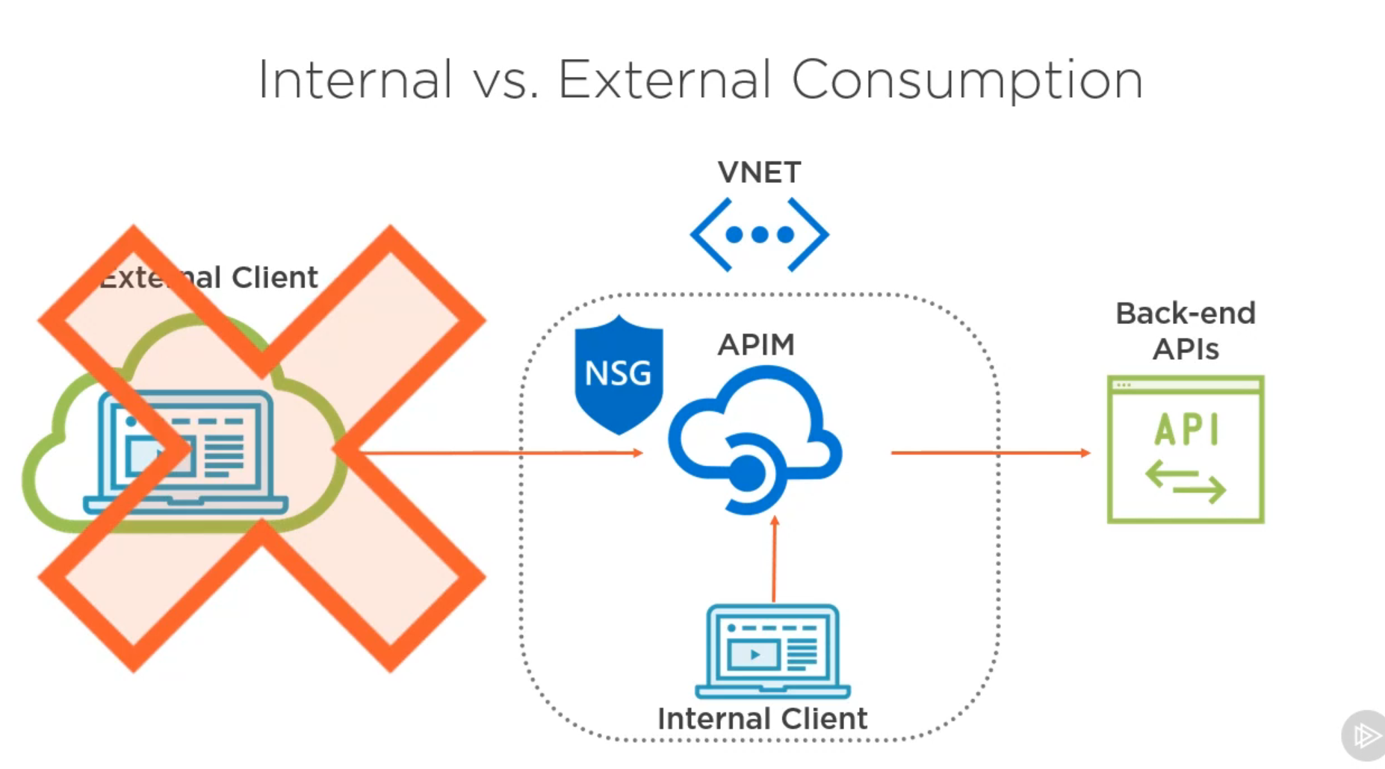

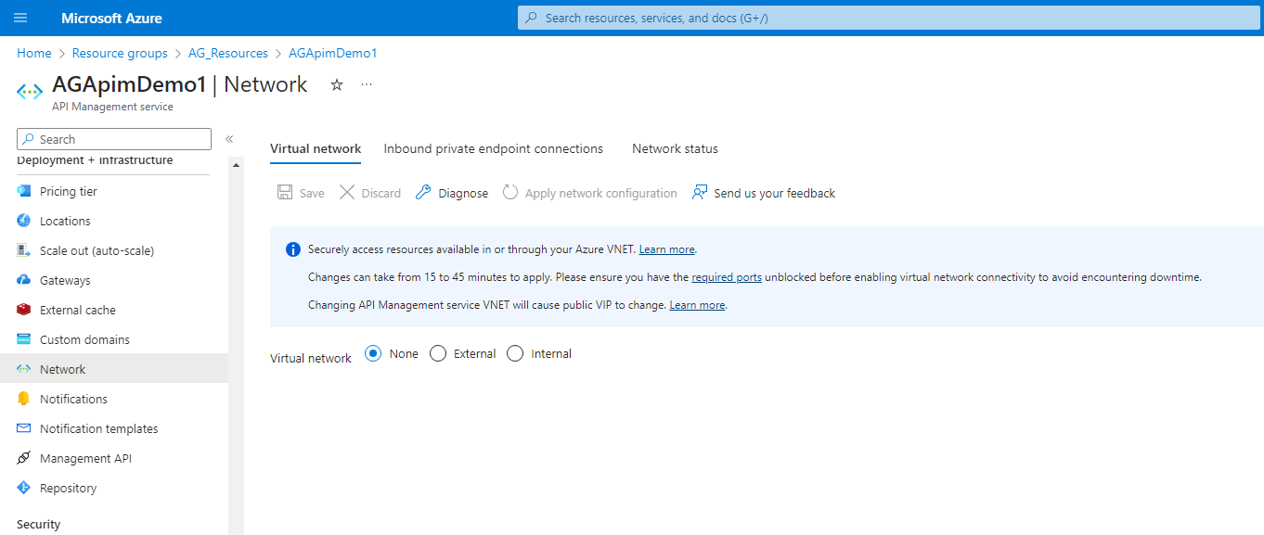

Inside the APIM we have the option of Network and inside it, we can add our APIM to a virtual network but for this, we should have a virtual network configured.

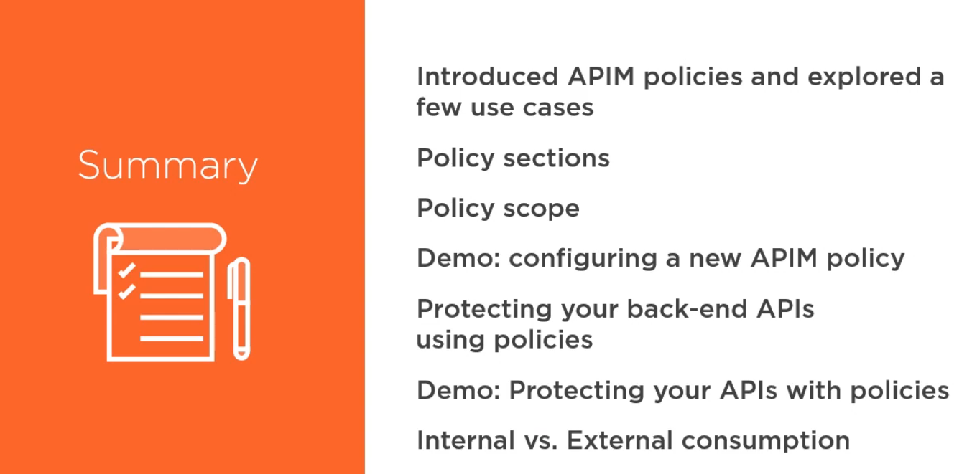

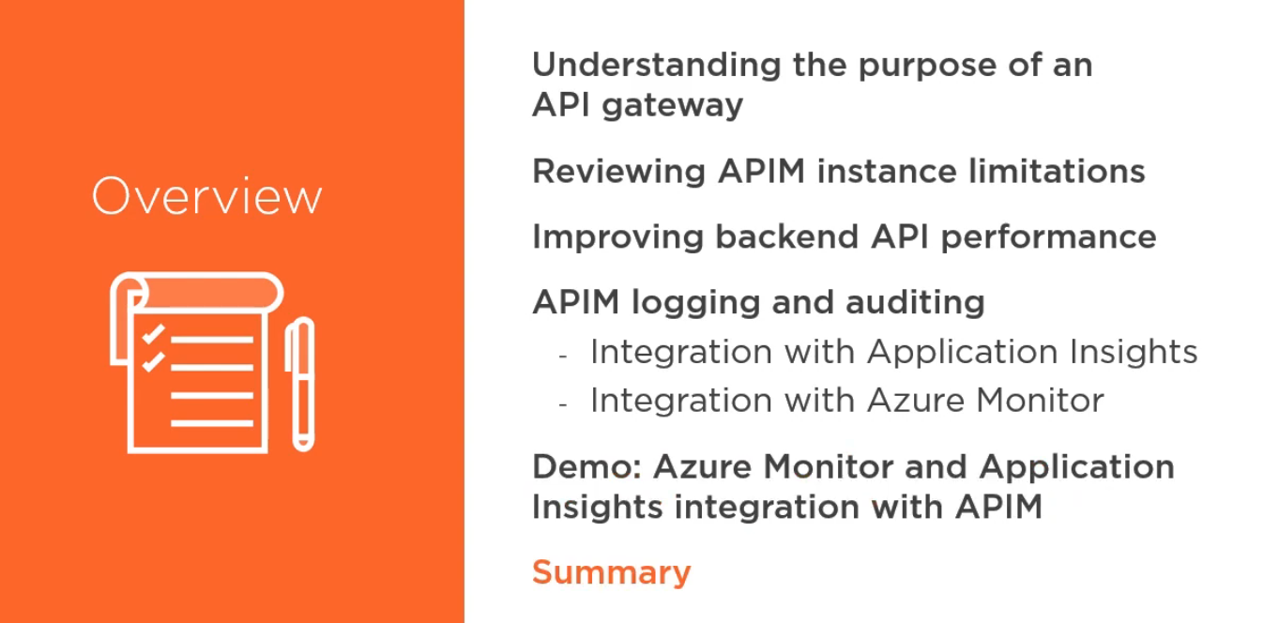

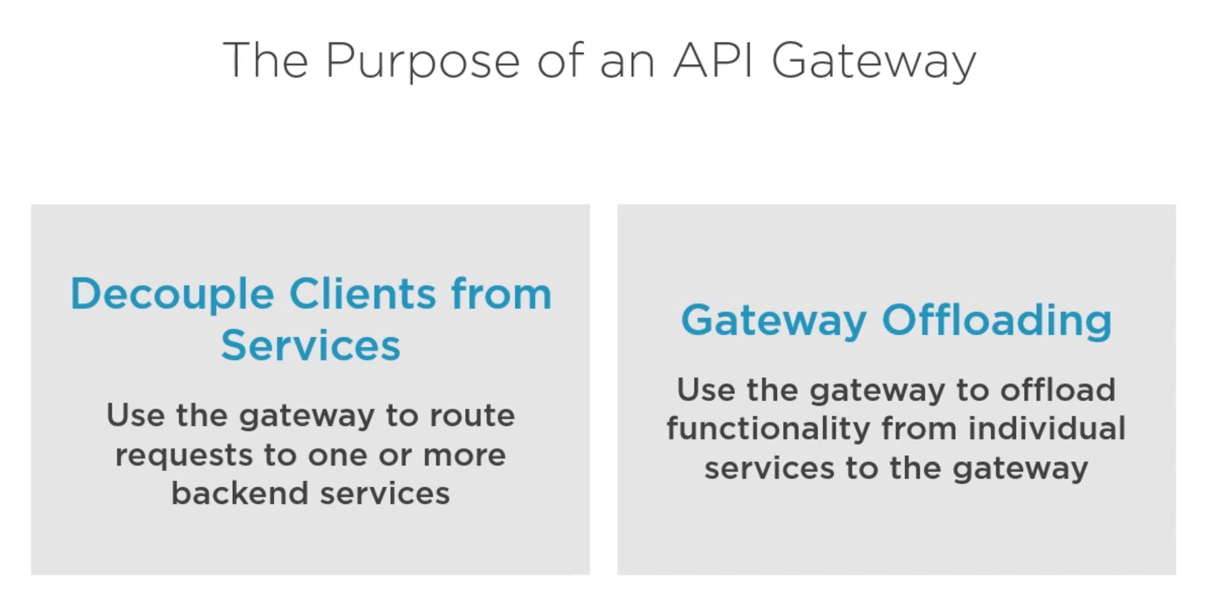

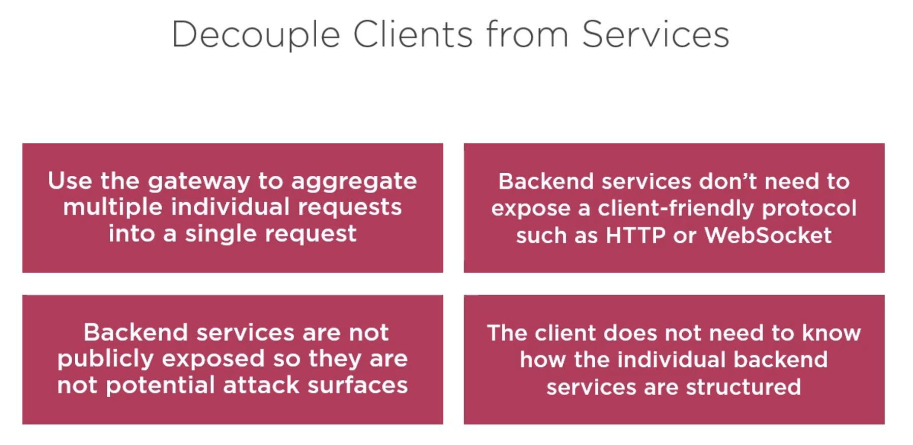

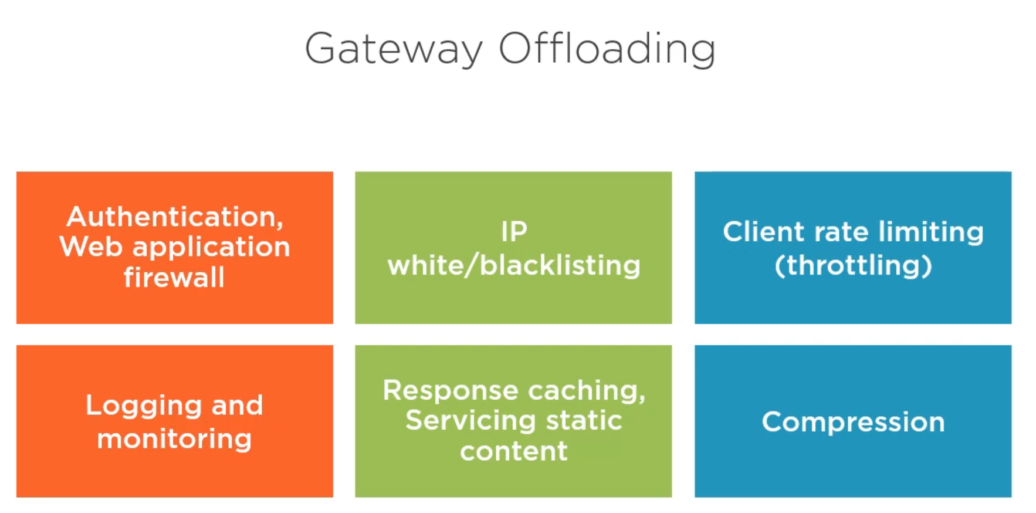

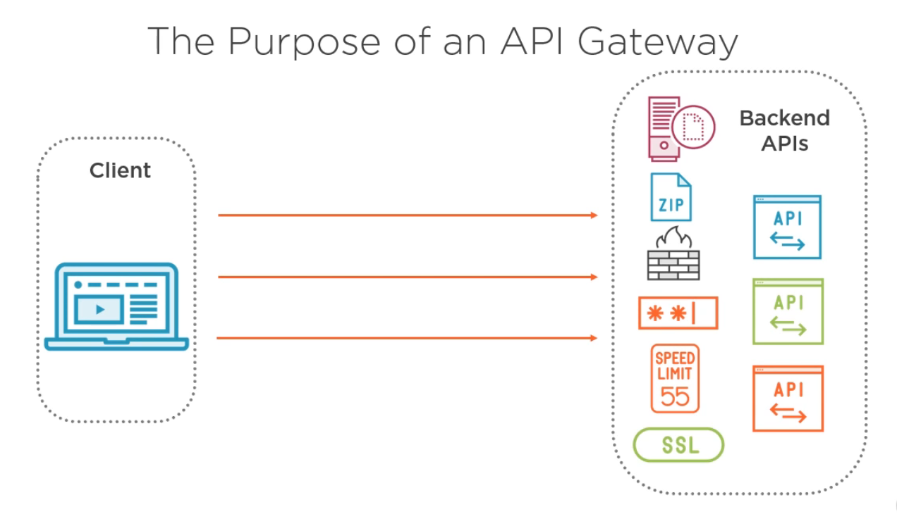

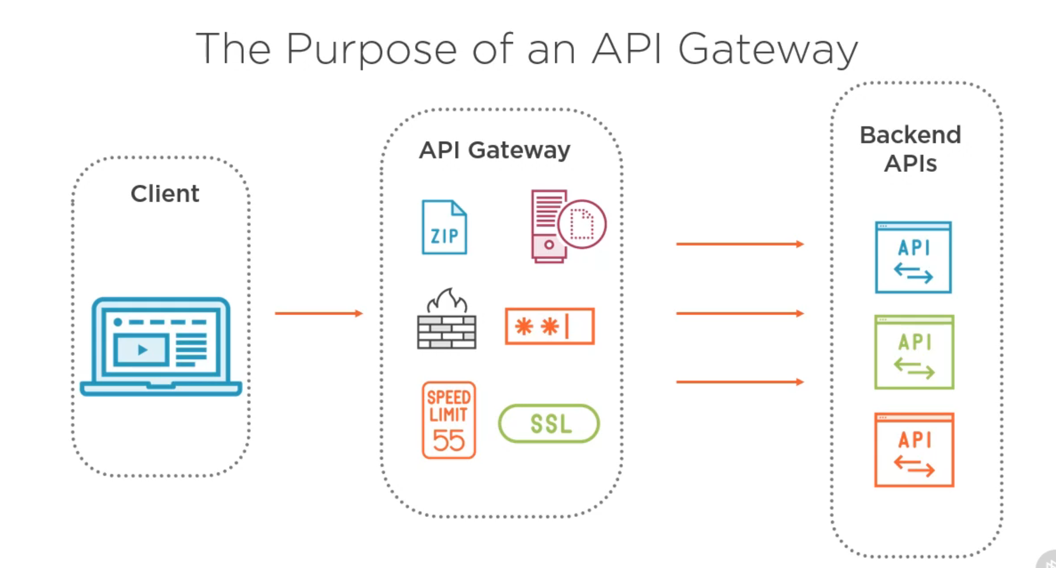



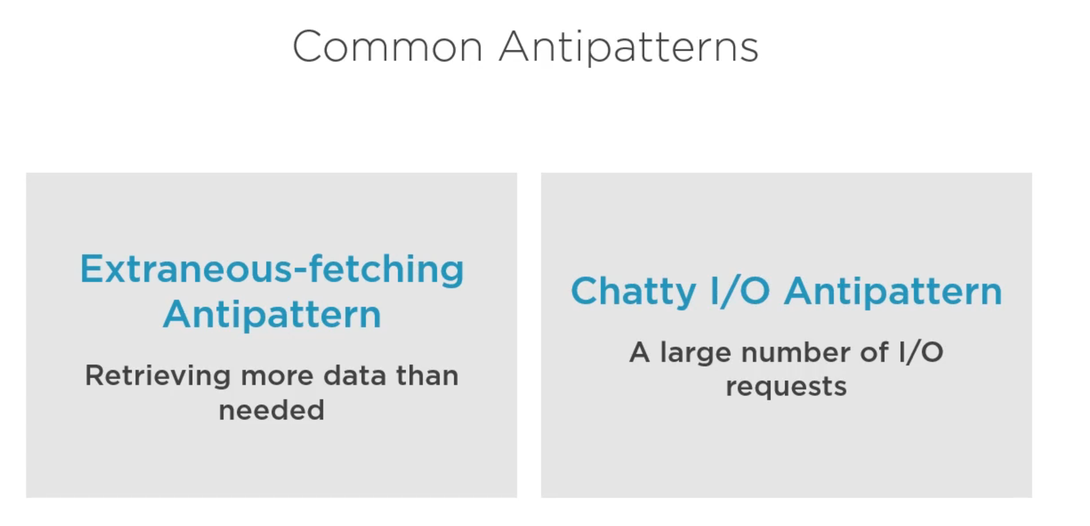

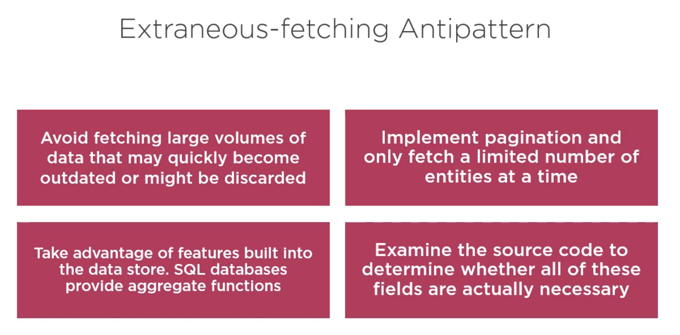

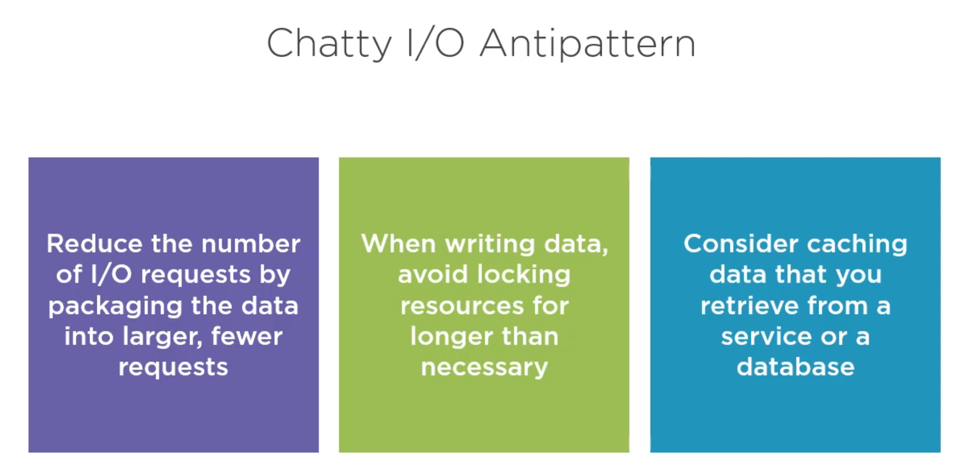

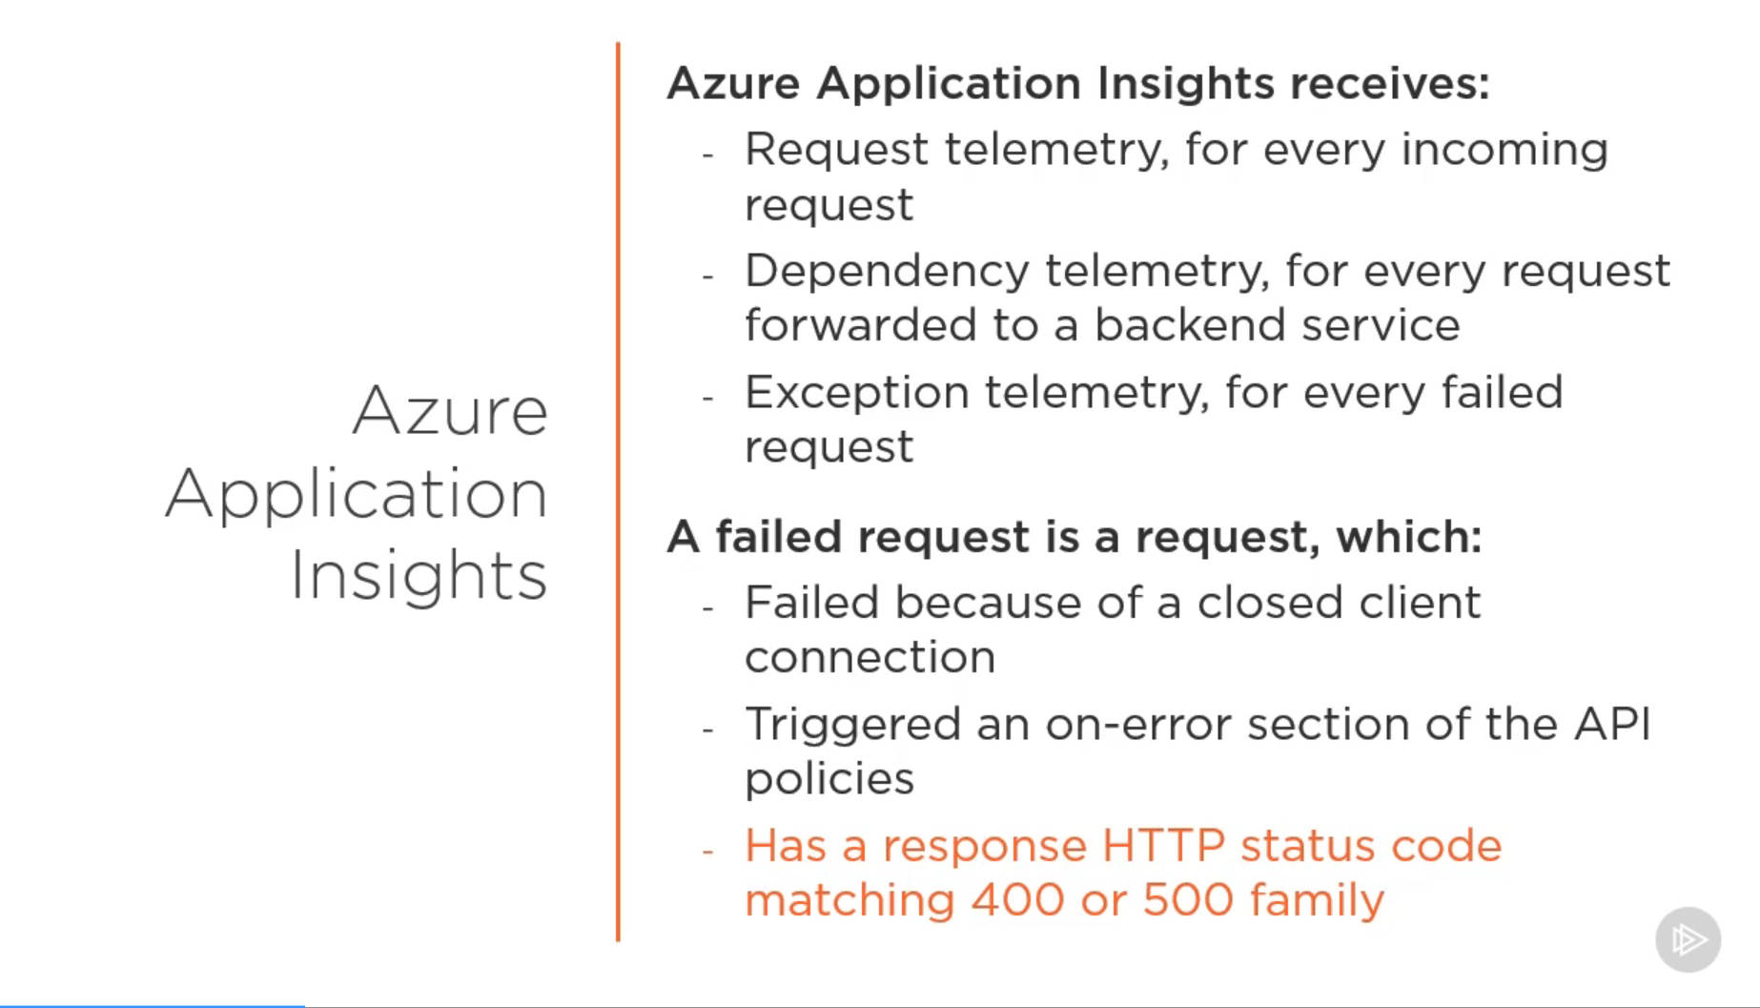

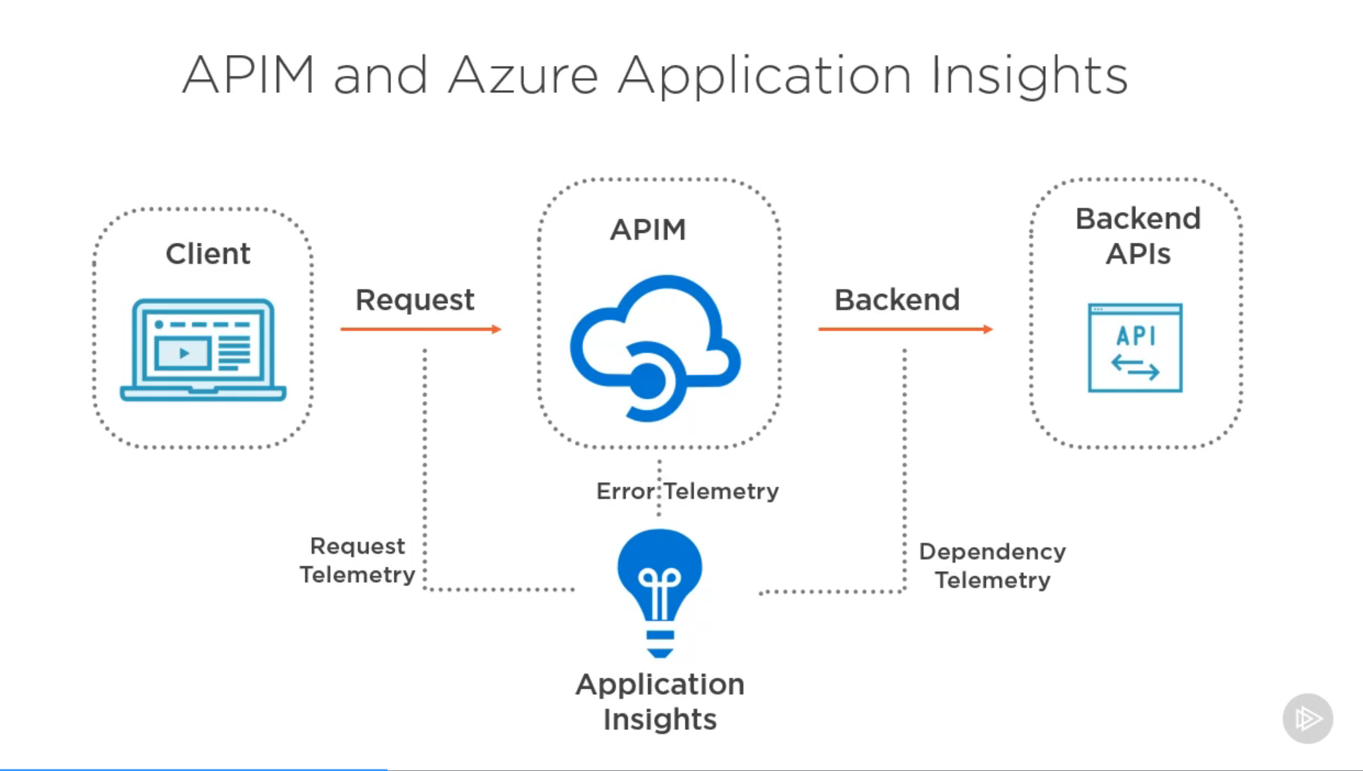

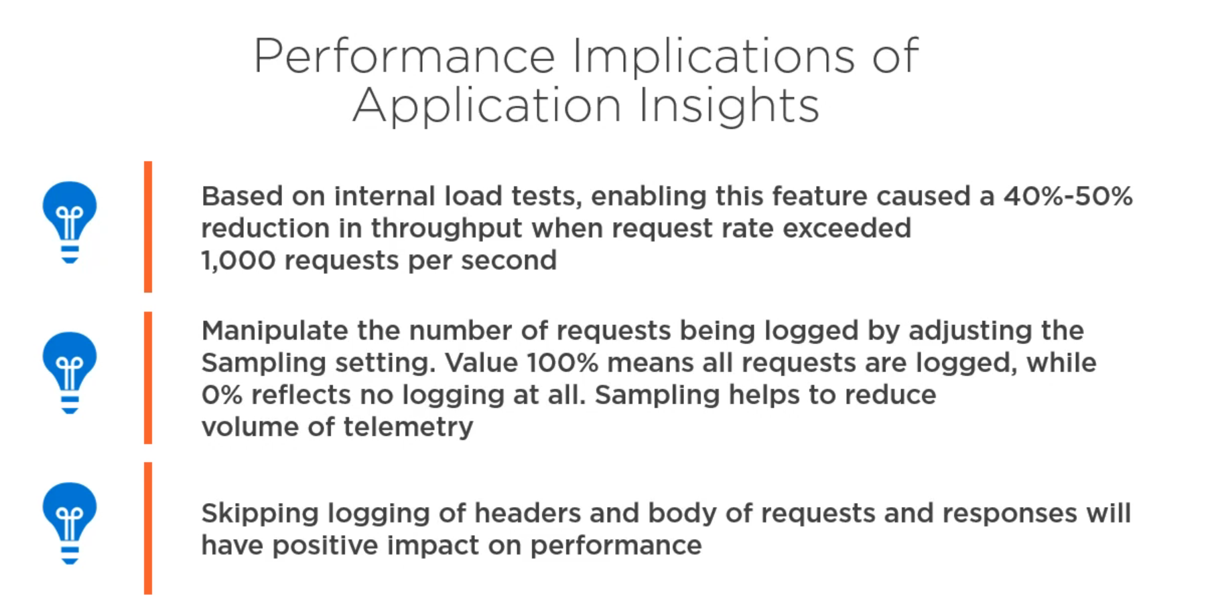

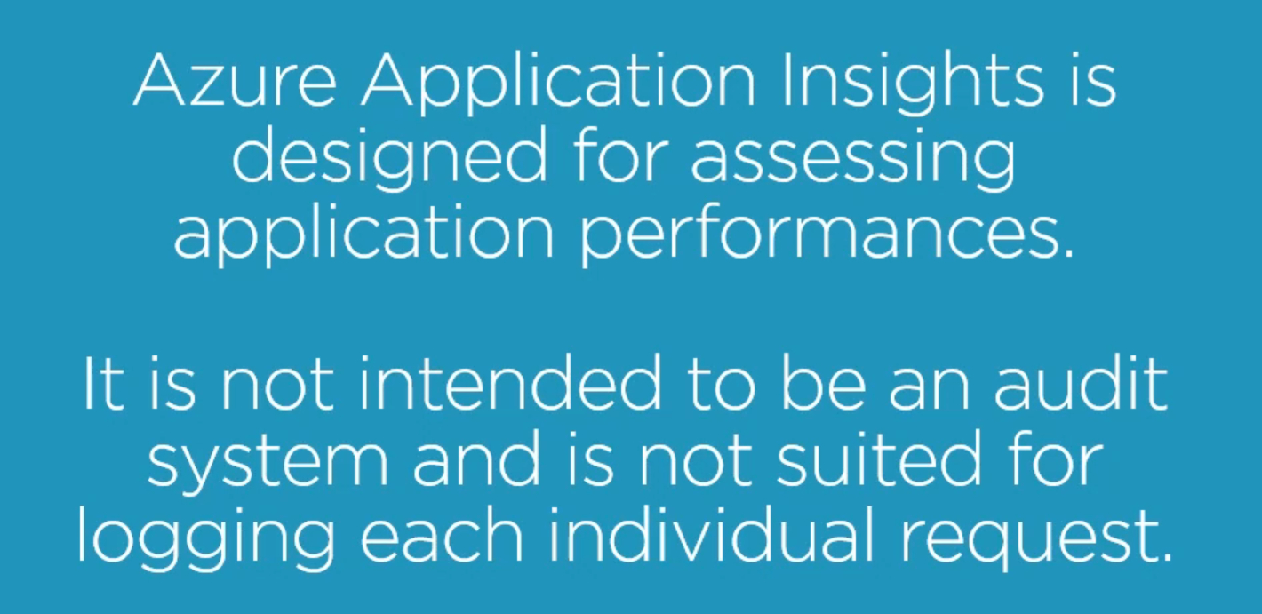

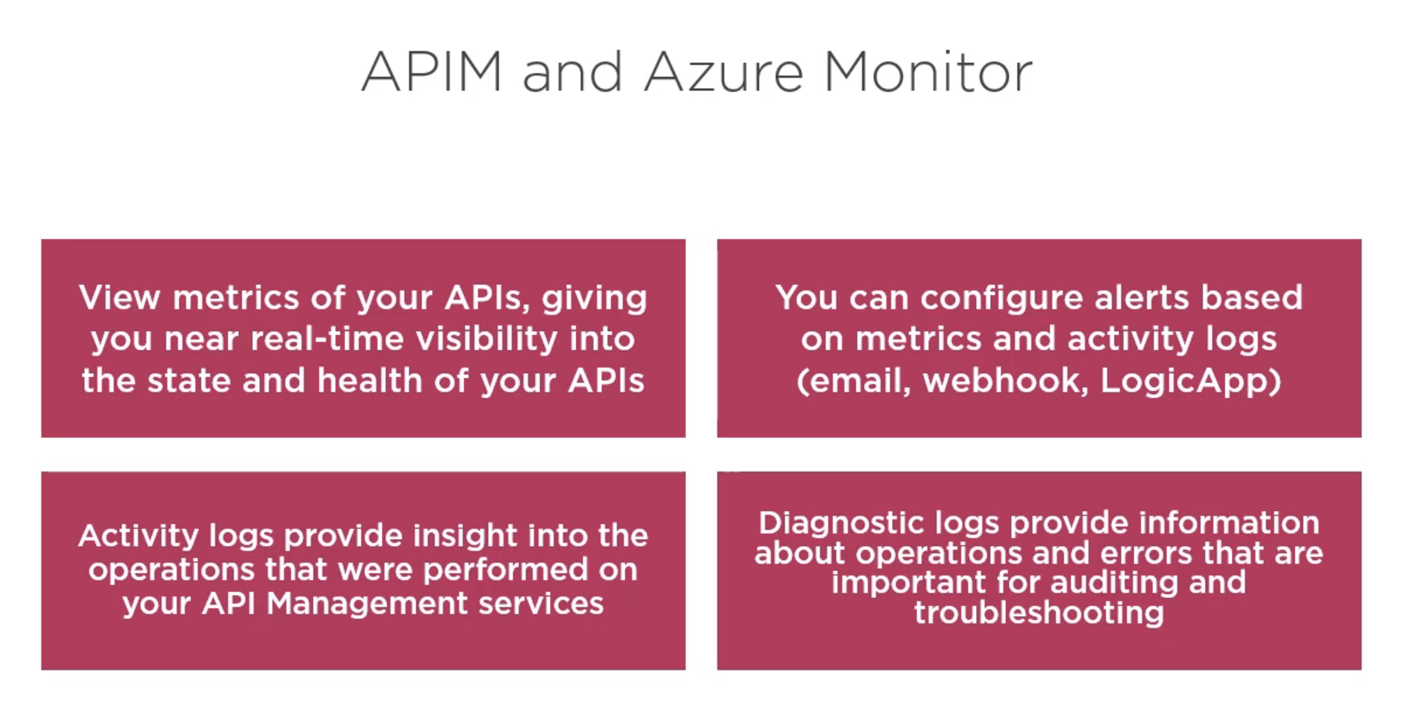

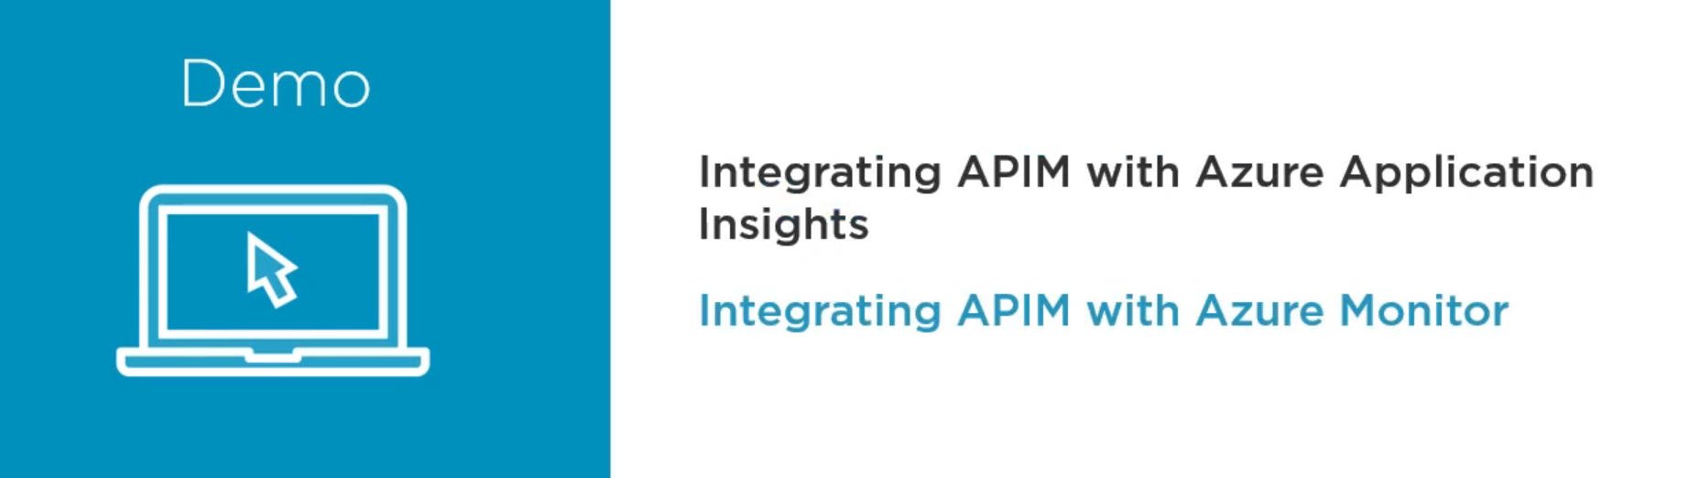

Search for Application Insights in the Azure Marketplace

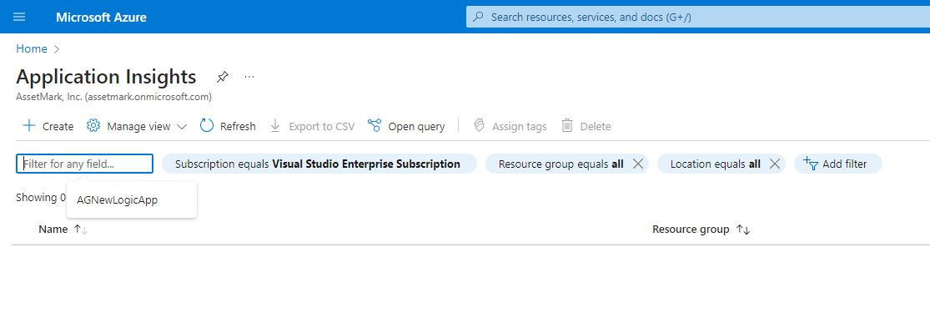

Create a new Application Insight

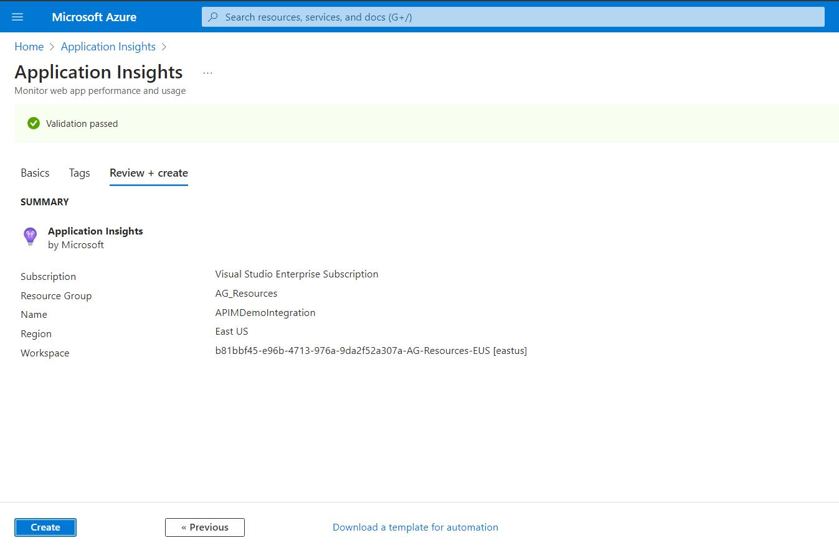

Once it is created go to your APIM instance and go to monitoring and click on Application Insights

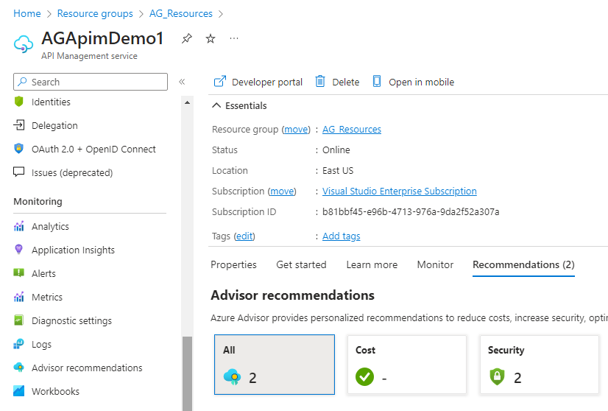

And now we are going to integrate the instance that we have created.

Click on Add and then select our Insight

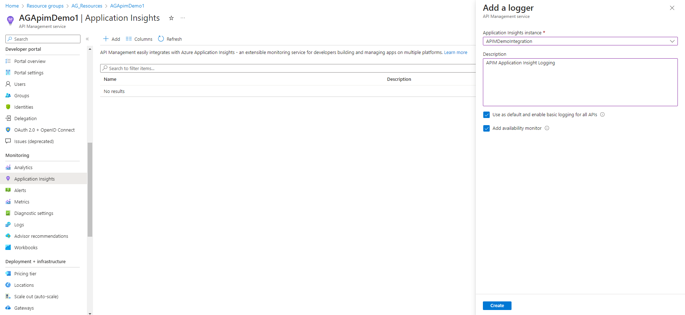

Now we need to enable logging inside our API’s

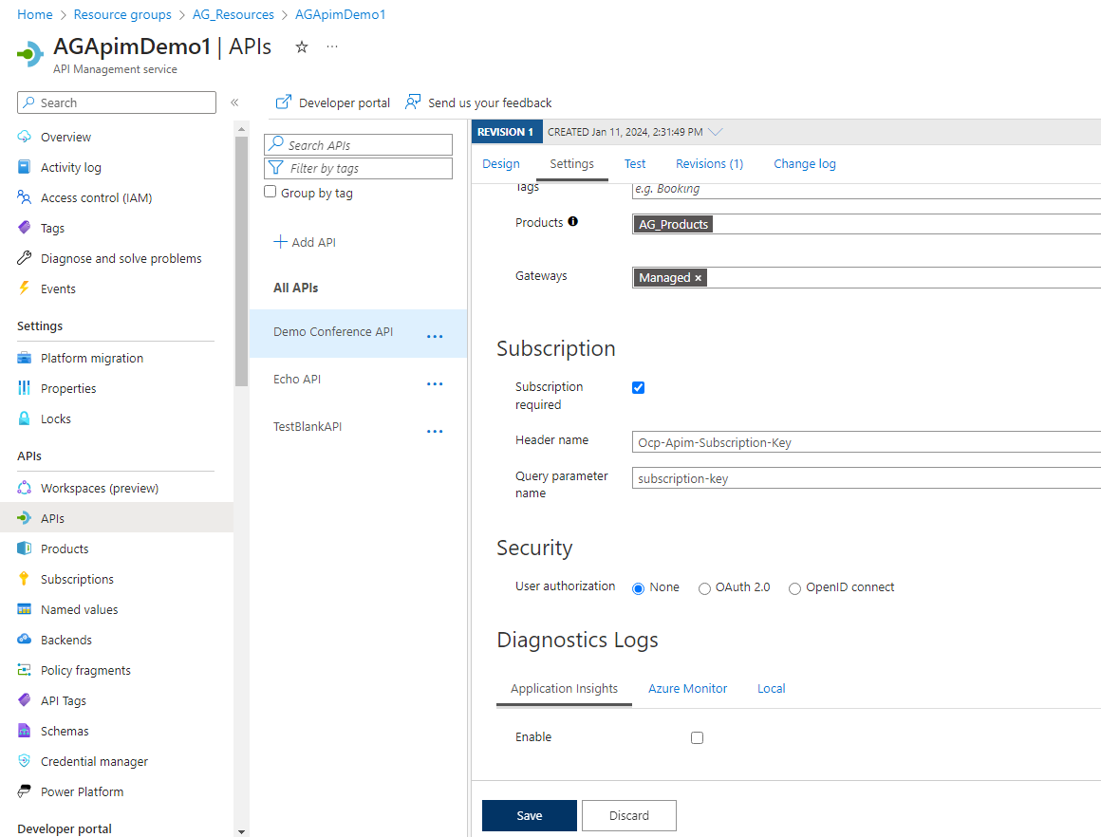

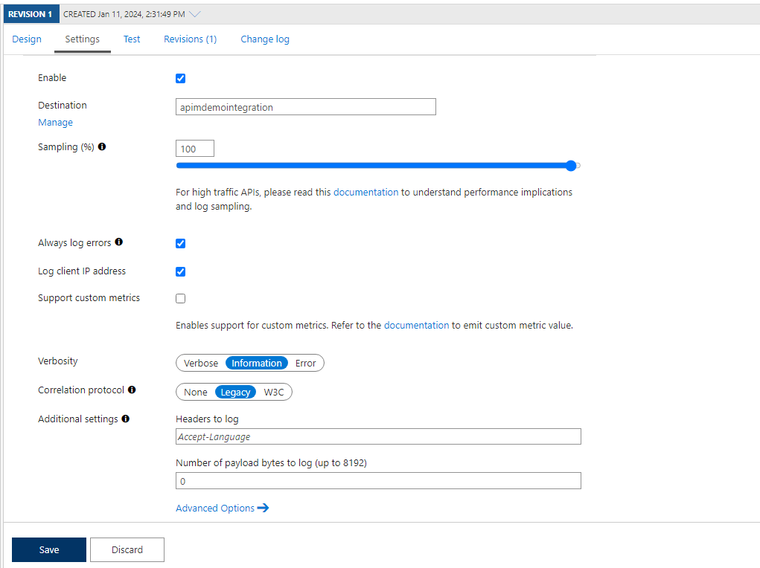

You can also Enable it on the global level.

With all of the APIs and even at the global level we will get an option of Azure Monitor with Application Insights

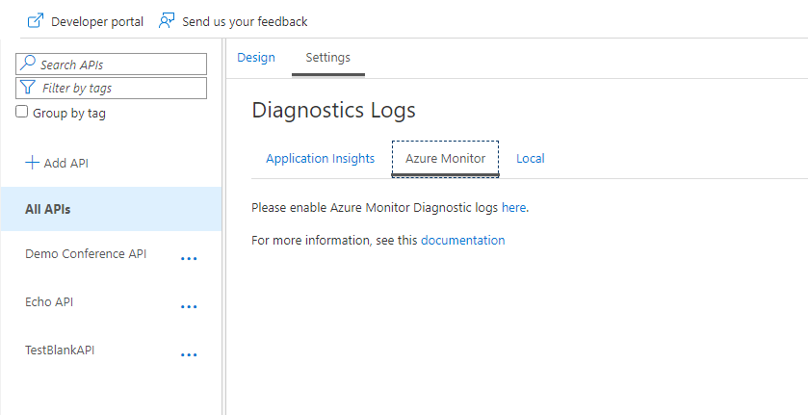

We also have some useful Monitoring tools inside the APIM.

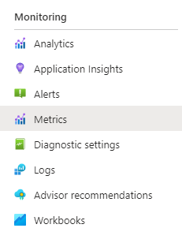

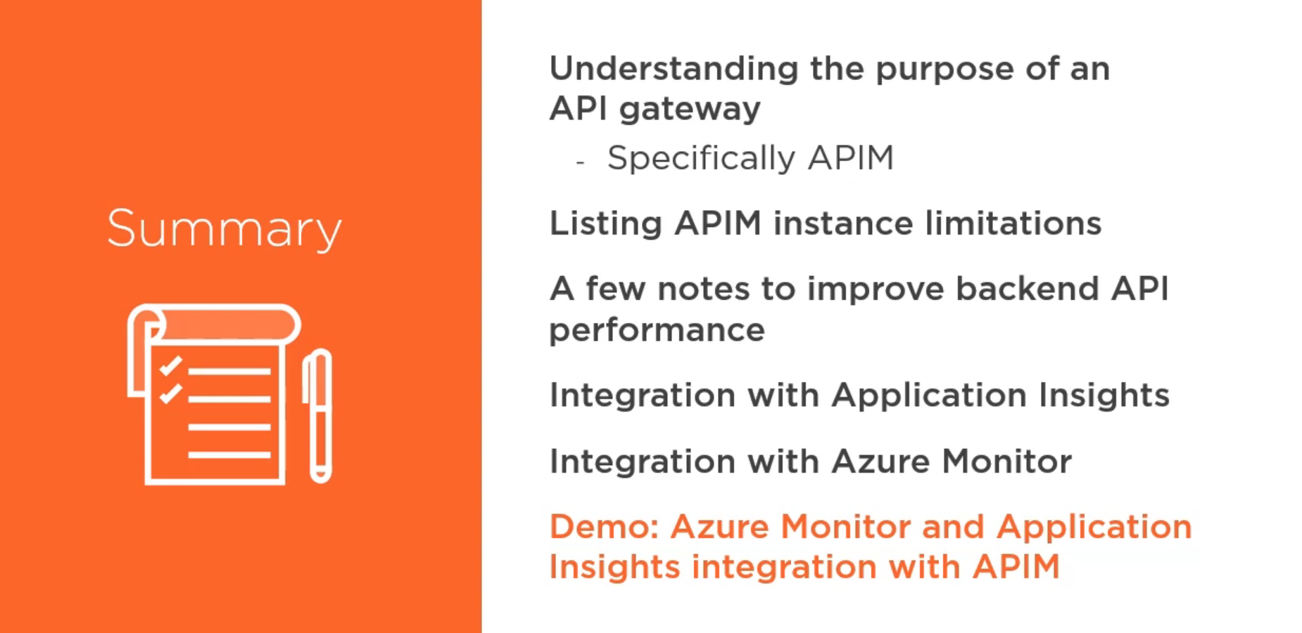



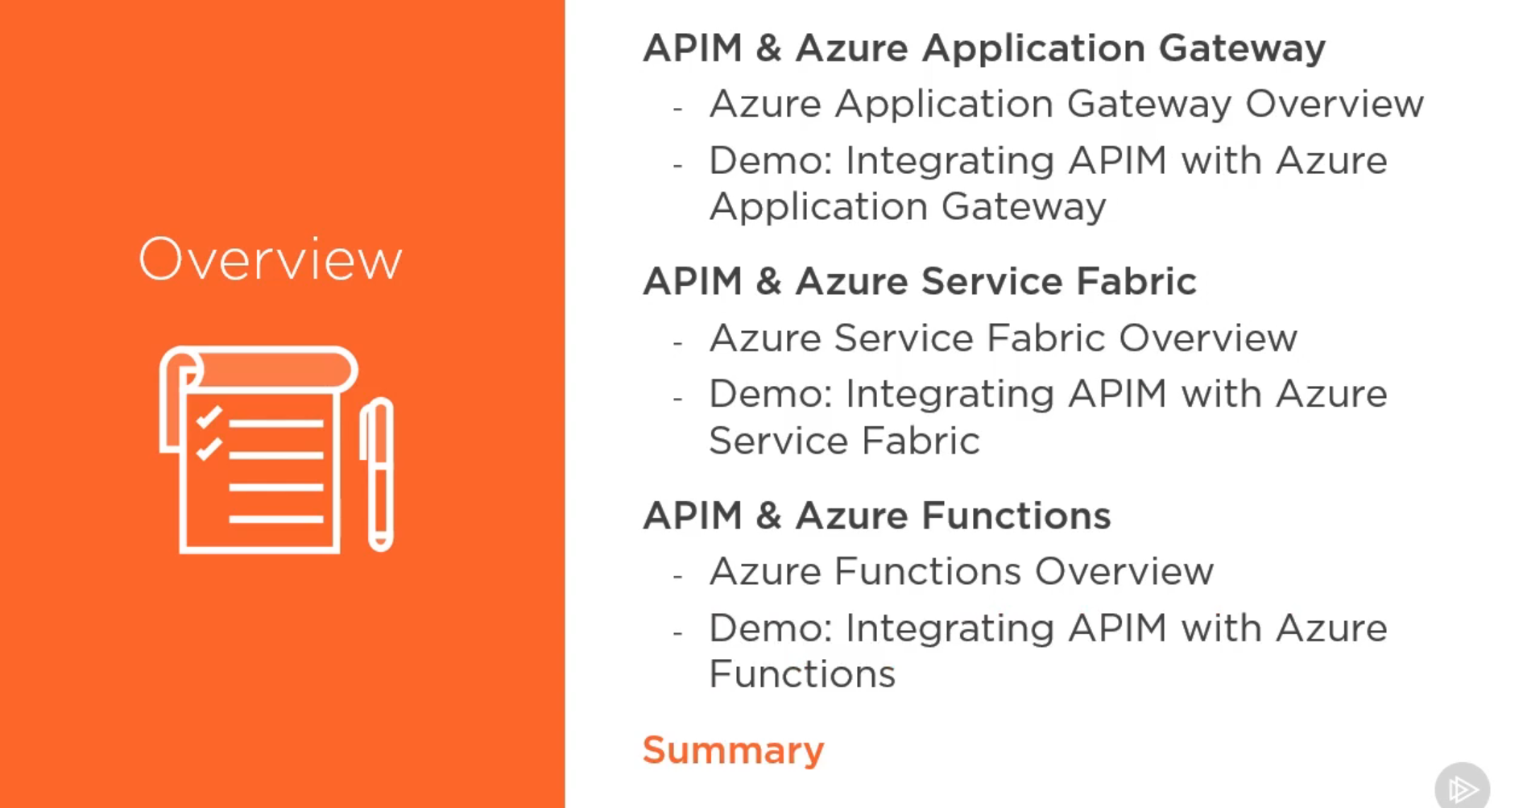



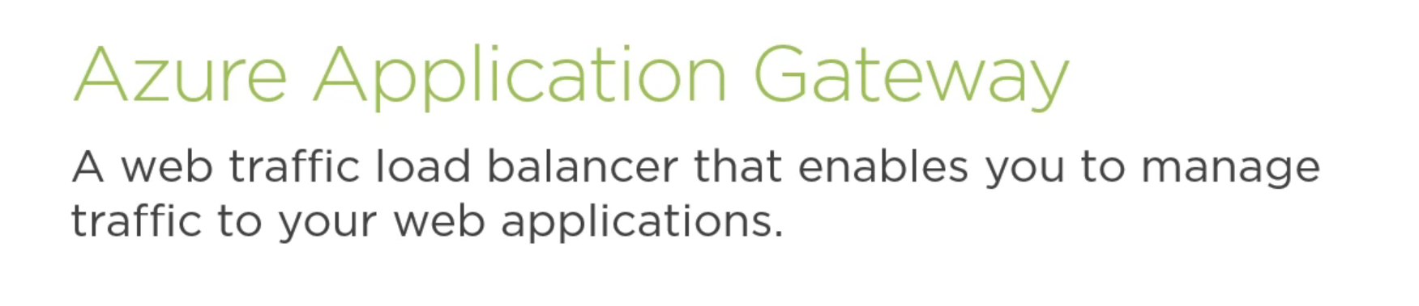

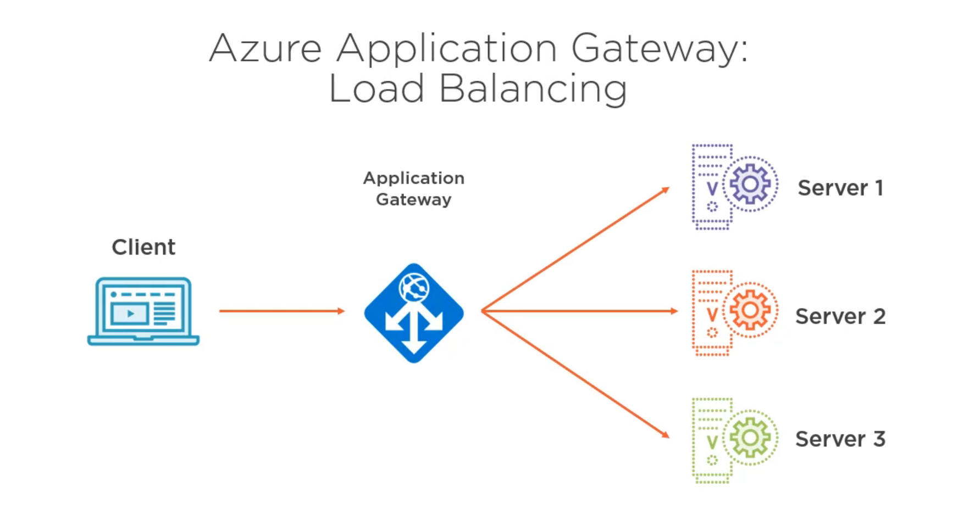

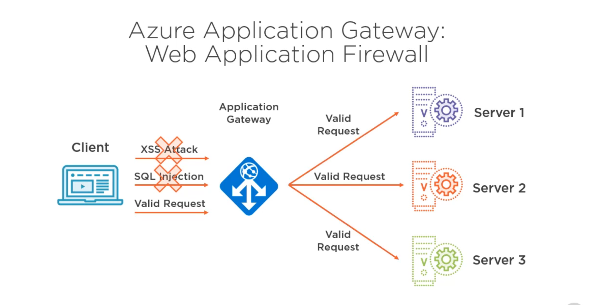

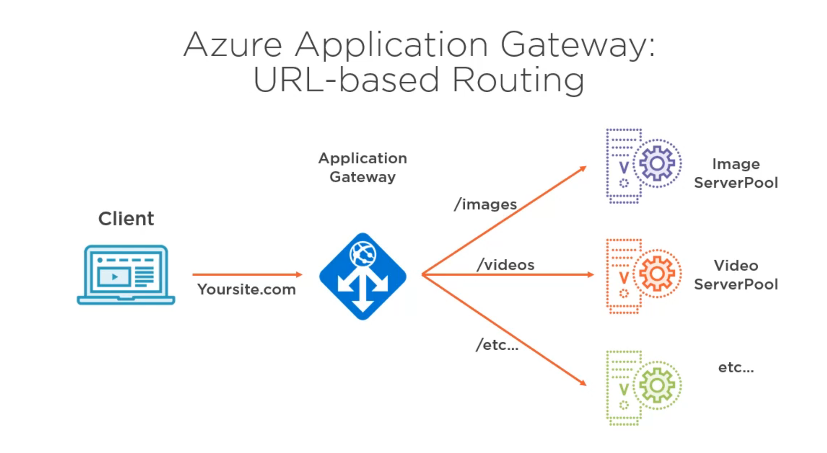

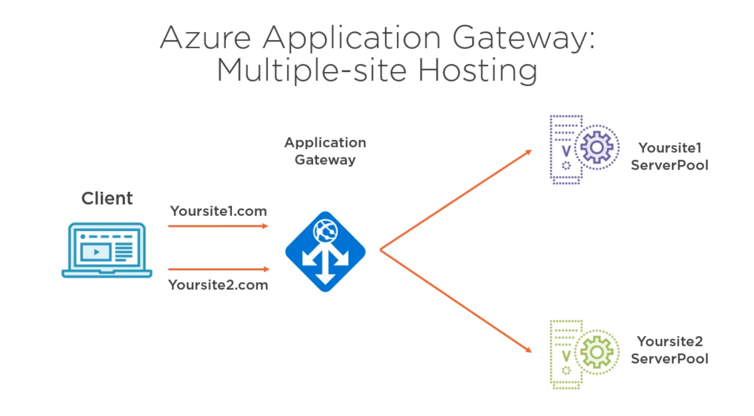

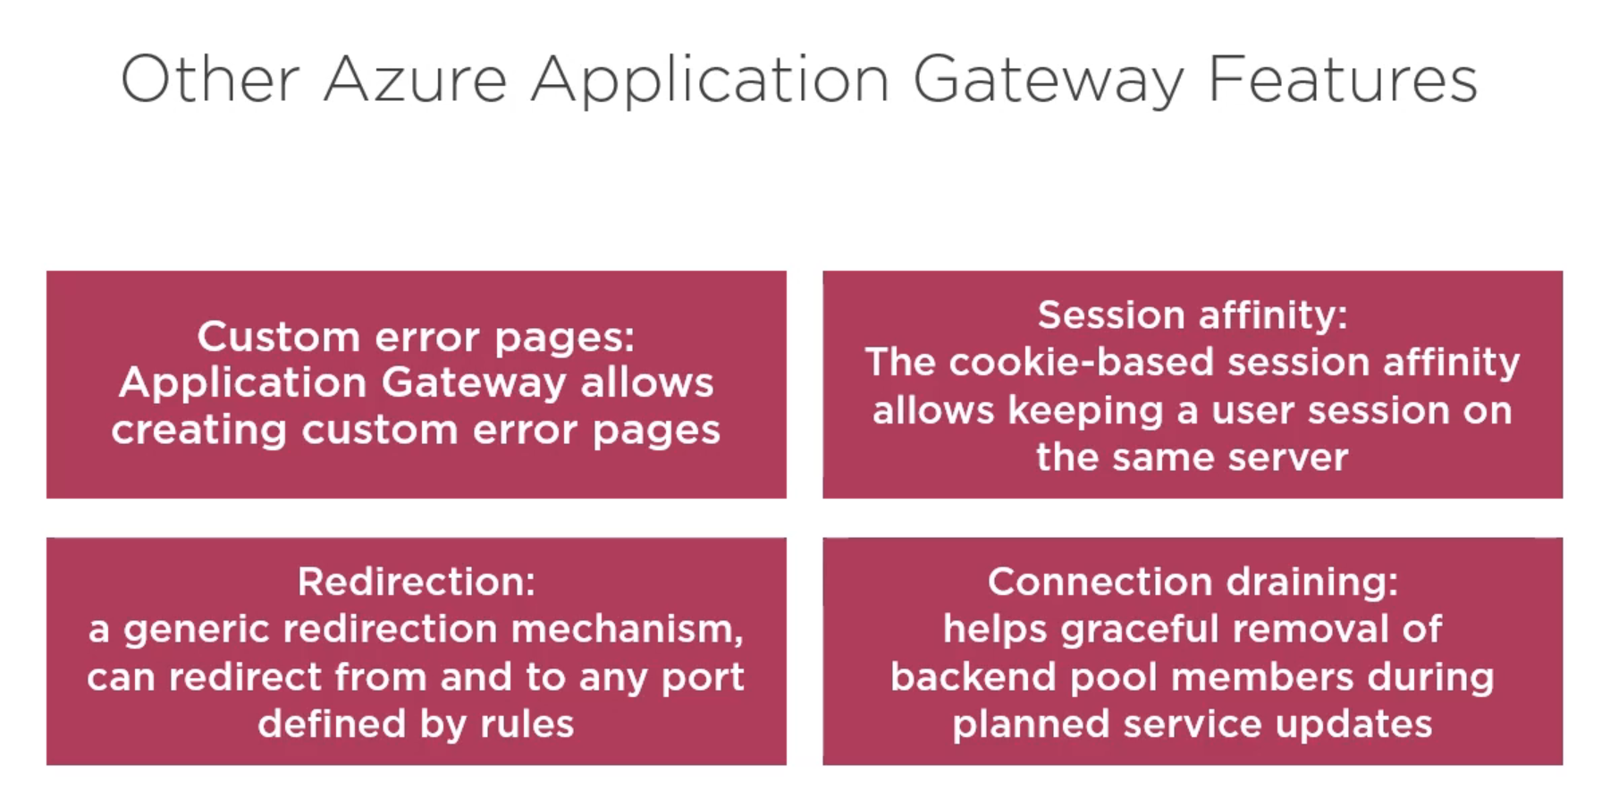

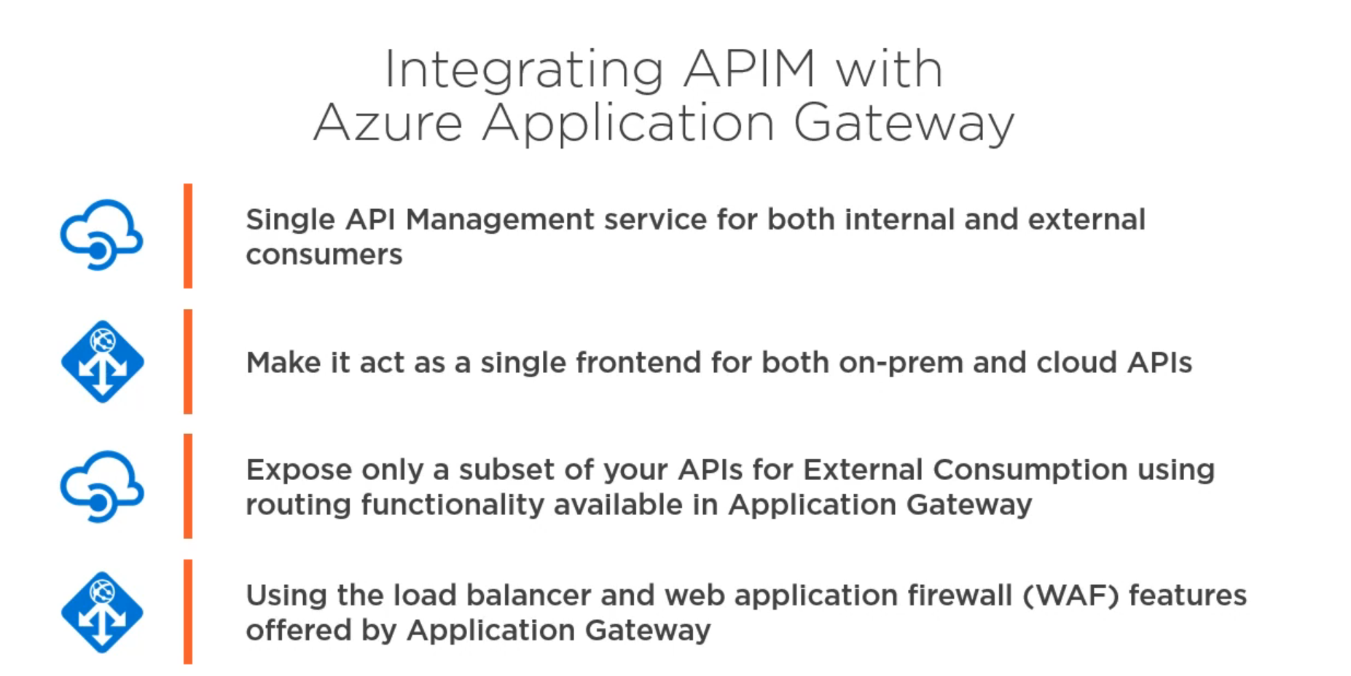

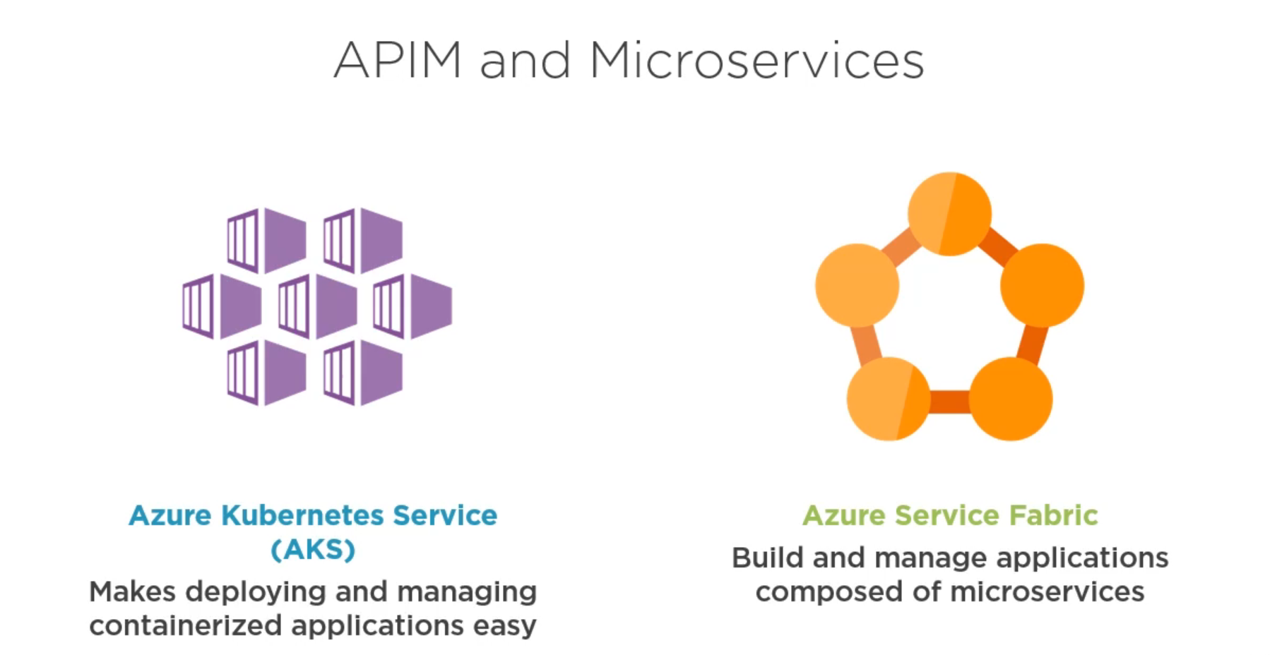

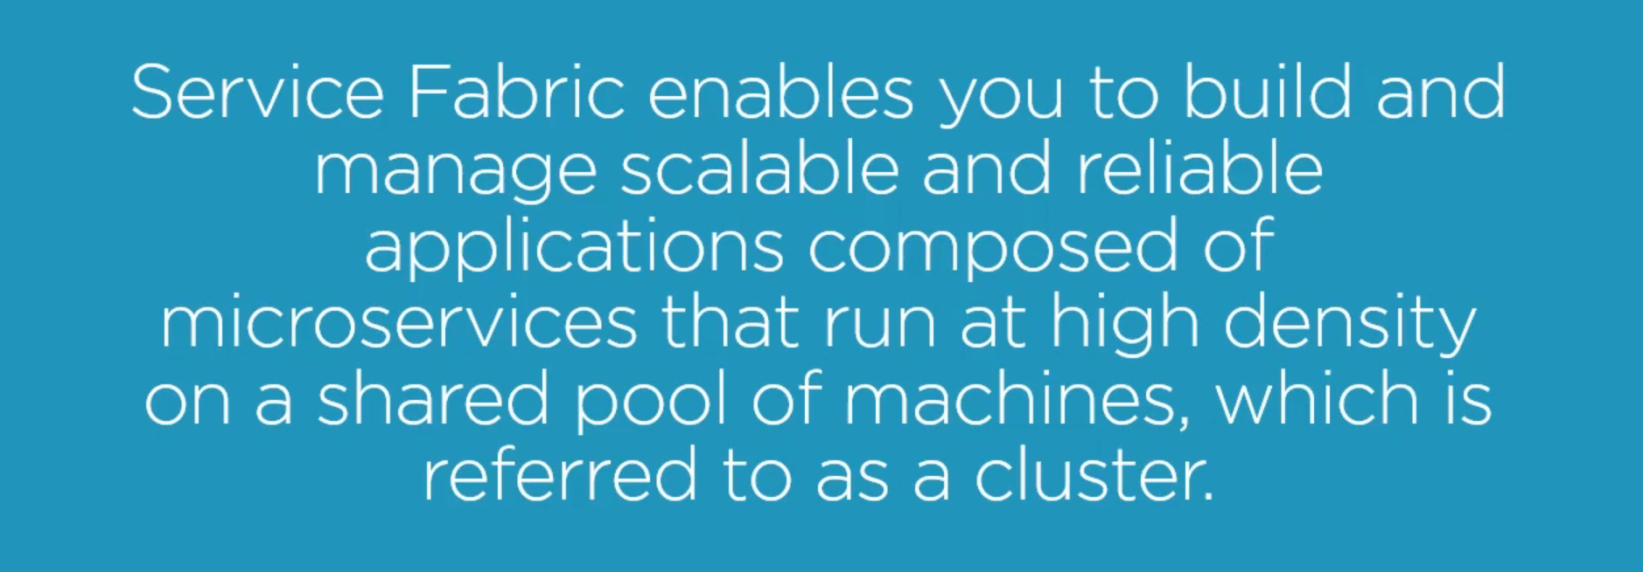

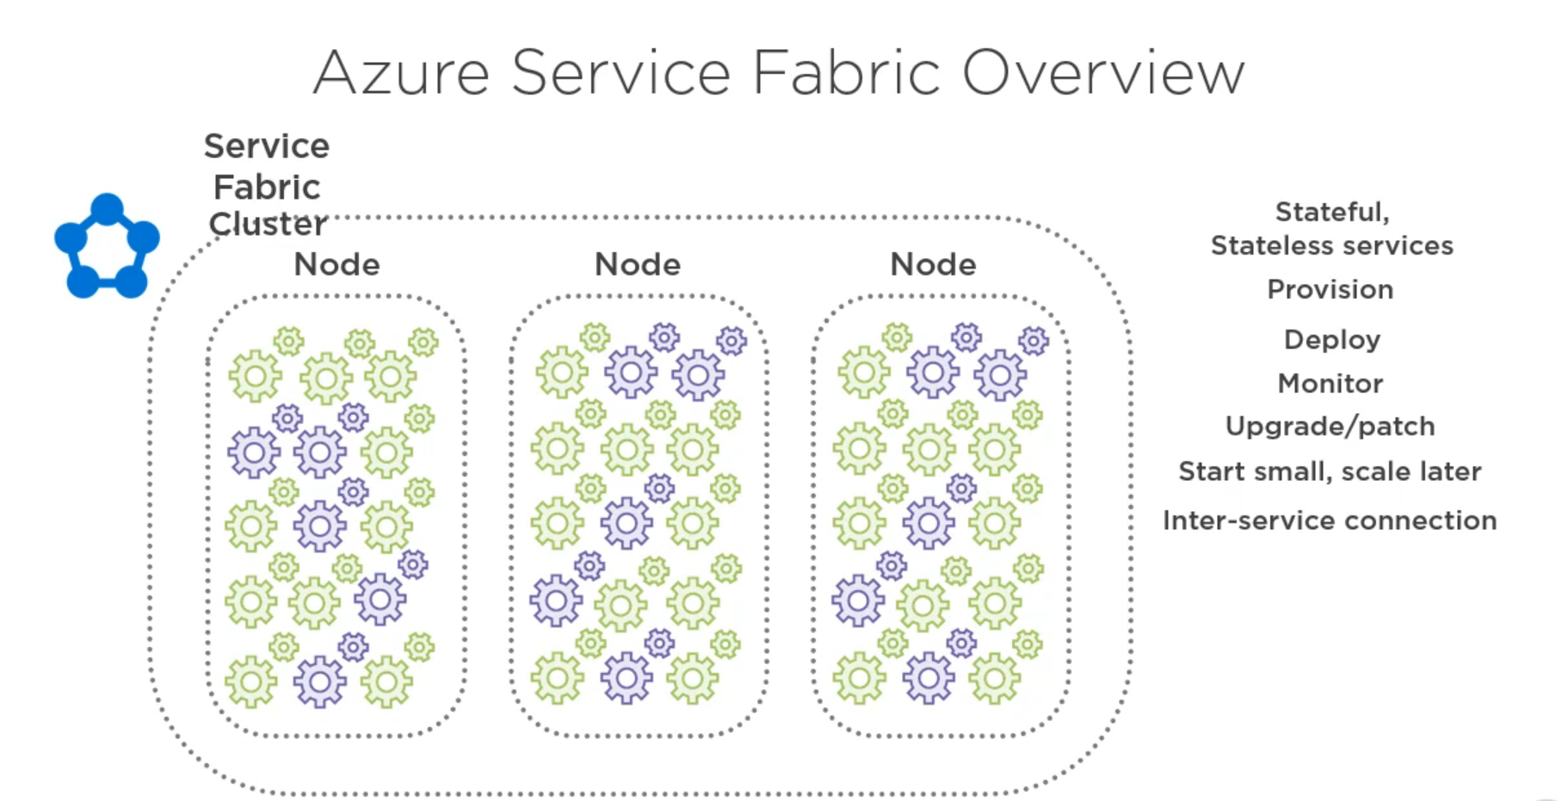

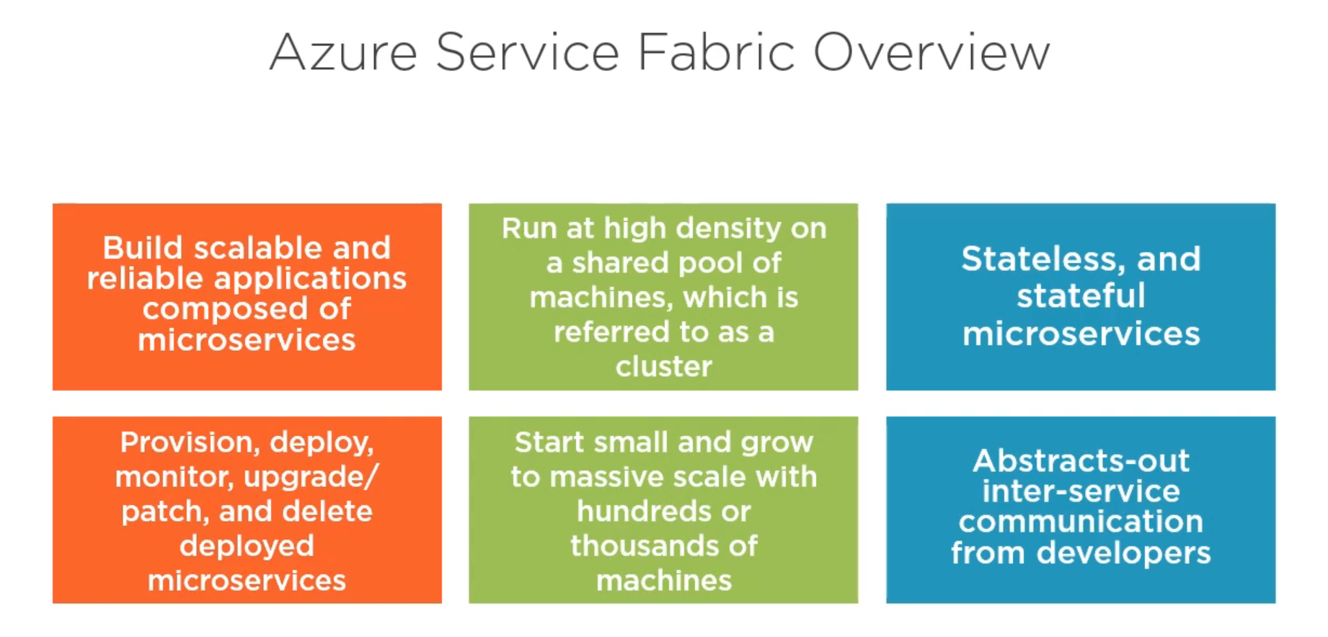

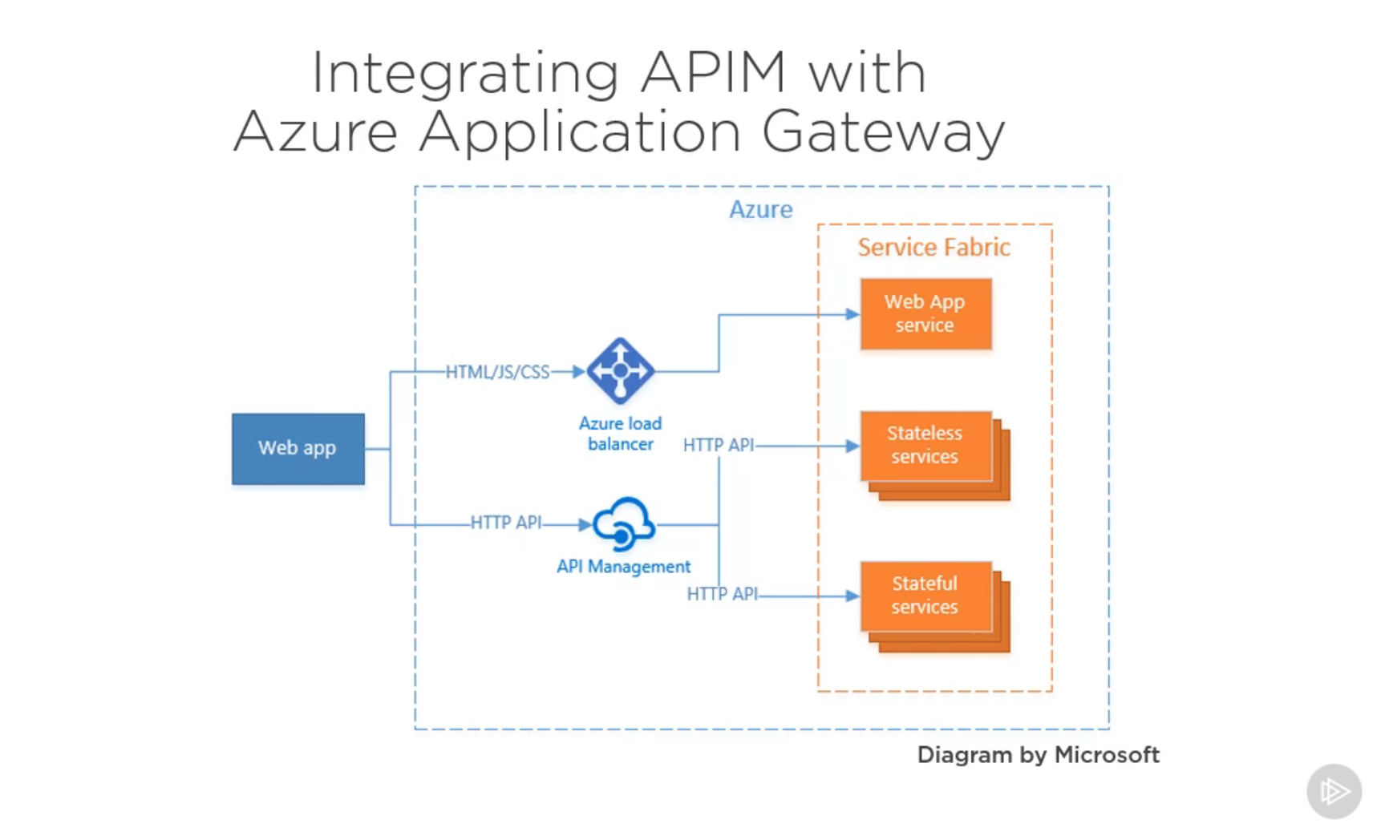

**Azure Functions**

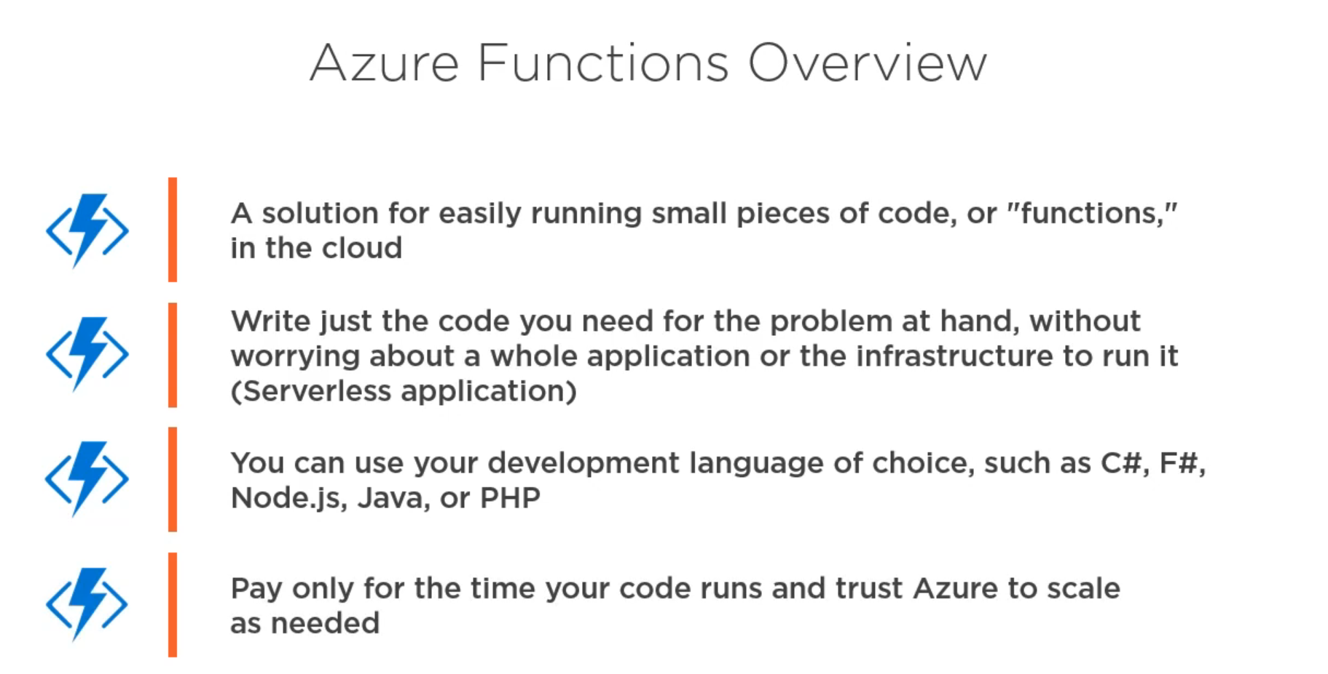

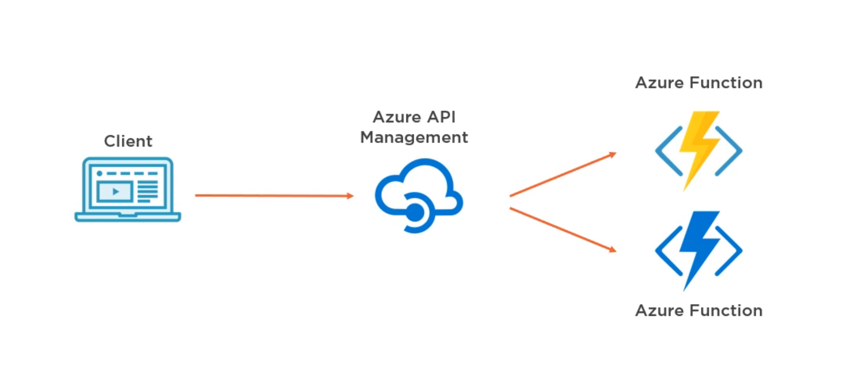

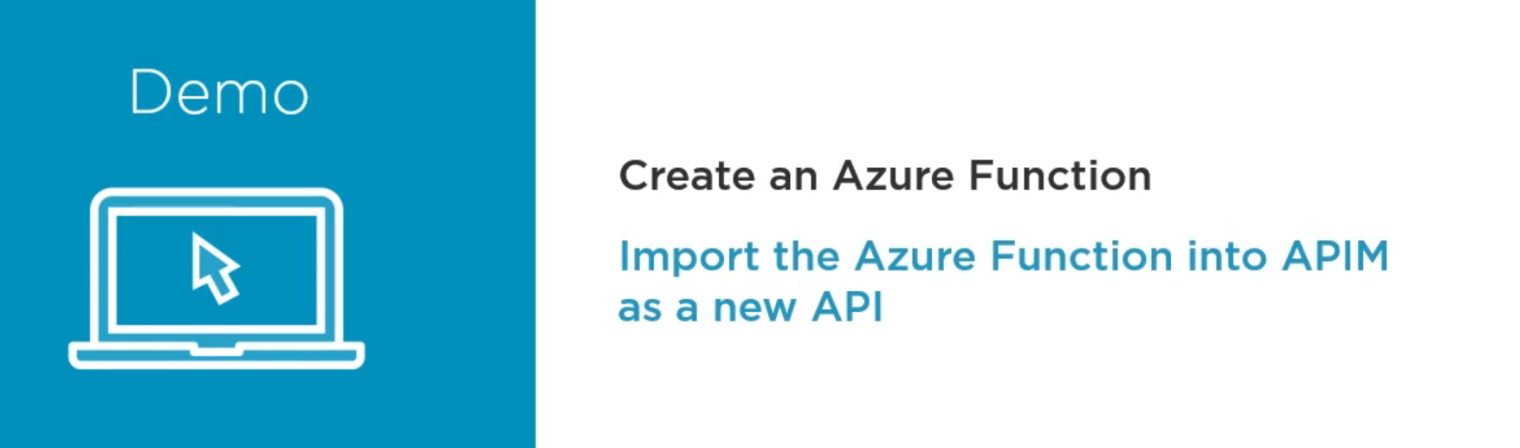

Let’s create a new Azure Function

First we need to create a new Function App.

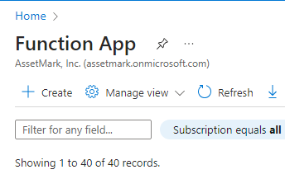

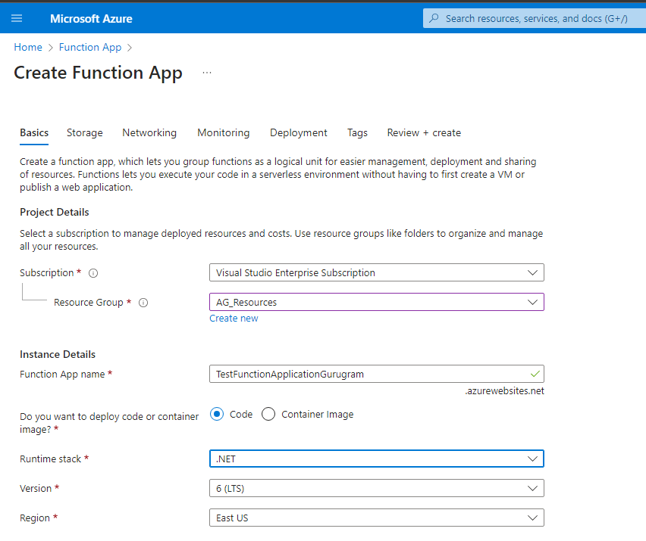

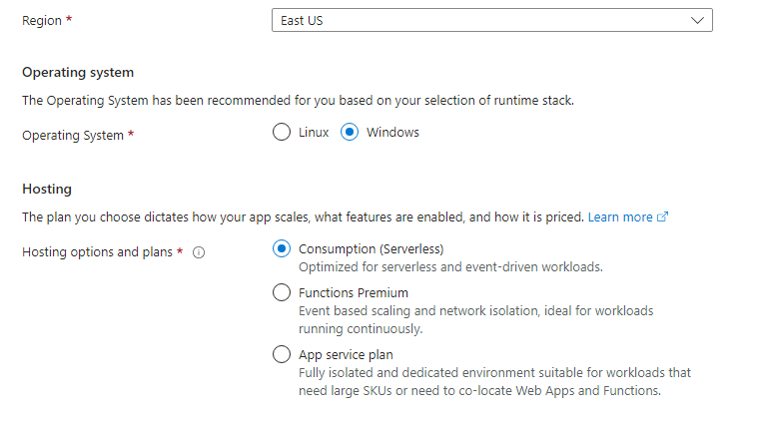

You have to add a storage account to store the definition of the Function.

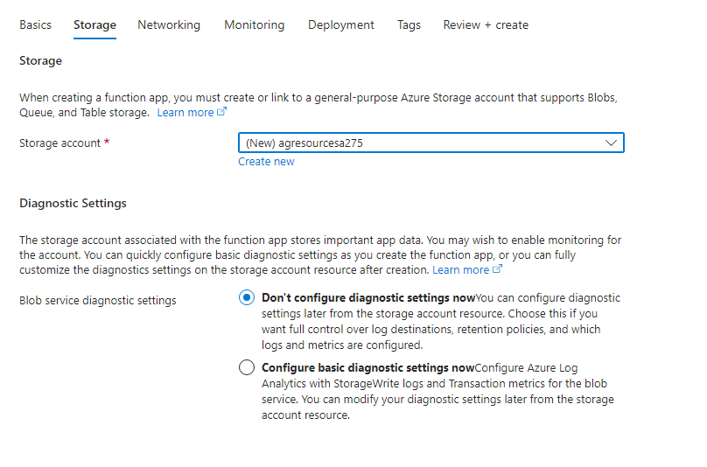

Now our function app is created

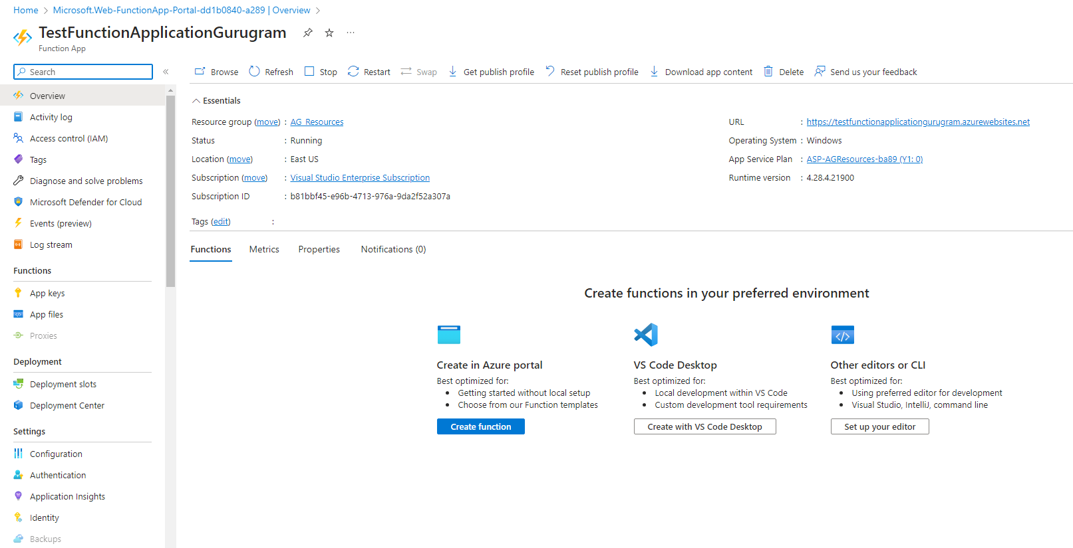

Now let’s create a function with HTTP trigger

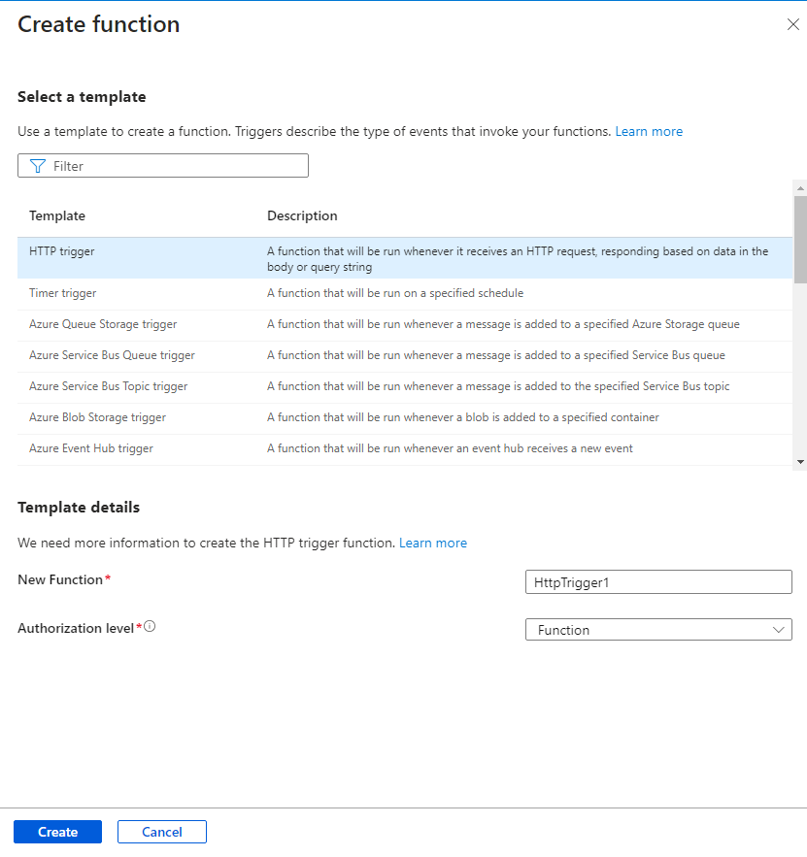

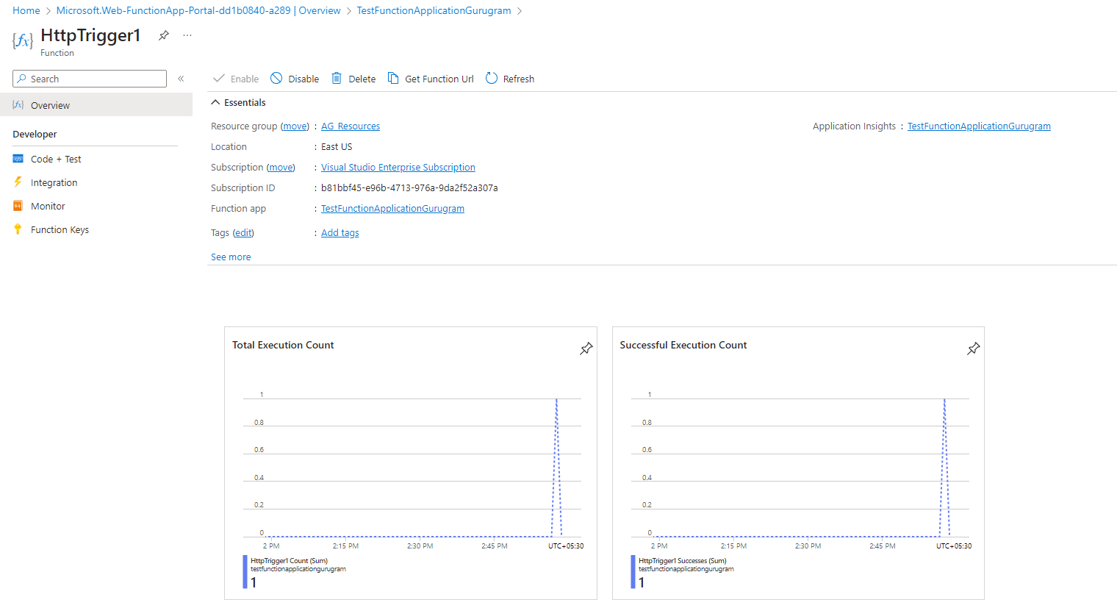

When we go to Code+Test there you can get the Code for the Function.

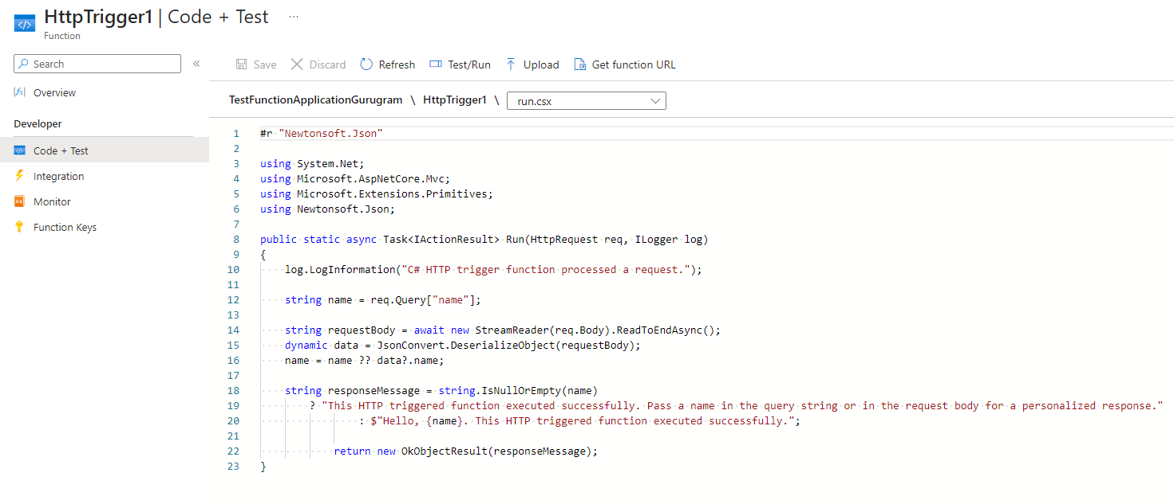

You can go to Test/Run to execute this function.

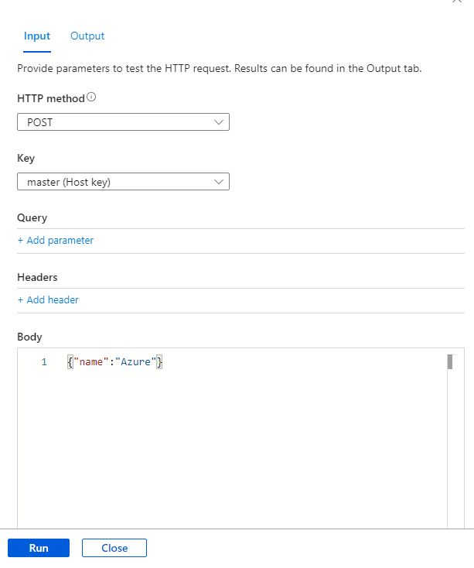

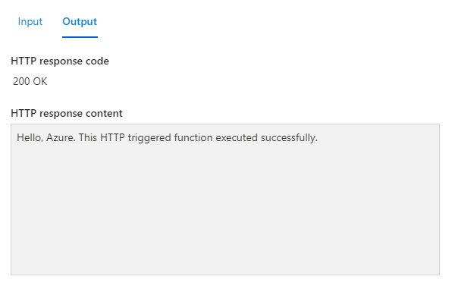

You can also execute this function form the url form the another tab

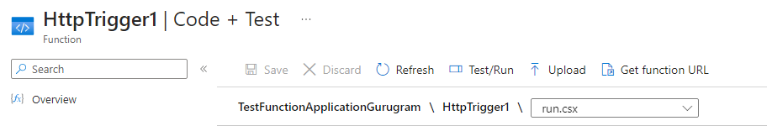

Get the function URL and then paste it inside another tab

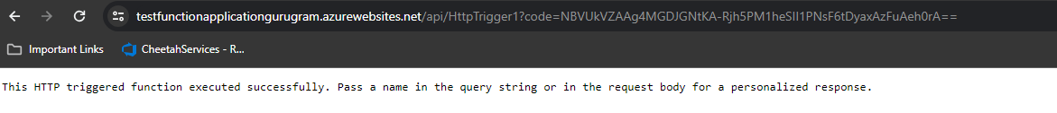

You can see that the function secret code is also present inside the url itself.

We can find this code inside the Function Keys

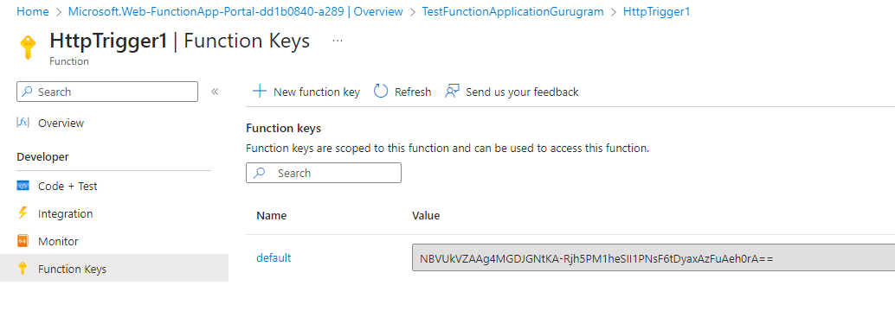

Also we can pass the name from the url to the function.

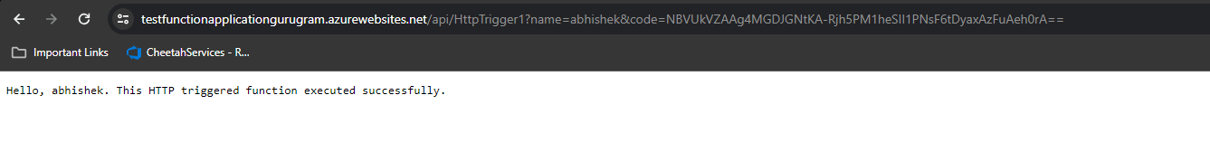

Modified url :- <https://testfunctionapplicationgurugram.azurewebsites.net/api/HttpTrigger1?name=abhishek&code=NBVUkVZAAg4MGDJGNtKA-Rjh5PM1heSII1PNsF6tDyaxAzFuAeh0rA==>

Now we have a working version of the azure function, let’s integrate it to our APIM.

When we navigate to our APIM and go to Add API then we have the option to add a Function App.

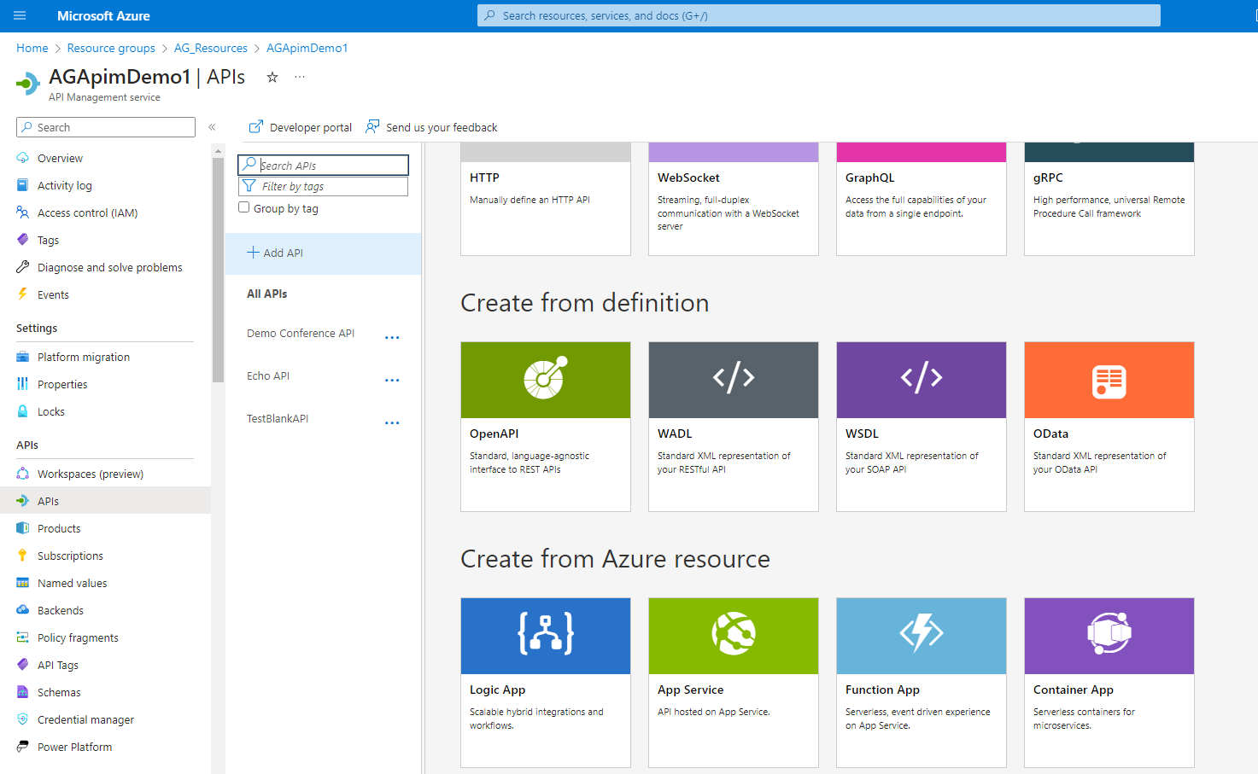

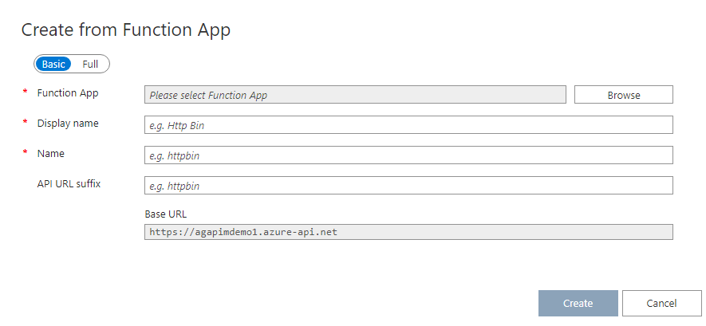

Browse your newly created Function app and select the function you want to integrate in your api.

You can see that a new API is added inside our APIM

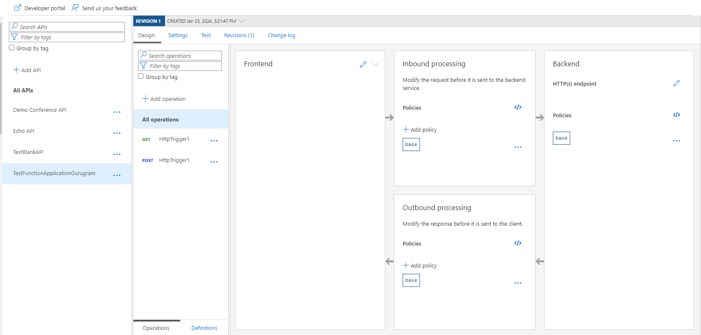

Now you can test it from APIM

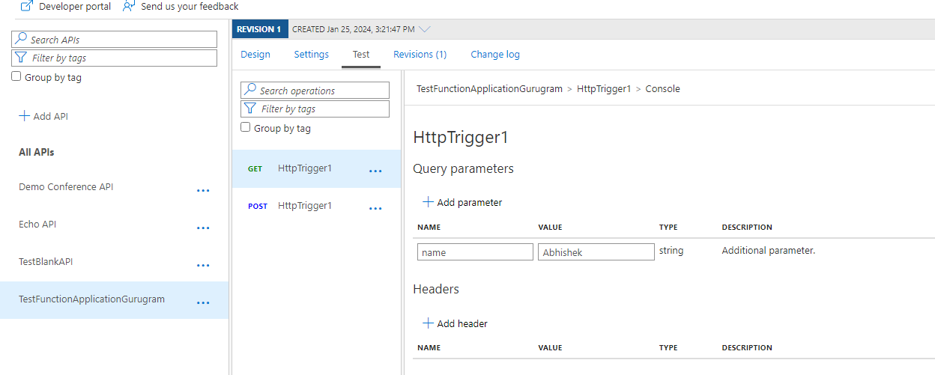

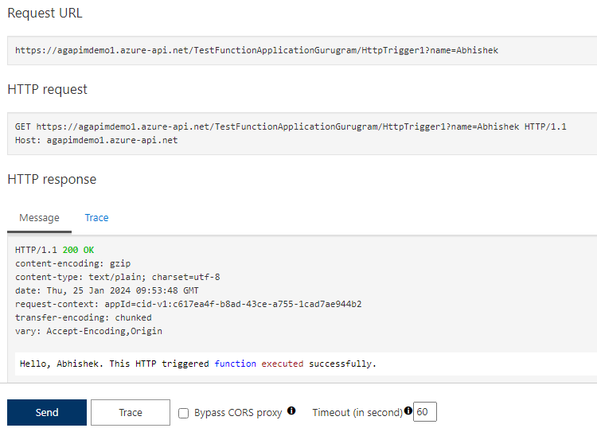

I am getting the desired output.

We can see that a set-backend-service policy is added to our newly added API.

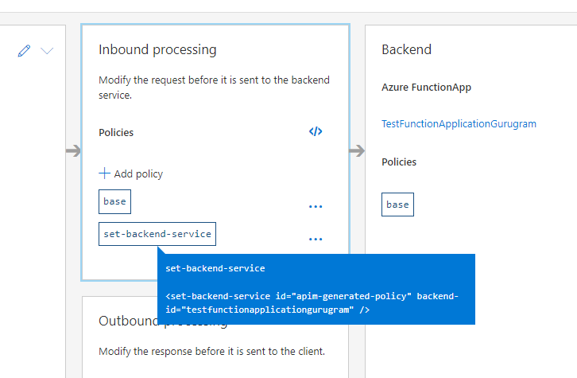

Which is actually redirecting the request to our function app.

When you will go to the Named Values inside the APIM we can see that a new Secret Function key is automatically added, this is basically how we are executing the functions of the Function app.

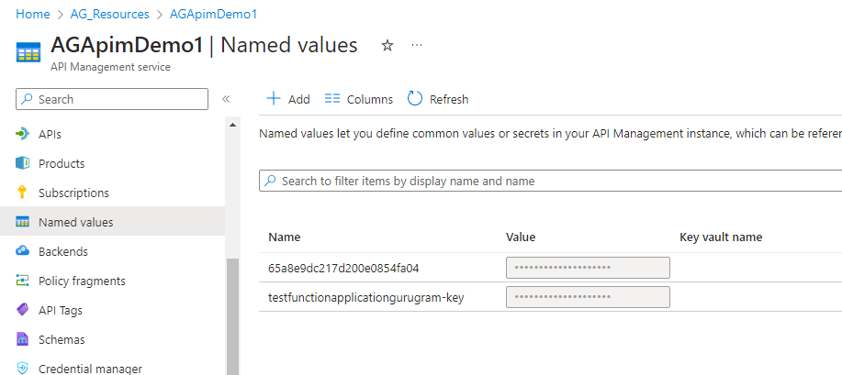

This same key can be seen at the Function App, App Keys.

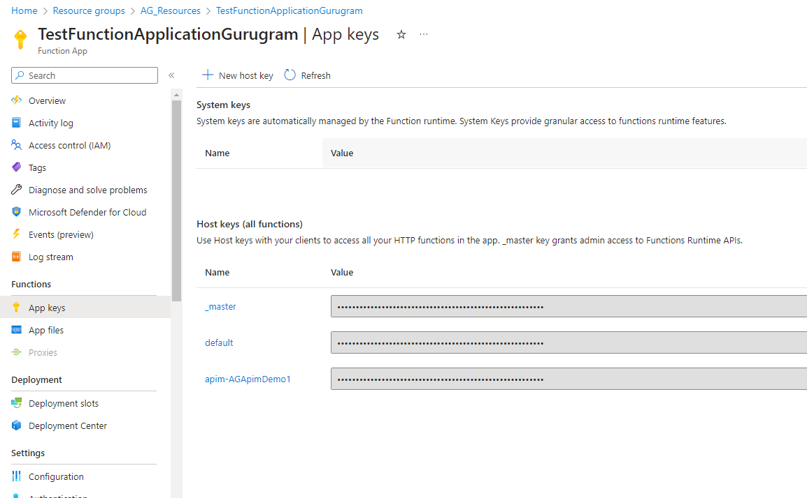



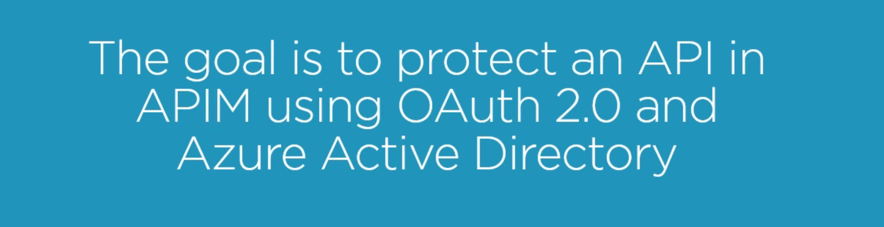

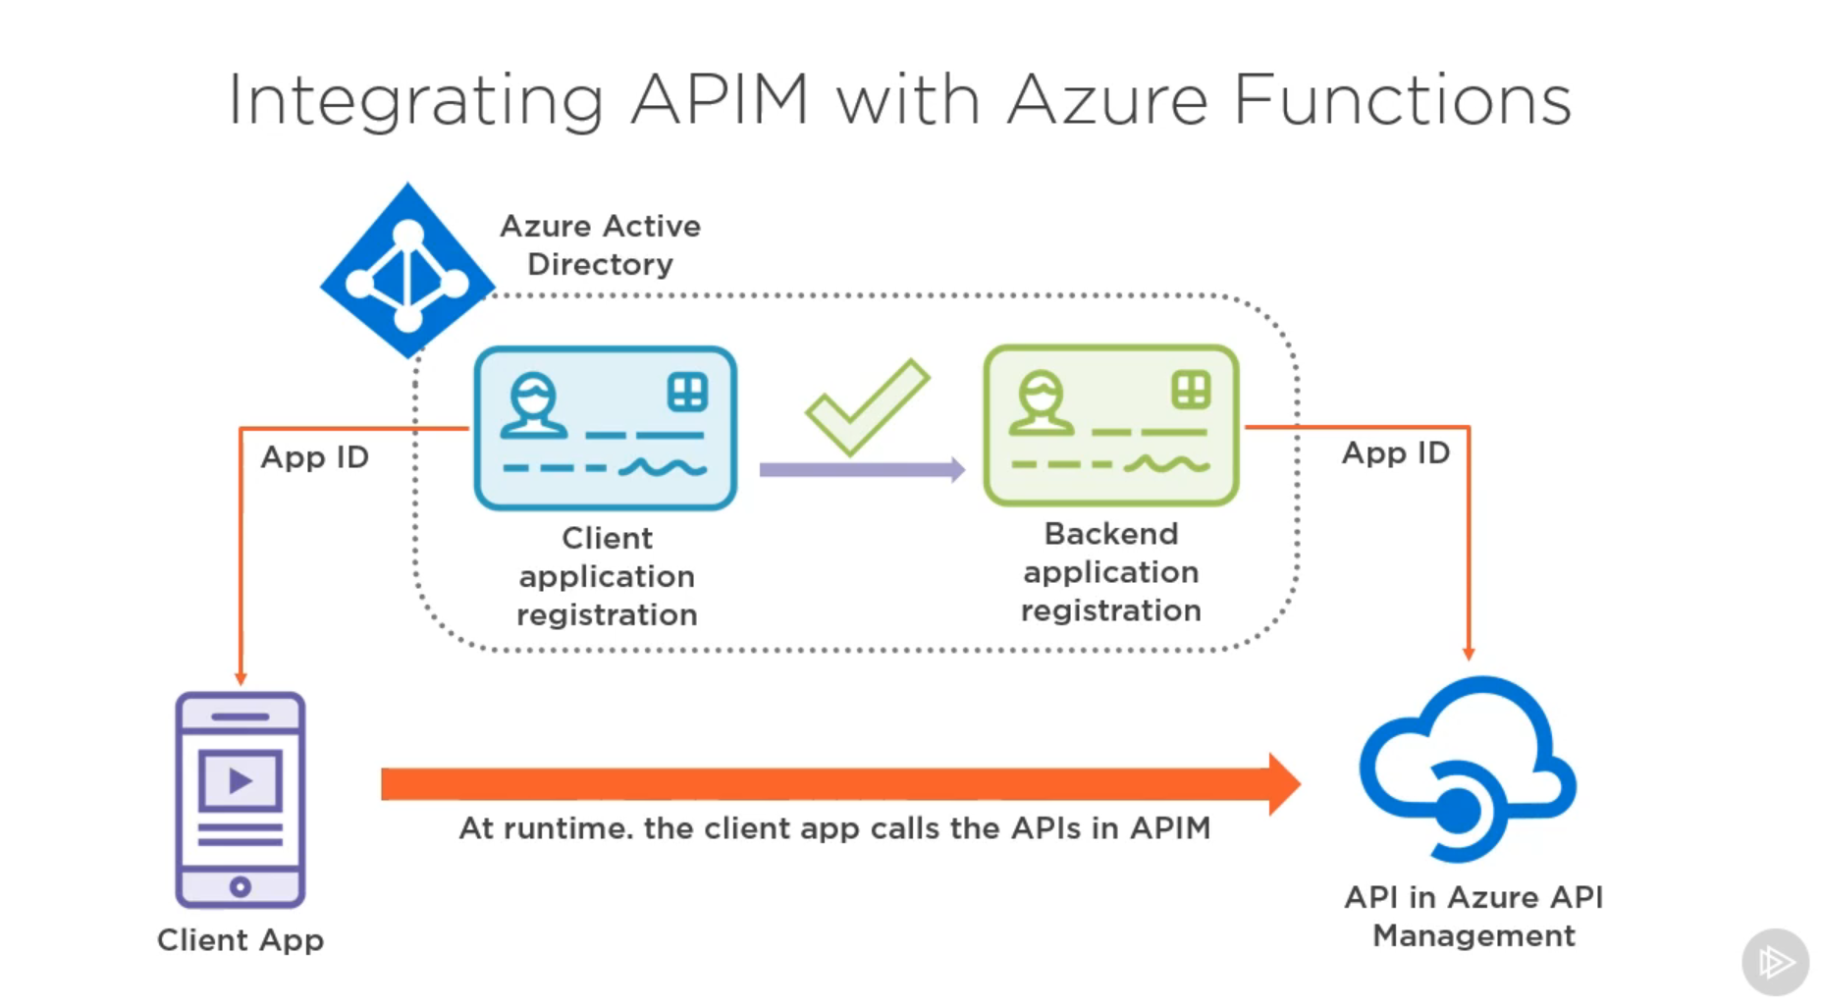

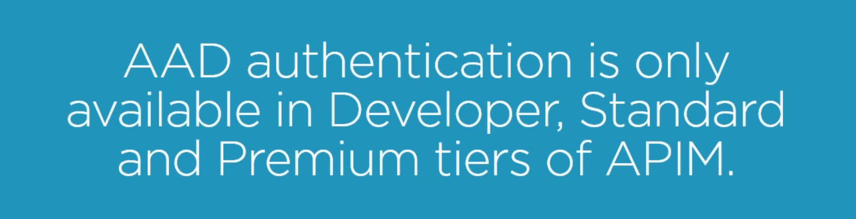

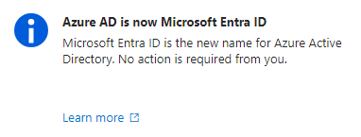

So navigate to Microsoft Entra ID and go to App Registrations and create a new Registration

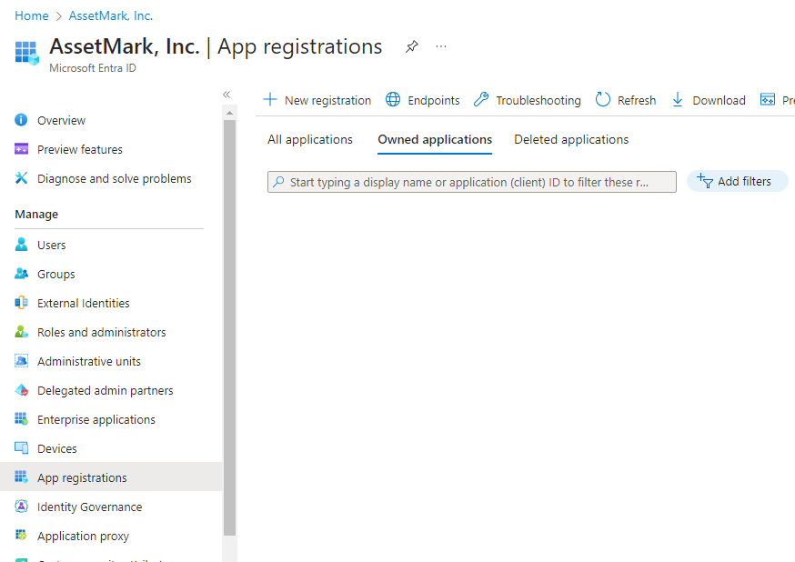

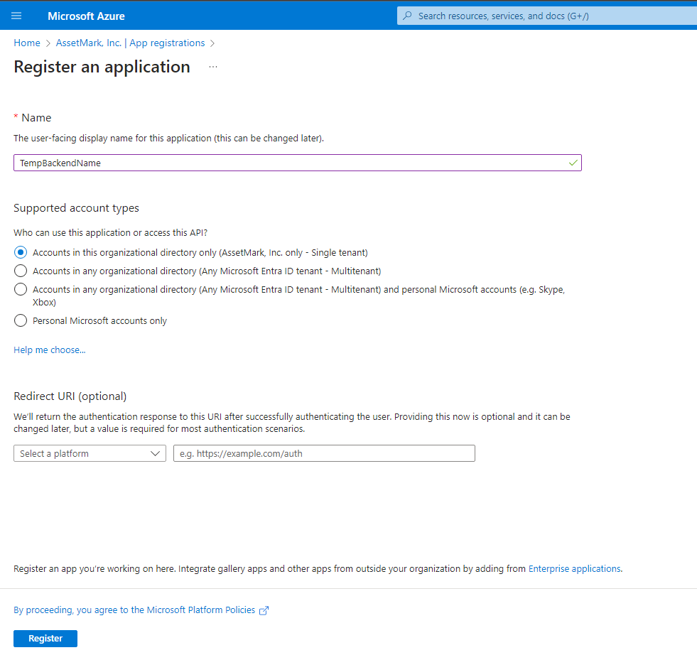

After registering go to Expose an API and enable Application ID URI and then add a scope

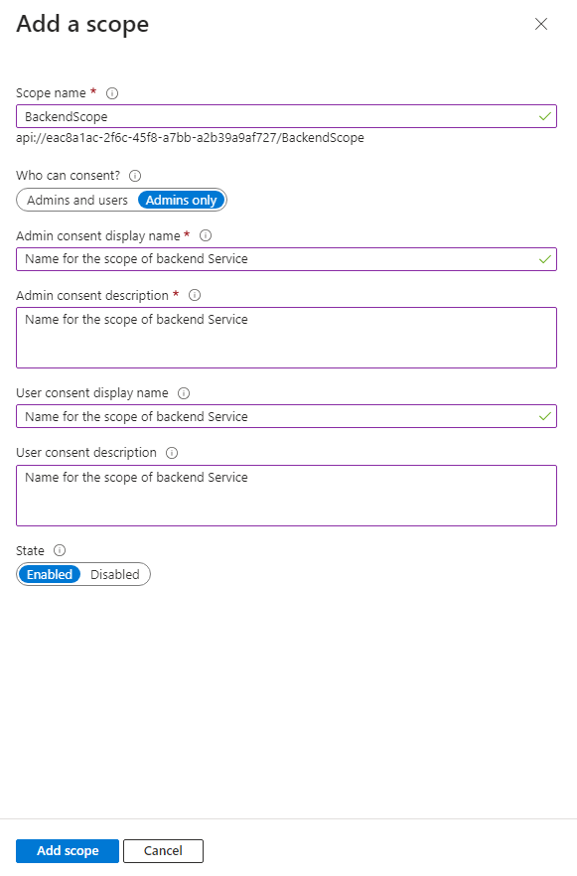

Similarly Register an Application for the client.

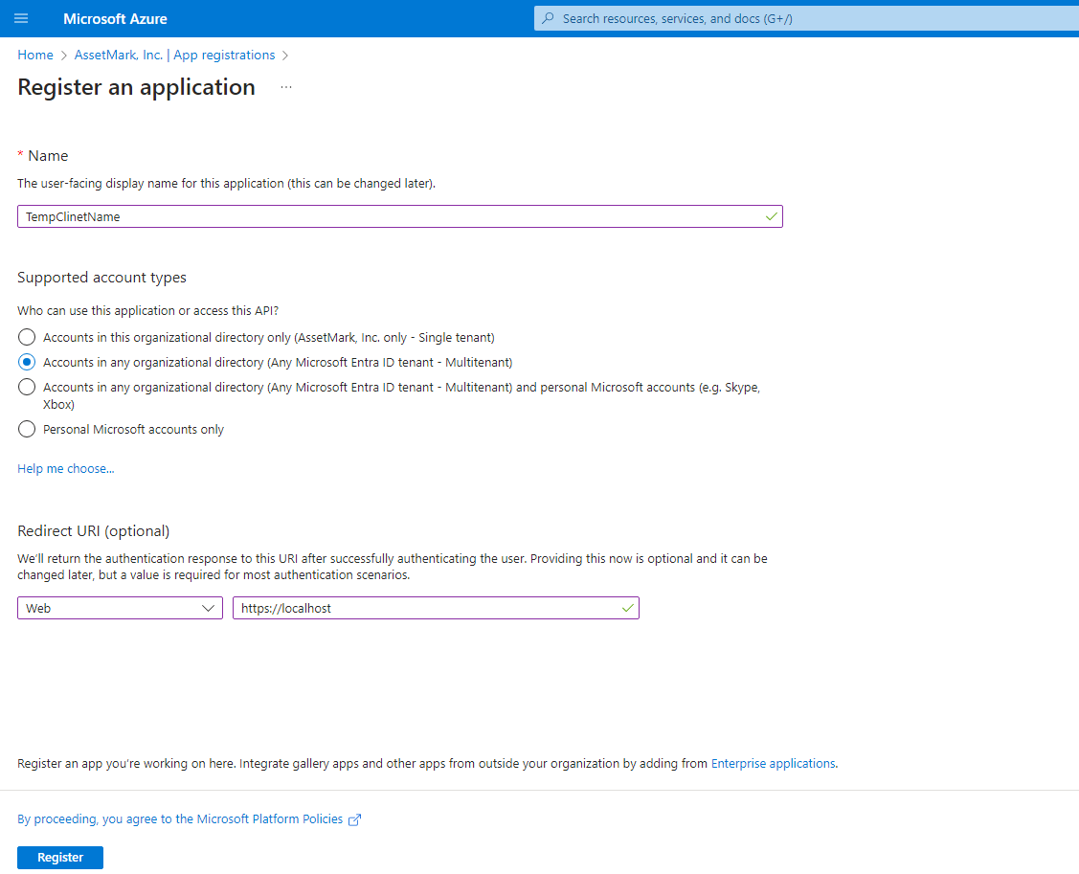

We also need to create a secret for client

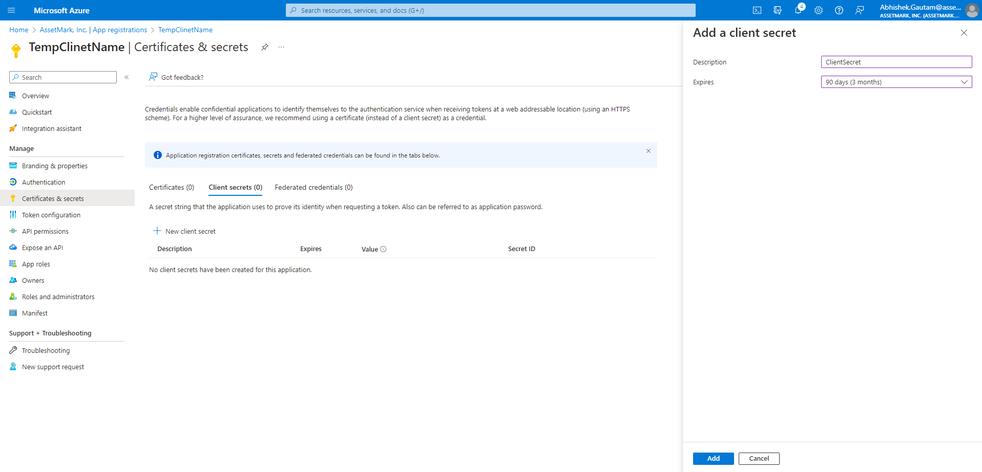

Now go to the API Permissions in TempClientName and then Add a permission and go to My API’s, you will see TempBackendName

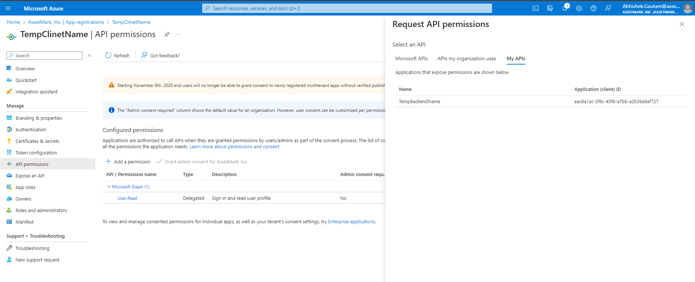

Select it and select the scope that we have created

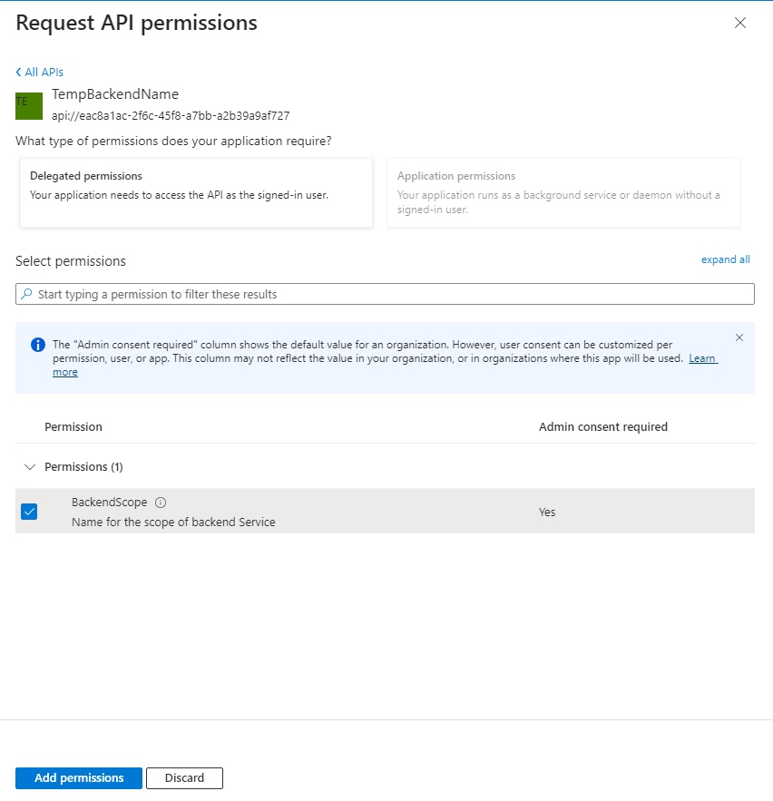

Now we have configured Microsoft Entra ID and now we need to configure our APIM

We need to configure OAuth 2.0 inside our APIM.

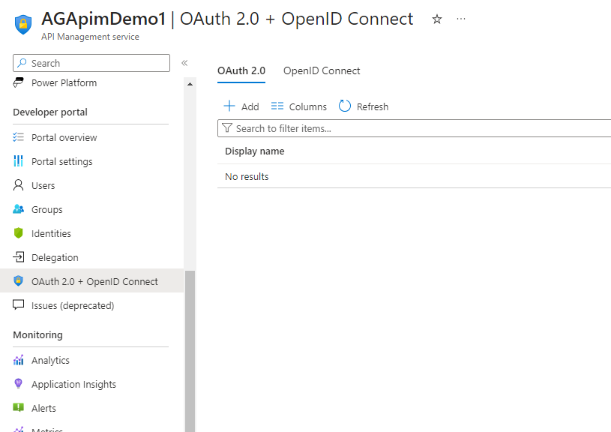

Click on Add and fill all of the values form the Registrations that we have made in Microsoft Entra Id.

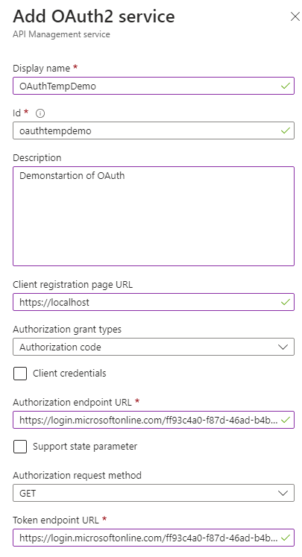

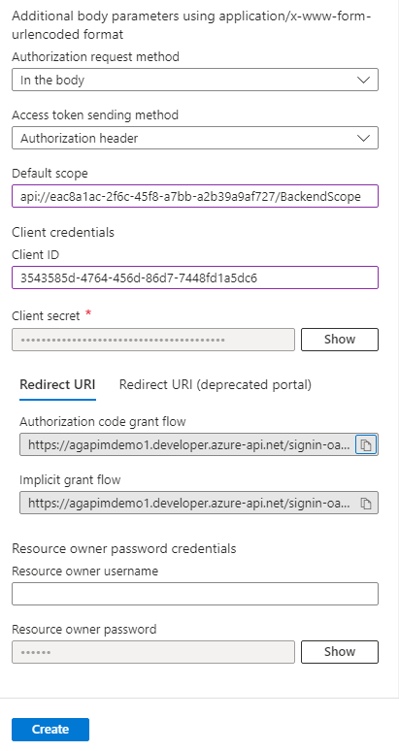

Copy this Authorization code grant flow.

Hit on create and go to your Microsoft Entra Id’s Client Registration, go to authrization and paste the url there and save.

Last step that we need to do is to go to settings of API inside our APIM and update the authorization.

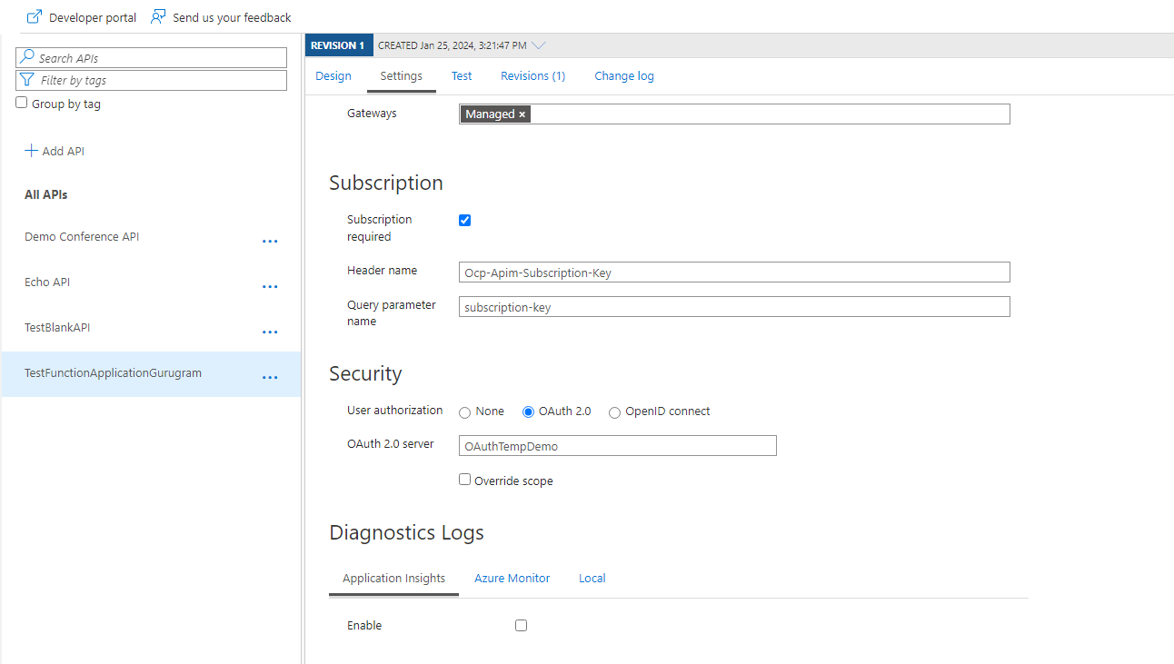

You can enable this authorization for any api that you like.

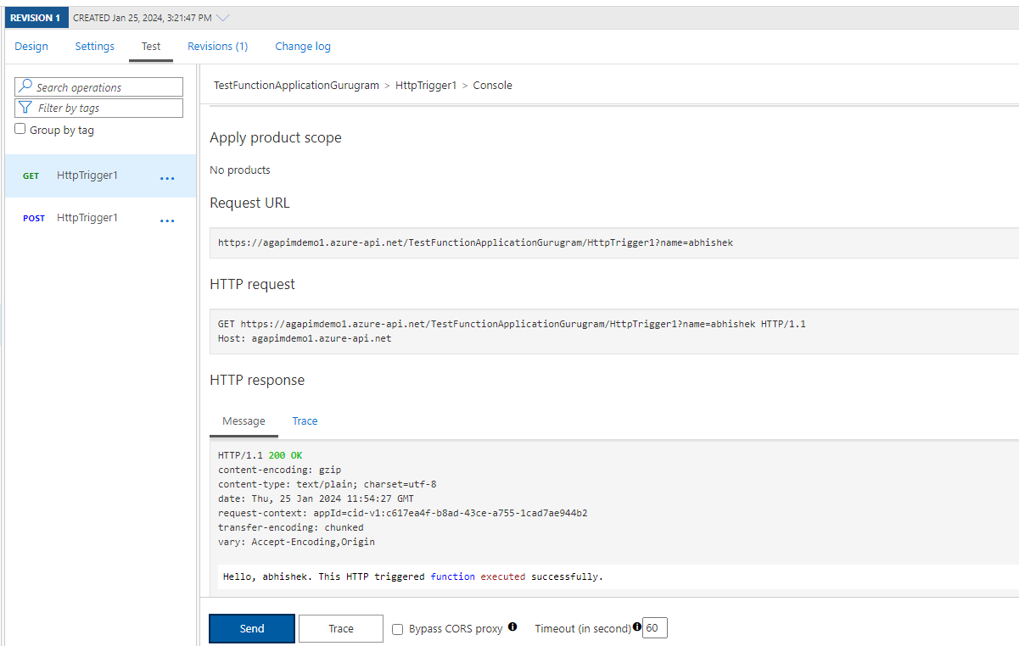

We are getting the desired output.

